One of the most impressive games played
in any Gibraltar Tradewise Festival, Emil Sutovsky
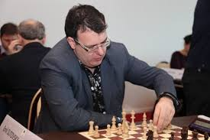
Daniel Gormally – Emil Sutovsky 2005:
Black to play and win:
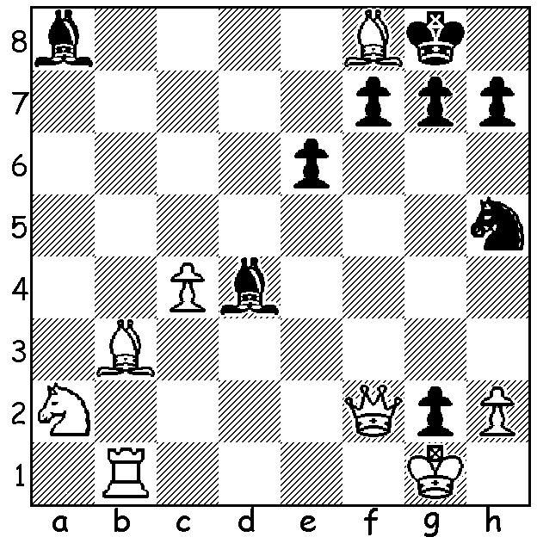

The 2017 Tradewise Gibraltar Chess Festival with 255 players in the main event was the major chess event of January. It was won by Hikaru Nakamura (USA) with 8/10, his third consecutive win and his fourth in all, overtaking Nigel Short with three previous successes. It was a come from behind victory, winning his final game as Black to catch leader 21 year old David Anton Guijarro (Spain). He then went into a three-way playoff, defeating firstly Yu Yangi (China) in two Blitz games after 2 rapidplay draws and then Guijarro 1.5-0.5 in two rapidplay games. Nakamura has now been unbeaten in his last 45 games on the Rock. Maxime Vachier Lagrave, Veselin Topalov, Boris Gelfand (7.5/10) were among those in equal fourth place. Australia's only representative Bobby Cheng scored 5.5.
With special female prizes the event is the major tournament most supported by women, especially as a player can win multiple prizes (women's number 1 Hou Yifan went home with Women's, Junior and a rating prize one year). Ju Wenjun (7), who defeated Hou Yifan in Rd 8, was this year's women's winner. Hou Yifan certainly blotted her copybook in the final round playing 1.f3 2.g4 and resigning in 5 moves as a protest against being drawn against seven women in the first nine rounds. However analysis of the computerised pairings has shown them to be perfectly legitimate. Nevertheless Hou Yifan produced one of the most interesting games with an audacious positional queen sacrifice on move 16 in her Rd 7 game:

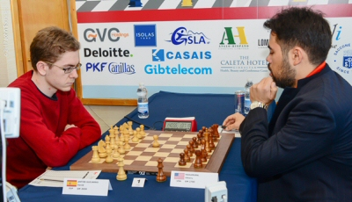
Ider Borya - Hou Yifan
2017 Gibraltar Tradewise, Rd 7
Queens Pawn: Double Fianchetto Defence
1.d4 Nf6 2.Nf3 b6
3.Bf4 Bb7 4.e3 g6
5.h3 Bg7 6.Be2 d6
7.c4 Nbd7 8.Nc3 0-0
9.0-0 e6 10.Qc2 Nh5 David Anton Guijarro v Hikaru Nakamura
11.Bh2 f5 12.d5 e5
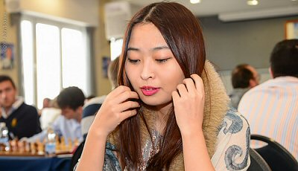
13.g4 fxg 14.hxg4 Nhf6
15.Ng5 Nxd5!? 16.Ne6 Nxc3
17.Nxd8 Nxe2+ 18.Qxe2 Bf3
19.Qd3 Nc5 20.Qa3 Rfxd8
21.e4(a) Rf8 22.Rae1 Bh6
23.b4 Ne6 24.c5 Nd4
25.Qd3 b5 26.Bg3 Bg5 Women's winner Ju Wenjun
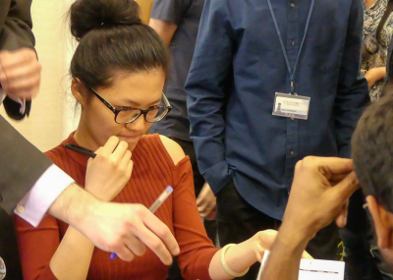
27.a4 a6 28.Qa3 Bxg4
29.Rd1 Nf3+ 30.Kg2 dxc5
31.bxc5 h5 32.Qa2+ Kh7
51.Kxf1(f) Rd8 52.Qh7+ Kg4
White resigns

a) Hoping for 21...Bxe4 when 22.f3 strengthens White on the kingside white squares. However the move weakens d4.
b) White should try to open up the queenside with 33.axb5 You Hifan losing in 5 moves
axb5 34.Qb2 Bf6 35.Ra1 h4.
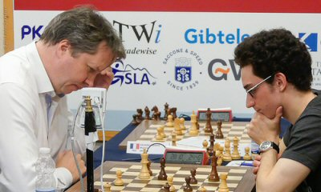
c) White stands more chance with the counter sacrifice
36.axb5 axb5 37.Qxb5 hxg3 38.fxg3 Nd4.
d) Brilliant! Black doesn't fear the coming discovered check.
e) If 45.Kxh2 Bf4+ 46.Kxh3 Rxe5 wins.
f) If 51.Qd7+ Re6! (deflection) 52.Qxe6+ Kh4.

The first of the 2017 WA Grand Prix events, the Perth Open,
will be played this weekend at Leeming Primary (Rds 1-3 Sat,
Rds 4-6 Sun). Details cawa.org.au & entries to Nigel Short defeating World gordondunlop64@gmail.com or 9368 6412 / 0409 812129. Number 2 Fabiano Caruana

SOLUTION: 1...Nf4! White resigns (2.Qxd4 Nh3#).

