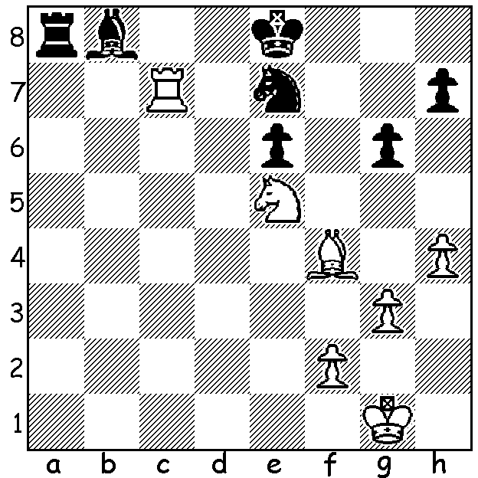

Stefanovic vs Khurtsidze
(Women's World Championship 2017):
White is able to create winning chances
(3 moves):

At time of writing the Women's World Championship has reached the quarter-final stage with three Chinese, Ju Wenjun, Tan Zhongyi, Ni Shiquun, plus Anna Kosteniuk (Russia, 2008 champion), Nana Dragnidze (Georgia), Antoaneta Stefanovic (Bulgaria, 2004 champion), Anna Muzychuk (Ukraine, sister of Mariya Muzychuk who lost a 2014 title match to top rated woman Hou Yifan who is not competing) and Dronavalli Harika (India) remaining from the original 64 players. A few leading players including the US champion Nazi Paikidze boycotted the event which is being played in Tehran because of the stipulation that all contestants must wear the hijab (scarf) in accordance with Iranian law. The knock-out format is comprised of a 2-game match at classical time limits (90 min for 40 moves with 10 sec increments, then 30 min plus 10sec to finish). If players are level two rapidplay games are played (25 min + 10 sec), then if necessary two more at 10 min + 10 sec, then (again if necessary) two Blitz at 5 min + 3 sec and finally if necessary an Armegeddon game with White (5 min + 3 sec) needing to defeat Black (4min + 3 sec). Muzychuk with a win vs Stefanovic in their first ¼-final game, followed up with a draw to win a place in the semis:

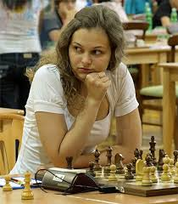
Anna Muzychuk vs Antoaneta Stefanovic
2017 Womens World Championship, ¼ Final, Game 1
Ruy Lopez, Breyer Defence (9...Nb8)
1.e4 e5 2.Nf3 Nc6
3.Bb5 a6 4.Ba4 Nf6
5.0-0 Be7 6.Re1 b5
7.Bb3 d6 8.c3 0-0
9.h3 Nb8 10.d4 Nbd7
11.Nbd2 Bb7 12.Bc2 Re8
13.Nf1 Bf8 14.Bg5 h6
15.Bh4 Qc8 16.dxe dxe
17.N3d2 Nh7 18.Ne3 Nc5 Anna Muzychuk
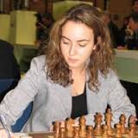
19.Nd5 a5 20.a4 bxa
21.Bxa4 Nxa4 22.Qxa4 Re6
23.Nc4 Bc6 24.Qd1 a4
25.Bg3 f6 26.b4 axb3
27.Rxa8 Bxa8 28.Qxb3 Ng5
29.Ra1 Bxd5 30.exd5 Re8
31.Ra7 Bc5 32.Rb7 Nxh3+
33.Kf1(a) Nf4(b) 34.d6 Qe6(c)
35.dxc7 Nd5 36.Qb5 Bf8
37.Nb6 Nxb6 38.Rxb6 Qg4
39.f3 resigns Antoaneta Stefanovic

a) Not 33.gxh3? Qxh3 (threat 34...Qxg3+) 34.Bh2 Bxf2+ 35.Kxf2 Qxh2+ & Black is better.
b) 33....Nxf2! is possible (34.d6 Kh8 35.Kxf2 cxd).
c) 34 Black is in difficulties but 34...Kh8 may have enabled her to hold in view of White's exposed king - 35.dxc Qd7 36.Rb8 Rf8.

The first WA Grand Prix event of 2017, the Perth Open, played last weekend at Leeming with 28 players, was won jointly by Andrew Hardegen and Ihsan Ferzkohi (5/6), followed by Patrick Gong and Adam Kelly (4.5). Patrick led after 5 rounds but lost his final game to Andrew. Lorenzo Escalante (4) gained the first Under 1850 prize with Ben Dagza (3.5) second.

SOLUTION: 1.Rxe7+ (deflection) 1...Kxe7 2.Nc6+ (fork and discovered attack) 2...Kf6 3.Nxb8 and White won a long endgame.

