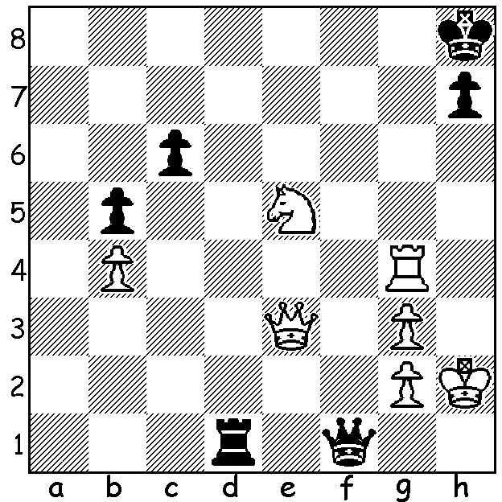

Tan Zhongyi – Dronavalli Harika
(Women's World Championship 2017, semi-final):
faced with mate White wins in 2 moves:

At time of writing the Women's World Championship has reached the final after two very contrasting semi-finals. But first the quarterfinal results: in the all Chinese clash Tan Zhongi defeated top-rated Ju Wenjun 1.5–0.5, Dronavalli Harika (India) needed two rapidplay games to defeat Nana Dzagnidze (Georgia) 2.5–1.5, Anna Muzychuk (Russia) defeated Antoaneta Stefanova (Bulgaria, 2004 champion) 1.5–0.5 and Alexandra Kosteniuk (Russia, 2008 champion) defeated Ni Shiqun (China) 1.5-0.5. In the semis Kosteniuk gained an early advantage in the first game against Muzychuk but missed opportunities to win and finally lost, then lost quickly in the second game. The Tan - Harika match, by contrast, went the maximum 9 games, each winning one classic game, one 25 min rapidplay and one 10 min rapidplay games before drawing the two blitz games (5 min + 3 sec). The games were certainly exciting with first one player and then the other appearing likely to win the tie with mistakes sometimes punished, sometimes unpunished. Game 2 lasted 161 moves each while Game 3 lasted only 17 moves. In game 4, needing a win to stay in the match, Harika gave up her queen for rook and bishop and, with Tan missing a perpetual check, pushed a passed pawn on to victory. The match finally hinged on the infamous Armegeddon game where White was given 5 min (+3 sec) to Black's 4 min but with White needing to win. Tan won the toss and chose Black. Harika gained a pawn but in a long queen and pawn ending was unable to find any winning chances and lost on time on move 99 with Q + p v Q + 2p. Perhaps the best of the games was the first:

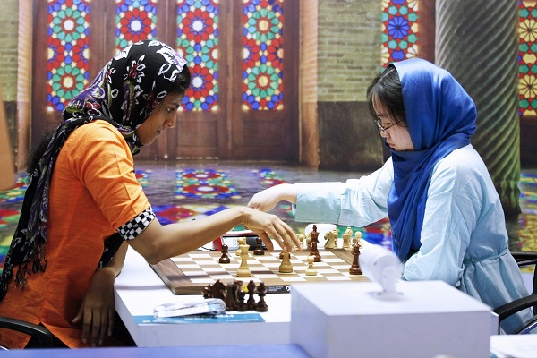
Tan Zhongyi - Dronavalli Harika
2017 Womens World Championship, ¼ Final, Game 1
Nimzo-Indian, Rubinstein Variation
1.d4 Nf6 2.c4 e6
3.Nc3 Bb4 4.e3 0-0
5.Bd3 c5 6.Nf3 d5
7.0-0 cxd 8.exd dxc
9.Bxc4 b6 10.Bg5 Bb7
11.Qe2 Bxc3 12.bxc3 Nbd7
13.Bd3 Qc7 14.Rac1 Ng4!(a) Tan – Harika (Blitz)
15.Be4 Rfe8 16.h3 Bxe4
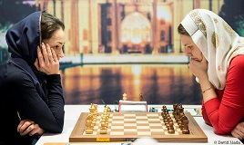
17.Qxe4 Ngf6 18.Qe2 Rac8
19.c4(b) Qb7 20.Rfe1 Qa6
21.Ne5 Nxe5 22.dxe5 Nd7
23.Qg4 Kh8 24.Qh5 Kg8
25.Qg4 Kh8 26.Re4 Qa3(c)
27.Rd1 Nf8 28.h4! Qc3
29.h5 h6 30.Bh4 Rc7
31.Red4 Qc2 32.R1d3(d) Rc5?
33.Rg3 Qh7 34.Rf4 Rc7 Muzychuk - Kosteniuk
35.Qf3 Nd7 36.Qe2!(e) Rf8
37.Be7 Rg8 38.Bd6 Rcc8
39.Rxf7 Qb1+ 40.Kh2 Nc5
41.Qe3 Qh7 42.Rg6 a5
43.Be7(f) Rc7 44.Rxh6! resigns(g)

a) Forcing White to trade off her dangerous d3 bishop.
b) Necessary to prevent 19...Qc4.
c) Black might try 26...Qxa2 (27.Qd1 Nc5 28.Rf4 Rc7 29.Qh5 Nd3! 30.Rxf7 Rxf7 31.Qxf7 Rg8
32.Rd1 Qxc4 33.Bh6! b5 34.Bxg7+ Rxg7 35.Qf8+ draw).
d) Threatening 33.Bf6! making the ugly 32...g5 the only real defence.
e) Not 36.Rxf7 Qb1+ 37.Kh2 Nxe5 38.Rxc7 Nxf3+ 39.gxf3 Qa1.
f) Black is helpless.
g) 44...Qxh6 45.Qxh6+ gxh6 46.Bf6+ Rg7 47.Rxc7.


Magnus Carlsen meets Homer Simpson
(via Skype): In a recent episode in USA
entitled 'The Cad and the Hat' Carlsen acts
as life coach to Homer and revives his dormant
interest in the game. Check it out if you can.

The 51st Begonia Open will be played 11-13
March with entries including Australian
Internationals GMs Zong-Yuan Zhao, Moulthan
Ly, Max Illingworth, Darryl Johansen. Check
details on begoniaopen.com

SOLUTION: 1.Nf7+! (clearance sacrifice) 1...Qxf7 2.Qe5+

