Tan Zhongyi – Dinara Saduakassova 2012:
White mates in 7 (including 2 useless blocks by Black):
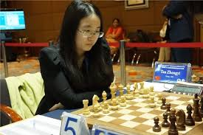
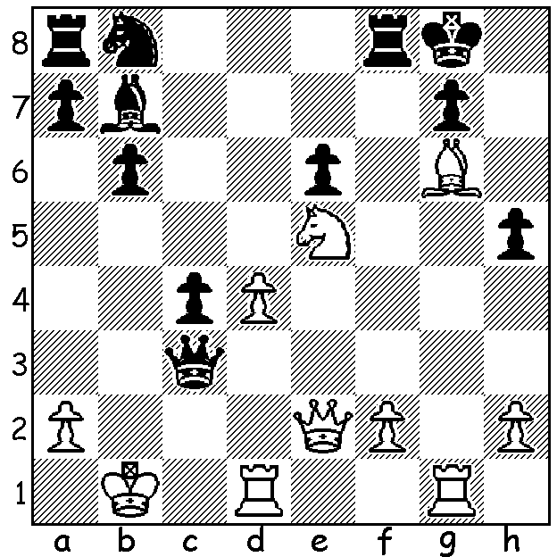

The final of the Womens World Championship in
Tehran was won by Tan Zhongyi (China), defeating
Anna Muzychuk (Ukraine) by 3.5 – 2.5. Comparing
the two, most would have backed Muzychuk as the
likely winner. She celebrated her 27th birthday during
the event while Tan was just a year younger but with
much less experience. Muzychuk's rating of 2569 (she
had been the 4th woman to have reached 2600) was
nearly 70 points higher, she was ranked 2nd in the event
compared to 9th and had the experience of winning the
Womens Rapidplay and Blitz Championships in 2016.
She was much fresher having had a much easier path
to the final scoring 9/10 compared to Tan's 16/28, who in a number of rounds needed a win to avoid elimination, including two Armegeddon games. After a Game 1 draw Tan opened the scoring only for Muzychuk to win game 3. With Game 4 drawn, the match went to Rapidplay and after one draw, in which she just managed to hold on, Tan decisively won Game 6.

Tan Zhongyi - Anna Muzychuk
2017 Womens World Championship Final, Game 2
Queens Gambit, Semi-Slav Defence
1.d4 d5 2.c4 c6 3.Nf3 Nf6
4.Nc3 e6 5.Qd3 dxc 6.Qxc4 b5
7.Qd3 a6 8.e4 c5 9.dxc Bxc5
10.Qxd8+ Kxd8 11.Bd3 Bb7(a) 12.e5 Ng4(b)
13.Ne4 Bb4+ 14.Ke2 Nd7 15.Bf4 Nc5
16.Nxc5 Bxc5 17.Rhc1 Bb6 18.Ng5 Ke7
19.Be4 Bxe4 20.Nxe4 Rhc8 21.f3 Nh6
22.g4 Ng8 23.Nd6 Rxc1 24.Rxc1 Kd7(c)
25.Nxf7 Ne7(d) 26.Be3 Bxe3 27.Rd1+ Ng7
28.h4 Rf8 29.h5 Ne7 30.Ng5 Nd5+
31.Kf2 h6 32.Ne4 Ra8 33.a3 a5
34.Nc3 Rc8 35.Rd1 Ke7 36.Nxd5+ exd5
37.Rxd5 Rc2+ 38.Ke3 Rxb2 39.Ke4 a4
40.f4 Rb1 41.Kf5 Rb3 42.Rc5 Kd7
43.Kg6 b4 44.axb Rxb4 45.Kf5 Ke7
46.Rc7+ Kf8 47.Ra7 Kg8 48.g5 hxg
49.fxg Rb6 50.Rxa4(e)

a) 11...Nbd7 was necessary to deter the e pawn advance.
b) 12...Nfd7 was better as the knight will get pushed to the poor square h6
c) Either setting a faulty trap or giving up a pawn to avoid drifting into a completely passive position.
d) 25...Rf8 does not win a piece - 26.Rd1+ Ke7 27.Nd6! Rxf4 28.Nc8+.
e) 50.e6 wins quickly but the point was gained after 50...g6+ 51.hxg Rb1 52.Ra8+ Kg7 53.Ra7+ Kg8 54.g7 Rf1+ 55.Kg6 Ra1! 56.Rf7 resigns

Anna Muzychuk - Tan Zhongyi:

2017 Womens World Championship Final, Game 3
French Defence, Steinitz Variation
1.e4 e6 2.d4 d5
3.Nc3 Nf6 4.e5 Nfd7
5.f4 c5 6.Nf3 Nc6
7.Be3 Be7 8.Qd2 0-0
9.dxc Bxc5 10.0-0-0 Qa5
11.a3 Be7 12.Bd3 a6 (12...Nc5)
13.h4 b5? 14.Bxh7+! Kxh7
15.Qd3+ Kg8 16.Ng5 f5 Anna Muzychuk
17.Nxd5! b4 18.Nxe7+ Nxe7
19.Bd2 Rb8 20.Qd6 Qc5 21.Bxb4 Qxd6
22.Bxd6 Ng6 23.Nxe6 Re8 24.Bxb8 Rxe6
25.g3 Bb7 26.Rh2 Nc5 27.Rd8+ Kh7
28.Bd6 Ne4 29.h5 Nh8 30.h6! Nf7
31.Rd7 Rxd6 32.Rxf7 resigns.

WA ALLEGRO CHAMPIONSHIP will be held Sunday 19 March at Leeming Primary (11am – 5pm). Entries and enquiries to Gordon Dunlop (gordondunlop64@gmail.com or 93686412 or 0409812129).( Gordon will also be running the Gufeld Cup in my absence.)

SOLUTION: 1.Bh7+! (tempo gaining deflection sacridice) 1...Kxh7 (if 1...Kh8 2.Ng6+! Kxh7 3.Qxh5+ Kg8 4.Ne7+) 2.Qxh5+ Kg8 3.Rxg7+! Kxg7 4.Rg1 Bg2 5.Rxg2+ Qg3 6.Rxg3+ Kf6 7.Qg5#.

