Another win by new Womens World Champion
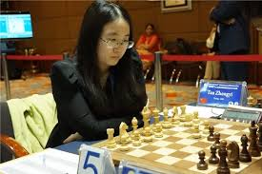
Tan Zhongyi (v Guo Yu 2006):
BLACK to play and win (4 moves):
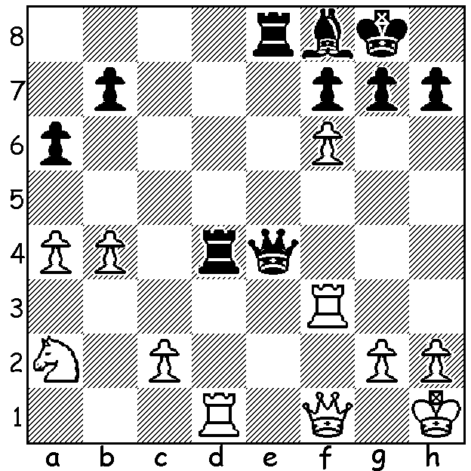

After three weeks at the Womens World Championship we remain in Iran with news that two of its young players, 18 year old WGM/IM Dorsa Derakhshani, and her 15 year old brother Borna have both been banned from events in their homeland after falling foul of government policy while competing in the Gibraltar Chess Festival in February. In the case of Dorsa, who is the second highest ranked Iranian female, the offence was wearing a simple headband rather than the stipulated hijab, (which all contestants in the World Championship were obliged to wear). As she now resides in Spain she maintained she should only have to wear the hijab when representing or sponsored by Iran. Her brother Borna was banned for playing an Israeli although he was unaware of his opponent's nationality at the time. Iranian players are ordered to forfeit a game when paired against an Israeli although most tournament organisers avoid such pairings (the Gibraltar officials admitted their mistake in this case).

Ahmed Abbas Khouri v Dorsa Derakhshani
Abu Dhabi International Chess Festival 2016
Giuoco Piano
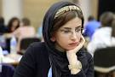
1.e4 e5 2.Nf3 Nc6
3.Bc4 Bc5 4.0-0 Nf6
5.d3 a6 6.a4 Ba7
7.Bg5 h6 8.Bh4 d6
9.c3 Be6 10.Bxe6 fxe6
11.Qb3 Qc8 12.a5 0-0
13.Nbd2 Qd7 14.Bxf6 gxf6
15.Nh4 Kh7 16.Ndf3 d5
17.Rfe1 d4 18.Re2 Rg8

19.Rc2 Rab8 20.Qc4 Rg7
21.Ra3 Rbg8 22.Kf1 Qd6
23.Ra1 Rd7 24.Rd2 Qe7
25.h3 Rgd8 26.Ne1 f5
27.g3 Qf6 28.Nhf3 Rg7
29.Qb3 dxc 30.bxc fxe
31.Qxb7 Rd6 32.Nh2 e3
33.Re2 exf 34.Ng2 Rxg3
35.Qxc7+ Qe7 White resigns Dorsa Derakhshani
(with & without the hijab)

Borna Derakhshani v Per Green
Queens Pawn, 2017
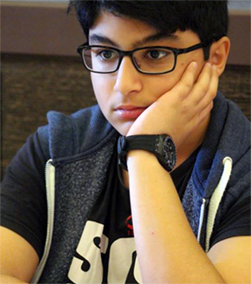
1.d4 Nf6 2.Bf4 d5
3.e3 c5 4.c3 Qb6
5.Qb3 Nc6 6.Nd2 g6
7.Ngf3 Bg7 8.Qa3 cxd
9.exd Bf5 10.Nh4 Bd7
11.Bd3 0-0 12.0-0 Rfe8
13.Bg3 Nh5 14.Qb3 Nxg3
15.hxg3 Qxb3 16.axb3 e5
17.dxe Nxe5 18.Bc2 Nc6
19.Rfd1 Bg4 20.Ndf3 d4
21.cxd Re2 22.Bd3 Rxb2
23.Bc4 a6 24.d5 Ne5
25.d6 Nxc4 26.bxc4 g5
27.Nxg5 Bxd1 28.Rxd1 Bf6
29.Ne4 Bd8 30.Nf5 a5 Borna Derakhshani
31.Re1 f6 32.d7 Kf7
33.Ned6+ Kg6 34.Re8 h6
35.Rg8+ resigns

WA ALLEGRO CHAMPIONSHIP will be held on Sunday (19 March) at Leeming Primary (11am – 5pm). Entries and enquiries to Gordon Dunlop (gordondunlop64@gmail.com or 93686412 or 0409812129).

SOLUTION: 1...Rxd1 2.Qxd1 Qxc2!! 3.Qxc2 (other moves allow 3...Qxa2!) 3...Re1+ 4.Rf1 Rxf1#.

