Grischuk v Sokolov 2002:
White to play and win (6 moves):
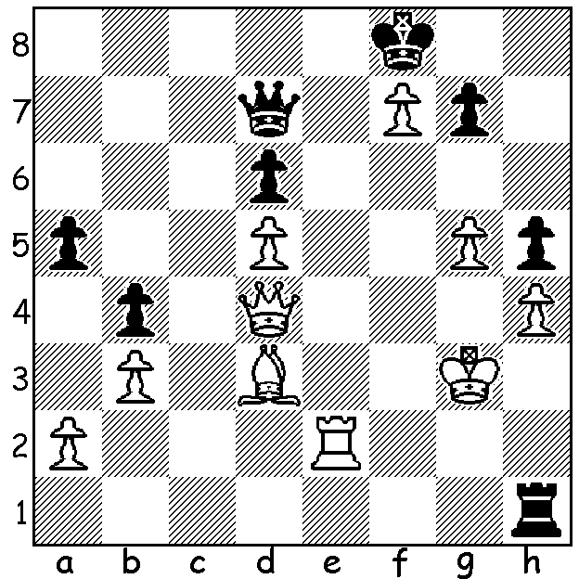
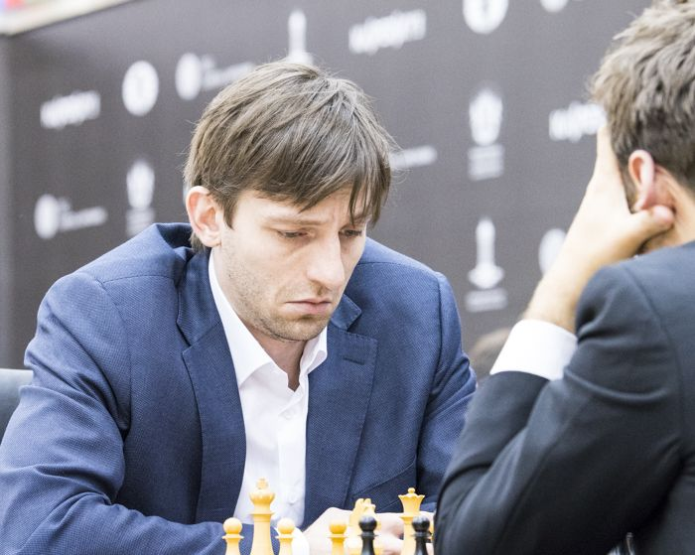

Grischuk at Sharma

The Sharjah Grand Prix event which ended on Feb 27 was won jointly by Alexander Grischuk (Russia), Shakhriyar Mamedyarov (Azerbaijan) and Maxime Vachier-Lagrave (France), all on 5.5/9. While Grischuk and MVL played a short final round draw, Mamedyarov defeated leading female player Hou Yifan. This was Hou's only loss and on her birthday too. Also by not competing in Tehran she was about to be deposed as Womens World Champion. 4th= in the 18 player field were Ding Liren (China), Michael Adams (UK), Dmitry Jakovenko (Russia) and Hikaru Nakamura (USA). Criticism was made of the large number of shortish draws with no requirement to play at least 30 moves. However as the Grand Prix consists of four legs (Moscow, Geneva and Palma de Mallorca to come) with the top two overall players to qualify for the World Championship Candidates it was important for players to avoid poor scores. Here though is a longish entertaining draw between two of the winners:

Maxime Vachier-Lagrave vs Shakhriyar Mamedyarov
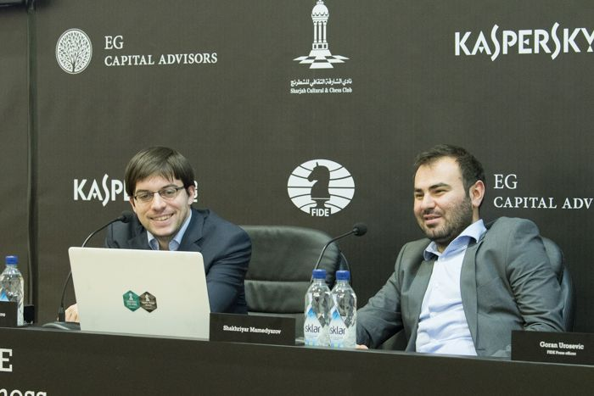
Sharjah Grand Prix 2017, Rd 3
Ruy Lopez
1.e4 e5 2.Nf3 Nc6
3.Bb5 a6 4.Ba4 Nf6
5.0-0 Be7 6.d3 b5
7.Bb3 d6 8.a3 0-0
9.Nc3 Na5 10.Ba2 Be6
11.b4 Bxa2 12.Rxa2 Nc6
13.Bg5 Nd7 14.Be3 Nf6
15.Bg5 Nd7 16.Be3 Nf6
17.Qb1(a) d5 18.exd Nxd5 At press conference after game:
19.Nxd5 Qxd5 20.c4 bxc 'It's not a normal position here.' (MVL).
21.dxc(b) Qe6 22.Qe4 Rad8 'We're not normal players, that's why.' (Mam.).
23.g4 h5! 24.g5(c) Qg4+(d)
25.Qxg4 hxg4 26.Nh4 g6 27.Kh1 e4
28.Rg1 Ne5 29.Bf4 Nxc4 30.Rxg4(e) c5
31.bxc Bxc5 32.Rc2 Rd4 33.Rg3 Re8!(f)
34.Kg2 Bf8 35.Rgc3 Nxa3 36.Ra2 Rd3
37.Rc6 a5 38.Nxg6!(g) fxg6 39.Rxg6+ Kh7
40.Rc6 Bb4 41.h4 Nb5 42.h5 Nc3
43.Rc2 Nd5 44.g6+ Kg8 45.Bg5 Rf3(h)
46.h6 Nf4+ 47.Bxf4 Rxf4 48.Rc8 Rxc8(i)
49.Rxc8 Rf8 50.Rc7 Rf6 51.Rc8+ DRAW

a) Declining a draw by repetition.
b) With a potential endgame advantage.
c) White originally planned 24.h3 but now saw 24...hxg 25.hxg f5! 26.gxf Rxf5 27.Nh2 Nd4 28.Rd2 Nf3+! 29.Nxf3 Qg6+ 30.Bg5 Rxd2.
d) Black did not wish to exchange queens but saw 24...f5 25.gxf Rxf6 26.Kh1 Qh3 27.Qh7+!
e) 30.Bxc7 was better.
f) A mysterious rook move – anticipating 34.Rgc3 Bd6 35.Rxc4 Rxc4 36.Rxc4 Bxf4 & the e pawn is defended (if 37.Nf3? exf3 38.Rxf4 Re1#).
g) This desperate sacrifice gives White good chances of drawing.
h) If 45...Ne7 46.h6!! Nxc6 47.Bf6 Rd7 48.Rxc6 Ra8 49.h7+ Rxh7 50.gxh7+ Kxh7=.
i) 48...Rff8? loses 49.R2c7!! Rxc8 50.h7+ Kh8 51.g7+ Kxh7 52.gxf8=N+!

SOLUTION: 1.Re8+! Kxf7 2.Bg6+! Kxg6 3.Qe4+ Kf7 (3...Qf5 4.Re6+) 4.g6+ Kf6 5.Re6+ Qxe6 6.Qxe6#.

