Ian Rogers v Robert Hamilton (Ballarat 1986):
White to play and win
(consider 2 Black moves on move 1): Ian Rogers
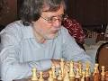
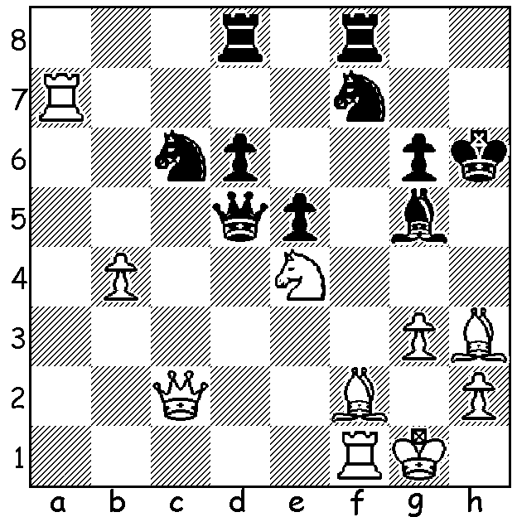


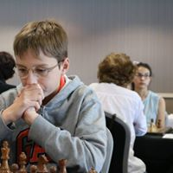
Some weeks ago I advertised the Begonia Open
in Ballarat. Played over a holiday weekend the
event attracted 115 players of vastly differing
abilities ranging from GMs to near beginners
including a number of primary school children.
The event is the second longest running Open in
Australia (behind the Doeberl Cup in Canberra)
and at its 50th anniversary last year had Nigel
Short (=1st) participating. This year again saw
multiple winners with GM Zhou Zong-Yuan, Zhou Zhong-Yuan Anton Smirnov
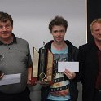
IMs James Morris, teenage sensation Anton
Smirnov and veteran Stephen Solomon all on
6/7. 18 year old Ari Dale, winner of the NZ
Open and the Christmas Open in last year, led
up to the final round but missed a draw near the
end of a 70+ move game and finished without a
prize. Here though is one of his wins, playing a
former Australian champion (the game was
selected in an article by Ian Rogers), and then an
IM falling foul of a pet line:
Stephen Solomon (left)
Ari Dale vs Max Illingworth James Morris (centre)
2017 Begonia Open
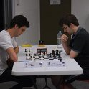
Nimzoindian Defence, Rubinstein Variation
1.d4 Nf6 2.c4 e6
3.Nc3 Bb4 4.e3 d5
5.Nf3 0-0 6.Bd3 b6
7.0-0 Ba6 8.Ne5 Nfd7
9.f4 c5 10.Nb5 cxd
11.exd Bb7? 12.c5! bxc
13.Nd6! Qe7 14.Bxh7+! Kxh7
15.Qh5+ Kg8 16.Rf3 Nf6
17.Qh4 Rc8 18.Rh3 Kf8
19.Qh8+ Ng8 20.Ndxf7 Qf6 Dale (L) v Illingworth
21.Qxg8+! Ke7 22.Qh7 Nd7 23.Rg3 Rg8
24.f5 Qxf5 25.Bg5+ Nf6 26.Bxf6+ Qxf6
27.Rf1 resigns

Reza Daneshav vs Mirko Rujevic
2017 Begonia Open
Giuoco Piano, Italian Gambit
1.e4 e5 2.Nf3 Nc6 3.Bc4 Bc5
4.0-0 Nf6 5.d4 Bxd4 6.Nxd4 Nxd4
7.Bg5 h6 8.Bh4 g5 9.f4! d5
10.exd Nxd5 11.fxe5 Ne3 12.Qh5 Qd7
13.Rxf7 Qg4(a) 14.Rf8+! resigns(b)

a) Black has a multitude of threats:
b) 14...Kxf8 15.Qf7# or 14...Kd7 15.Qe8#.

JUNIOR CHESS: WA Primary (Sunday 9th April) and Secondary Championships (Tues 11th & Wed 12^{th,,} each day 10am to 5pm). See cawa.org.au (calendar of events) for entry or contact yita.choong@ieee.org.au

The WA Allegro (Rapidplay) Championship (37 players) was won by WA's leading player Tristan Boyd with 8.5/9, well ahead of runners up WA champion Yita Choong and Syakir Shazmeer (7).
Women's champion was Kathryn Hardegen (6.5) and Senior champion new CAWA president Alan Wolstencroft (5.5). Under 1800 winner was Edward Calado (6), Under 1500 Victor Sun (5) and Under 1000 joint winners Kundan Dharmapuri and Sebastian Verncombe (4).

SOLUTION: 1.Rxf7! Rxf7 2.Nxg5 Kxg5? 3.Be3+ Kh5 4.Qe2+: if 1...Nxb4 2.Rh7+! Kxh7 3.Qc7+! Kh8 (3...Rf7 4.Nxg5+ or 3...Kh6 4.Qh7+! Kxg5 5.Be3+ Rf4 6.Qh4#) 4.Nxg5 winning.

