Another Ian Rogers win
(vs Zlatko Klaric 1984)
White to play and win: Ian Rogers
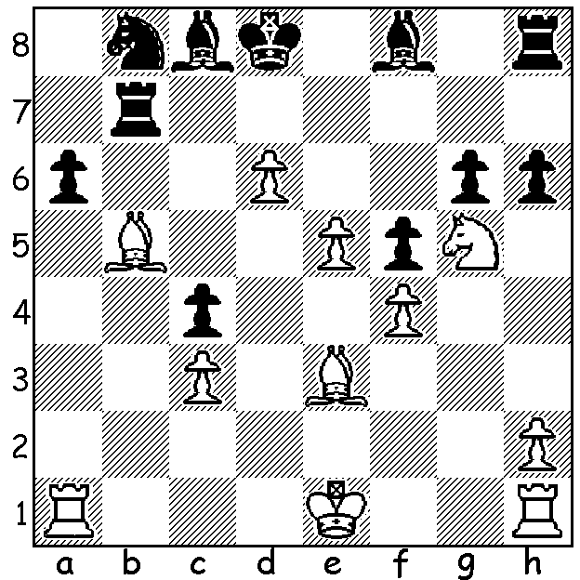
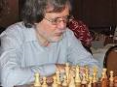

A strong Open tournament with 36 entrants has recently finished at the Southern Suburbs club. Joint winners were Igor Butsenko and WA champion Yita Chong with 6/7 (both +5 =2), followed closely by Ihsan Ferozkohi with 5.5. Under 1870 winner was Saminda de Vas Gunawardhana (5), Under 1650 Edward Calado (4) and Under 1250 & Unrated Victor Sun (4). Here are games by the winners, the first where an endgame piece sacrifice secures a queen promotion but not the win and the second an exciting game with both kings in danger:

Leon Taylor vs Igor Butsenko
2017 Southern Suburbs Open, Rd 4
English Opening
1.c4 e5 2.g3 Nc6 3.Bg2 f5
4.Nc3 Nf6 5.e3 d6 6.Nge2 Be7
7.d4 e4 8.Nf4 0-0 9.0-0 Re8
10.Rb1 a5 11.a3 Bf8 12.b4 axb
13.axb Ne7 14.d5 Ng6 15.Nxg6 hxg6
16.Ne2 Ng4 17.Bb2 Bd7 18.Ra1 Ne5
19.Bxe5 Rxe5 20.Qd4 Rxa1 21.Rxa1 Re8
22.Ra7 Bc8 23.Bf1 Be7 24.c5 Bf6
25.Qc4 Be5 26.Nd4 Bxd4 27.Qxd4 g5
28.Bb5 Rf8 29.Ra8 Qe7 30.cxd Qxd6
31.Qc5 Kf7 32.Bc4 Re8 33.Qxd6 cxd6
34.Bb5 Rd8 35.Ra7 Kf6 36.Bc6(a) bxc6
37.dxc6 Be6 38.c7 Rc8 39.b5 Bd5
40.b6 Ke6 41.Ra5?(b) Bc6 42.Rb5?(b) Bxb5!(c)
White resigns

a) An imaginative sacrifice.
b) With a cheap threat of 42.Rxd5 Kxd5 43.b7: 42.b7 (41...Bxb7 42.Rxb7 g4!) should be played.
c) A brilliant finish – 43.b7 Rxc7 44.b8=Q Rc1+ 45.Kg2 Bf1+ 46.Kg1 Bh3#.

Ihsan Ferozkohi vs Yita Choong
2017 Southern Suburbs Open, Rd 6
English Opening
1.c4 Nf6 2.Nc3 c5 3.Nf3 e6
4.g3 b6 5.Bg2 Bb7 6.0-0 Be7
7.d4 cxd 8.Nxd4 Bxg2 9.Kxg2 a6
10 e4 Qc7 11.Be3 0-0 12.Rc1 d6
13.g4 Qb7 14.Qf3 Nbd7 15.Bf4 Ne5
16.Bxe5 dxe5 17.Nde2 Rac8 18.b3 b5
19.cxb axb 20.Ng3 Rfd8 21.g5 Nd7
22.h4 Nc5 23.Rfd1 b4 24.Nce2 Qa6
25.Rxd8+ Rxd8 26.Rc2 Nd3 27.Kf1 Bc5
28.Nh5 Qb6 29.Neg3 Nxf2! 30.Nxg7(a) Rd3
31.Qf6 Ng4 32.N3h5 Nxf6 33.gxf6 Rf3+
34.Ke1 Bf2+ 35.Kd1 Qd4+ White resigns

a) Loses quickly but if 30.Rxf2 Bxf2 31.Qxf2 Qxf2+ 32.Kxf2 Rc2+ winning (30.Rxc5 is similar).

JUNIOR CHESS: WA Primary (Sunday 9th April) and Secondary Championships (Tues 11th & Wed 12^{th,,} each day 10am to 5pm). See cawa.org.au (calendar of events) for entry or contact yita.choong@ieee.org.au

The Gufeld Cup (WA Grand Prix) will be played April 15/16 and the WA Lightning Championship on April 23, both at Leeming Primary. Details cawa.org.au

SOLUTION: 1.Bb6+! (deflection of overworked piece) 1...Rxb6 2.Nf7#.

