Zherebukh vs Akobian (US Champ 2017)
Black to play and win (2/3 moves):
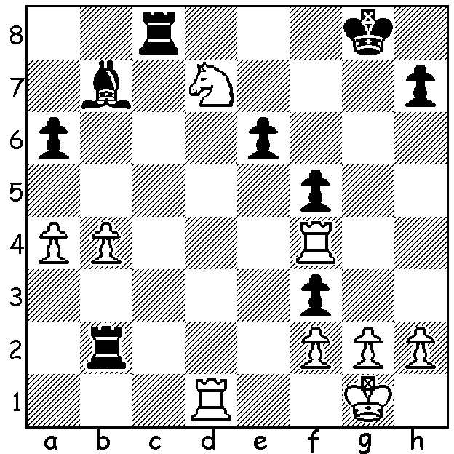
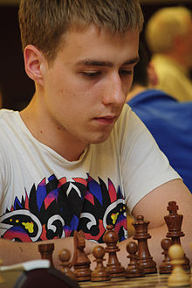
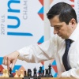

Zherebukh Akobian

The 2017 12 player all GM US Championship will go down as the strongest ever with five past champions including 5 times winner Gata Kamsky, who lost a world championship match to Anatoly Karpov in 1996 7.5 – 10.5, 4 times winner Alexander Shabalov, 2006 winner Alexander Onischuk as well as 2016 World Junior champion Jeffrey Xiong. The championship also included a blend of ages with three players in their forties and six in their twenties and teenager Xiong. Favourites were Wesley So aged 23 (ranked 2 in the world), 2016 champion Fabiano Caruana 24 (3 in the world) and 4 times champion Hikaru Nakamura 39 (9 in the world). The first six rounds saw So (+2 =4) on 4 pts, a half point ahead of his main two rivals. The game chosen today pitted the aggressive 22 year old Ray Robson, runner-up in 2015, against the veteran in the field at 49, Alexander Shabalov:
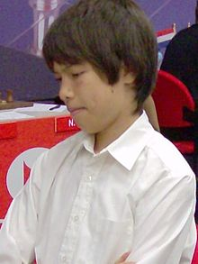
Ray Robson vs Alexander Shabalov
2107 US Championship, Rd 5
Modern Defence
1.e4 g6 2.d4 Bg7
3.Nc3 c6 4.f4 d5
5.e5 Nh6 6.Nf3 f6
7.Be3 0-0 8.h3 Qb6
9.Qd2 Qxb2 10.Rb1 Qa3
11.g4 Nf7 12.Bd3 fxe Robson
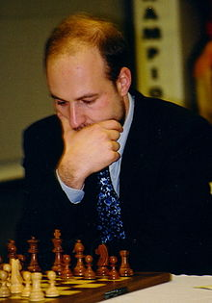
13.dxe Na6 14.Rb3 Qa5
15.0-0 e6 16.h4 Nc5
17.h5 Nxd3(a) 18.cxd3 gxh
19.g5 Nh8 20.Qh2 Ng6
21.Qxh5 Nxf4(b) 22.Bxf4 Rxf4
23.Ne2 Rf8 24.Ng3 Qc5+(c)
25.Kh1(d) Qe7(e) 26.Rb2 Qf7
27.Qh3 b6(f) 28.Rh2(g) Qg6
29.Nh5 Ba6 30.Nf6+ Kf7(h)
31.Nd4 resigns(i) Shabalov

a) Black decides the bishop is the more dangerous piece although engines suggest the rook should be taken.
b) 21...c5 is an excellent alternative.
c) The greedy 24...Qxa2 is safe althoughWhite retains attacking chances (25.g6 h6 26.Rbb1 Qa3 27.Rbd1 b6 28.Qg4).
d) 25.d4 seems the obvious move.
e) If 25...Qc2 a possible continuation is 26.g6 h6 27.Nh2 Rxf1+ 28.Ngxf1 Qf2 29.Rb1 b6 30.Ng4 Qf3+ 31.Kg1 Qf4 32 Rb2 Ba6 33.Rf2 Qg5 34.Qxg5 hxg5 36.Rf3 Rf8 37.Nf6+ Bxf6 38.exf6.
f) 27...Qg6 is the only move (28.Nh5 Qf5 29.Qxf5 Rxf5 30.Nf6+ Kh8 31.Rh2 Bxf6 32.exf6 e5 33.Re2 Rxf3+! 34.Rxf3 Bg4 35.Kg2 Re8 36.Kf2 Bxf3+ 37.Kxf3 Kg8 38.Kg4 Kf7 38.Kf5 e4! 39.dxe4 Rxe4 40.Rh2).
g) The spurned rook prepares to join the attack.
h) If 30...Bxf6 31.gxf6 Kh8 32.Rg1 Qf5 33.Qxf5 exf5 34.Rg7 wins.
i) If 31...Rae8 32.Nh7+ Kg8 33.Nf6+ Kf7 34.Nxd5+ Kg8 35.Nf6+ (moves 32 -35 the seesaw motif) 35...Kf7 36.Nxe8+ Kxe8 37.Rf6! (obstruction) 37...Bxf6 38.Qxe6+ winning.

The WA Lightning Championship this coming Sunday on April 23, 1 - 5pm at Leeming Primary. Details cawa.org.au and entries to ellisd19@bigpond.com or 0439798607.

SOLUTION: 1...Rd2 White resigns (2.Rxd2 Rc1+ mating: 2.Rd4 Rxd4 3.Rxd4 Rc1+ mating: 2.Re1 Rxd7).

