Gata Kamsky – Varuzhan Akobian (US Ch 2017) White plays the desperado 1.Bxd8 (1.Rxd8 2.Bxd3): however Black finds a move forcing immediate resignation: find Black's winning move and a saving first move for White:


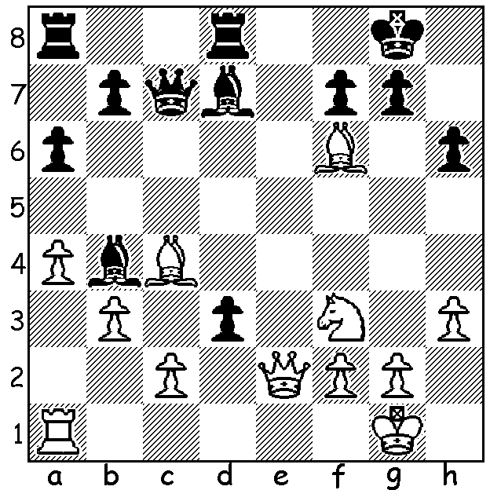

Kamsky Akobian

Wesley So continued in the lead after Round 6 of the US Championship but was unable to shake off his pursuers. However his main rivals Fabiano Caruana and Hikaru Nakamura both suffered losses (Nakamura to Alexander Onischuk in Rd 9 and Caruana to Yaraslov Zherebukh in Rd 7 and Varuzhan Akobian in Rd 9, the second after having Q, N + 6p v Q, N + 4p). After the final round So was on 7/11 (+3 =8), equal with Alexander Onischuk (+4 =6 -1) necessitating a play-off (report next week). Other scores: Akobian, Nakamura, Caruana 6.5, Zherebukh 5.5, Daniel Naroditsky, Sam Shankland, Gata Kamsky 5, Jeffrey Xiong 4, Alexander Shabalov 3.5. Almost certainly the outstanding game of the tournament was So's win against 2016 World Junior Champion Jeffrey Xiong:
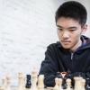
Jeffrey Xiong -Wesley So
2017 US Championship, Rd 9
Queens Gambit, Catalan System
1.d4 Nf6 2.c4 e6
3.g3 d5 4.Bg2 Be7
5.Nf3 0-0 6.0-0 dxc
7.Qc2 a6 8.a4 Bd7
9.Rd1 Bc6 10.Nc3 Bxf3
11.Bxf3 Nc6 12.Bxc6 bxc6(a) Jeffrey Xiong

13.Bg5 Rb8 14.e3 c5!
15.dxc Qe8 16.Rd4 Nd7!(b)
17.Bxe7 Qxe7 18.c6 Ne5
19.Qe4 Qc5 20.Nd5 Nd3
21.Nxc7 Nxf2!!(c) 22.Kxf2 Rxb2+
23.Kf1 Qh5 24.Qg4 Qxh2
25.Qf3 c3 26.Rc1 e5!
27.Rh4(d) Qd2 28.Rd1 Rd8
29.Nd5(e) Rxd5 30.Rd4 Rxd4
31.exd4 Qxd1+! White resigns(f) Wesley So

a) The tripled pawns look ugly but don't seem a significant weakness.
b) So's innovation.
c) A stunning sacrifice which had commentators uncertain of its soundness.
d) There are some amazing winning variations after 27.Rc4: 27...Rfb8! 28.Nd5 (28.Nb5 axb5 29.axb5 – 29.c7 bxc4! - 29...Qh3+ 30.Ke1 Re8! 31.c7 e4 32.c8=Q Rxc8 33.Rxc8+ Qxc8 34.Qxe4 Qb8 35.Qg4 Qb7 winning) 28.Rf2+!! 29.Qxf2 Qh1+ 30.Qg1 Qxd5 31.R4xc3 Rb2 32.e4 Qd2 33.R1c2 Qd1+ 34.Kg2 Rxc2+ 35.Rxc2 Qxc2 36.Kf3 Qxc6 winning: if 28.g4 Qd2 29.R4xc3 e4 30.Qg3 Rd8 31.Nxa6 Qe2+ 32.Kg1 R/Qd1+ wins.
e) 29.Rxd2 Rxd2 & mates.
f) 32.Qxd1 c2 33.Qc1 Rb1 34.c7 Rxc1+ 35.Ke2 Re1+! wins.

SOLUTION: 1.Bxd8 is met with the counter desperado 1...Qxc4! & White resigns (2.cxd Qc3 or 2.bxc4 dxe2 or 2.Qf1 Qc3 3.B moves dxc winning). White should have played 1.Qe4! (or Qxd3!) & if 1...gxf6 (1...Qc6 2.Bxf7+! Kh8 3.Qxc6 Bxc6 4.Bxd8 dxc 5.Bg6 Rxd8 6.Bxc2 Bxf3 gxf3=) 2.Qg6+ Kh8 3.Qxh6+ Kg8 4.Qg6+ Kh8 5.Qxf6+ Kg8 (5...Kh7 6.Ng5+) 6.Bxf7+ Kf8 7.Be6+ Ke8 8.Qf7#)

