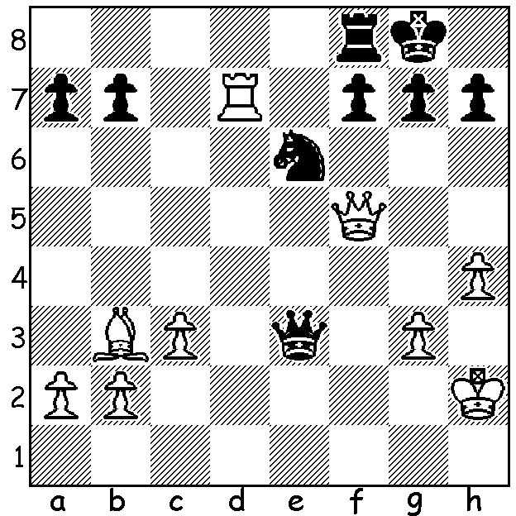
In previous years I have published a series of
puzzles entitled 'Bobby Dazzlers' and 'Short
and Sweet', higlighting brilliant finishes by
Bobby Fischer and Nigel Short. I'm now starting
another, this series called 'So Good' featuring
finishes by Wesley So.
Firstly Wesley So vs Josef Strasser 2006:
White to play and win (3 moves):

After a draw in the final round of the US Championship leaving him with 7/11 (+3 =8), Wesley So left the building aware that two players could possibly overtake him. However the two players, Varuzhan Akopian and Alexander Onischuk, were both Black facing respectively 4 times champion Hikaru Nakamura and 5 times champion Gata Kamsky and So felt confident neither of his close rivals would win, a confidence that proved justified when Akopian lost and Onischuk drew. In the first of the play-off games (25 mins + 5 secs) a transposition of moves in the opening by Onischuk (Black) lost him two pawns and he resigned on move 31. In the second it seemed that Onischuk would win and force the tie to an Armagedden game but a pawn up and with the better position he took a second pawn allowing So to set up enough counter play to draw. This left So winner by 1.5 – 0.5, the US championship and the extension his unbeaten run to 67 games. During this period (from July 2016) he has won three top rated tournaments, the Sinqefield Cup (US), the London Classic and Tata Steel (Netherlands) and seems the most likely player to emerge as challenger to Magnus Caelsen for the world title.
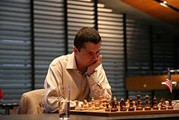
Alexander Onischuk vs Wesley So
2017 US Championship Play-Off, Game 2
Kings Indian Attack
1.Nf3 d5 2.g3 c6
3.Bg2 Bg4 4.0-0 Nd7
5.d3 Ngf6 6.h3 Bh5
7.Nbd2 e5 8.e4 Be7
9.Qe1 0-0 10.Nh4 Re8
11.Ndf3 dxe 12.dxe Nc5
13.g4 Bg6 14.Nxg6 hxg6 Onischuk
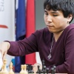
15.Nxe5 Bd6 16.Nc4 Ncxe4
17.Nxd6 Qxd6 18.Qd1 Qc5
19.Be3 Qa5 20.c4 Rad8
21.Qc2 Nc5 22.Rfd1 Ne6
23.Qc3 Qc7 24.Qa3 b6
25.b4 g5 26.Qa4 c5
27.bxc Nxc5 28.Qc2 Ne6
29.a4 Nf4 30.Bf1 Rxd1+
31.Rxd1 Ne4 32.a5 Nc5
33.axb axb 34.Qf5 f6 So
35.h4 Re5 36.Bxf4 gxf4 37.Qxf4 Qe7
38.Bg2 Re1+ 39.Rxe1 Qxe1+ 40.Kh2 Qe7
41.Qb8+ Kh7 42.Qxb6(a) Qe5+ 43.Kg1 Qd4
44.Qb1+ Nd3 45.Qc2 Kh8 46.Qe2 Ne5
47.Bd5 g5 48.h5 Kg7 49.Kg2 Kh6
50.Kg3 Qf4+ 51.Kh3 Qd4 52.Kg3 Qf4+
53.Kg2 Qd4 54.Be6 Nd3 55.Kg1 Nf4
56.Qc2 Qa1+ 57.Kh2 Qe5 58.Bg8 Nxh5+
59.Kg2 Nf4+ 60.Kf3 Ng6 61.Qe4 Nh4+
62 Ke3 Ng2+ 63.Kf3 Ne1+ 64.Ke3 Nc2+
Draw

a) 42.Bd5 leaves White close to a win. Now the initiative passes to Black (Q+N is usually stronger than Q+B).

The Metropolitan Open (7 Rd Swiss) will be played over successive Thursdays, starting May 18 and the WA Championships are scheduled for successive Sundays, 21 May to 9 July. See cawa.org.au for information.

SOLUTION: 1.Rxf7! Rxf7 2.Bxe6.

