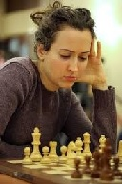
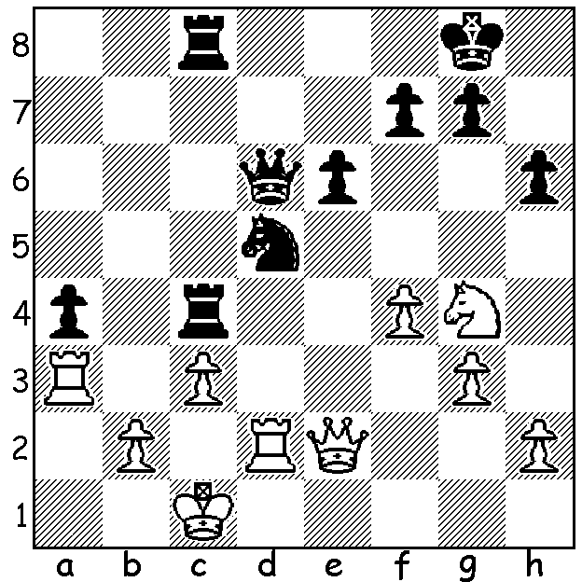

Carrissa Yip vs Irina Krush
(US Womens Ch 2017):
a surprise Black move mates
or nets a pawn:

Irina Krush

The US Womens Championship was played along the US Championship with the favourites for the title being last year's winner Nazi Pakidze and seven times winner Irina Krush. Another possible winner was Sabina Foisir, but her prospects seemed bleak after losing 2 of her first 4 games. However a score of 5 wins and 2 draws from the last 7 rounds saw her triumph with 8/11, a point ahead of Padkidze and a point and a half ahead of Krush. Sabina comes from a chess family with her parents both multiple Romanian championship medalists (her mother 4 times Romanian Women's champion) and her younger sister a WIM. Here is Sabina's spectacular final round game which clinched the title:

Apruva Virkud vs Sabina Foisor
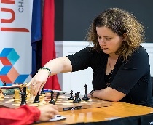
2017 US Womens Championship, Rd 11
Nimzoindian Defence
1.d4 Nf6 2.c4 e6
3.Nc3 Bb4 4.Qc2 0-0
5.Nf3 c5 6.dxc Na6
7.c6(a) bxc 8.g3 d5
9.Bd2 d4 10.Ne4 Rb8
11.Nxf6+ Qxf6 12.Bg2 e5
13.0-0 Bf5 14.Qc1 Bxd2
15.Qxd2(b) h6 16.Qa5 c5
17.b3 e4 18.Nd2 Rfe8
19.Rad1 Rb6 20.Nb1 Qe7 Sabina Foisir
21.e3 Bg4 22.Rd2 Nb4
23.exd(d) e3! 24.fxe Qxe3+ 25.Kh1 Rf6!
26.Rg1(e) Qxg1+!! 27.Kxg1 Re1+ 28.Bf1 Rfxf1+
29.Kg2 Rg1+ 30.Kf2 Ref1+ 31.Ke3 Rf3+
White resigns (f)

a) An idea of Morozevich but it is likely to give Black a strong centre.
b) 15.Nxd2 is better, holding up e5-e4.
c) 20.a3 and e3 are both preferable.
d)This can be seen as the fatal error allowing a decisive breakthrough.
e) White must defend the back rank.
f) 32.Ke2 Rf5+ 33.Ke4 Re1+ or 32.Ke4 Re1+.

The Metropolitan Open (7 Rd Swiss) will be played ove successive Thursdays, starting May 18 and the WA Championships are scheduled for successive Sundays, 21 May to 9 July. See cawa.org.au for information.

SOLUTION: 1...Qxa3!! 2.bxa3 Rxc3+: now if 3.Kb2 Rb3+ 4.Ka1 (4.Ka2 Nc3+ 5.Ka1 Rb1#) 4...Rc1+ 5.Ka2 Nc3# ): White wisely played 3.Rc2! losing just a pawn after 3...Rxc2+ 4.Qxc2 Rxc2+ 5.Kxc2. Krush, a seven times US Women's champion, was expected to win this ending against a 13 year old schoolgirl but after a further 30 moves had to concede a draw: 39...f5 40.Ne5 g5 41.Nd3 gxf 42.gxf Kf7 43.Kd2 Ke7 44.Nb2 Nxf4 45.Nxa4 Kd6 46.Nb2 Kc5 47.a4 Nd5 48.Nd3+ Kc4 49.Ne5+ Kd4 50.Nc6+ Kc5 51.Ne5 h5 52.Nd3+ Kc4 53.Ne5+ Kc5 54.Nd3+ Kd6 55.a5 Kc6 56.Ke2 Kb5 57.a6 Kb6 58.Kf3 Nc7 59.Kf4 Nxa6 60.Ke5 Nc5 61.Nf4 Kc6 62.Nxh5 Kd7 63.Nf4 Ke7 65.Nxe6 Nxe6 66.Kxf5 Draw.

