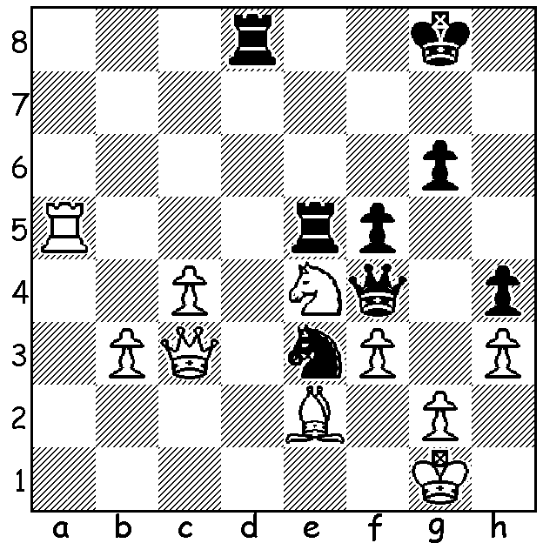

Vladimir Liberzon – Mark Taimanov 1967:
Black to play & win (5 moves):

MARK TAIMANOV (Part I)
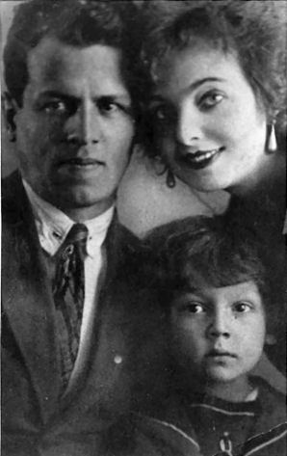
Since late last year I have been wanting to pay tribute to Grandmaster Mark Taimanov who died on 29th of November last year aged 90. Taimanov was one of those outstanding individuals who was simultaneously able to effectively combine two careers with great distinction. After his family moved from Ukraine to Leningrad (Petersburg) when he was a few months old, the young Taimanov learnt chess at an early age from his father, who was a passionate player, as well as music from his two parents who were both talented musicians. He gained surprising fame at the age of eleven when he was selected to take the part of a young violinist in the Russian film ‘Beethoven’. He went on A young Mark Taimanov to study music at the Leningrad Conservatory and with his parents became an accomplished concert pianist. He married fellow pianist Lyubov Bruk at the age of 19 and together they madefrequent tours together as dual pianists. In chess he became a Grandmaster in 1952 and
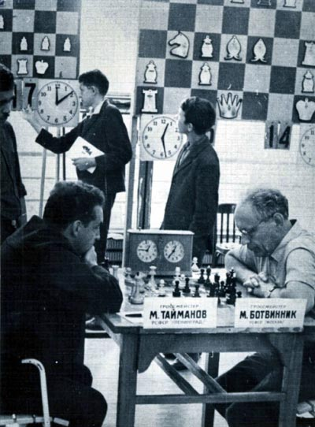
developed into one of the top ten chess players in the
world. His greatest successes were coming =1st in the USSR championship in both 1953 and 1956, losing the first play-off to his mentor, the great Mikhael Botvinnik,
and winning the second ahead of Yuri Averbakh and
future world champion Boris Spassky. In all he played in a
record 23 USSR championships. He saw chess, like music,
as an art and his play was influenced by a desire to create
beauty -”I considered those I played against not as opponents
but partners: together we created a work of art.” Here is a
wonderful win against a leading Russian grandmaster:

Taimanov in play against
Mikhail Botvinnik

Mark Taimanov - Lev Polugaevsky
Leningrad 1960
Queens Gambit Accepted

1.d4 d5 2.c4 dxc
3.Nf3 Nf6 4.Qa4+ Nbd7
5.Nc3 e6 6.e4 c5
7.d5 exd 8.e5 d4(a)
9.Bxc4 dxc3 10.exf6 Qxf6
11.Bg5 Qc6 12.0-0-0!! cxb2+
13.Kxb2 Be7(b) 14.Rhe1! f6
15.Bb5 Qb6 16.Kc1! fxg5
17.Bxd7+ Kf8 18.Rxe7! Kxe7
19.Qe4+ Kd8 20.Bf5+ Kc7
21.Qe5+ Kc6 22.Rd6+ Kb5
23.Qb2+ resigns (c)

a) Better 8…b5 (9.Qxb5 Rb8 10.Qa4 d4 11.exf6 dxc3 12.Bxc4 Rb4 13.Qc2 Nxf6) Miles v Karpov 1990.
b) If 13…Qxa4 14.Rhe1+ Be7 15.Rxe7+ Kf8 16.Rxf7+ Kg8 17.Rfxd7+! Qxc4 18.Rd8+ Kf7 19.Ne5+ Ke6 20.Nxc4 winning.
c) 23…Ka4 24.Bc2+ Ka5 25.Qa3+ Kb5 26.Qa4# or 23…Kc4 24.Ne2#.

SOLUTION: 1…Rxe4!! (a deflection sacrifice opening the f file) 2.fxe4 Rd1+! (now deflecting the bishop) White resigns – 3.Bxe1 Qf1+ 4.Kh2 Qxg2#.

