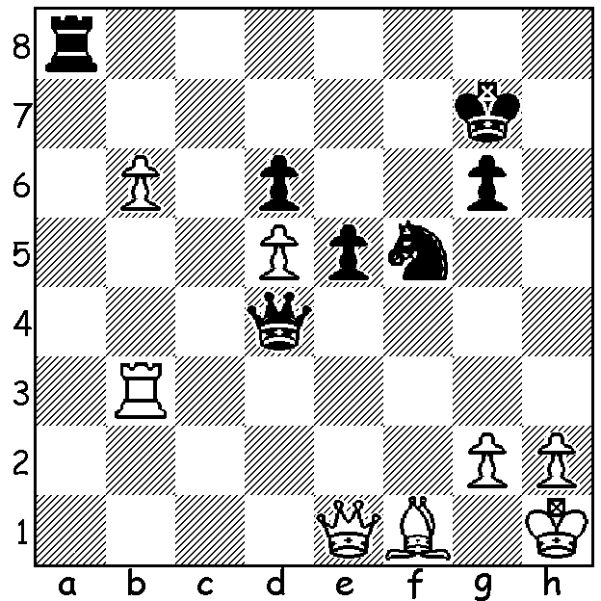

Anatoly Karpov– Mark Taimanov 1977:
Black employs a Switchback
(a theme popular with problemists)
to defeat a future world champion
(4 moves):

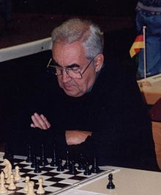

We continue our tribute to Mark Taimanov (1926-2016):
Until 1971 Mark Taimanov might well have been very contented with life. However his life as a successful concert pianist and leading chess Grandmaster was to change drastically for the worse following his World Championship
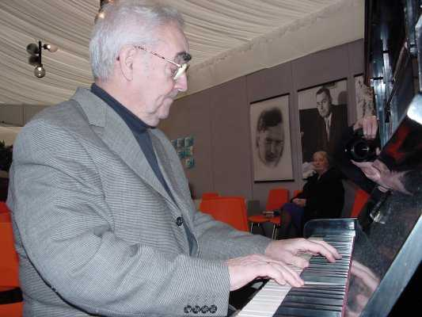
Candidates Match against the American Bobby Fischer in which he suffered a humiliating 0-6 loss and the censure of the Soviet regime. His salary was cancelled, he was deprived of civil rights, forbidden from travelling abroad and banned from society. The stress also caused the breakdown of his marriage.
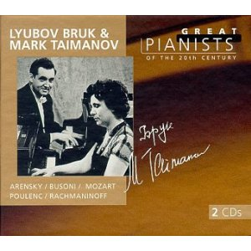
Taimanov wrote: “The Fischer match changed my life to hell.” However Fischer’s further demolition of ‘the Great Dane’ Bent Larsen, also 6-0, his comfortable victory against ex-world champion Tigran Petrosian and finally his convincing 12.5-8.5 victory to wrest the title from Boris Spassky put Taimanov’s loss more into perspective and he was officially ‘forgiven’ in 1973. He remarried and was able to continue to pursue his dual professions. He has twice been the world senior Champion
and in 1999 he was featured with his first wife Lyubov Bruk in the CD collection ‘Great Pianists of the 20th Century’. He was a prolific chess writer and theoretician who produced a legacy of opening variations with perhaps the most well known the Taimanov Variation in the Sicilian (1.e4 c5 2.Nf3 e6 3.d4 cxd 4.Nxd4 Nc6 5.Nc3 a6). He was married four times and became father of twins when aged 78. Here is another Taimanov gem in which he sacrifices his two ‘Harrwitz Bishops’ (bishops trained on the opponent’s castled king) in a game reminiscent of the Lasker-Bauer game of 1889:

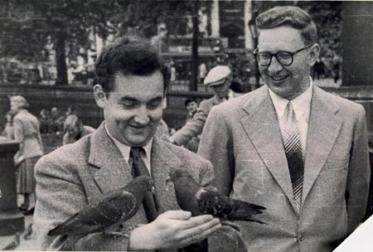
Mark Taimanov - Alexsander Shasin
USSR 1978
Nimzovitsch Attack
1.Nf3 Nf6 2.b3 d5
3.Bb2 Bg4 4.e3 e6
5.h3 Bxf3 6.Qxf3 Nbd7
7.g4 Bd6 8.g5 Ne4
9.h4 0-0 10.d3 Nec5
11.Nd2 a5(a) 12.a3 a4
13.b4 Na6 14.d4 c6
15.c4 e5(b) 16.cxd exd
17.Bxd4 c5 18.bxc Naxc5 Mark Taimanov & Vassily Smyslov taking a break from
19.Nc4 Nb3 20.Bd3! Bc5(c) chess to enjoy some sightseeing. Smyslov was also an
21.Bc3 b5(d) 22.Bxh7+! Kxh7 accomplished musician with a fine baritone voice and
23.Qh5+ Kg8 24.Bxg7! Kxg7 once auditioned for the Moscow Opera Company. 25.Qh6+ Kg8 26.g6 Nf6 Taimanov accompanied Smyslov on several occasions
27.Rg1 Qxd5 28.g7 resigns at impromptu concerts during chess events.

a) Logical is 11…Na6 to play …c5.
b) With White extended on both wings Black at the cost of a pawn attempts to open the centre.
c) 20…Nxd4 is met by 21.Qe4 while if 20…Nxa1 21.Bxa1 & White's raking bishops are ample compensation for the exchange.
d) Black should take advantage of White’s failure to sacrifice on h7 to play 21…f5 (if 21…Re8 22.Bxh7+! Kxh7 23.Qxf7) although White retains an immense attack: eg 22.Rd1 b5 23.d6! bxc4 24.Bxc4+ Kh8 25.h5 Qxg5 26.h6 Nf6 27.hxg7+ Qxg7 28.Qxf5. White is again better after 21…Nxa1 22.Qh5 f5 23.gxf6 Nxf6 24.Bxf6 Rxf6 25.Qxh7+ Kf8 26.Qh8+ Ke7 27.Qxg7+ Rf7 28.Qe5+ Kf8 29.Qh8+ Ke7 30.d6+ Bxd6 31.Qxa1. Now White brings off a sparkling double bishop sacrifice.

SOLUTION: 1…Ra1 2.Rb1 (the most logical reply) 2…Ng3+!! 3.hxg3 (3.Qxg3 Qxa1) 3...Ra8! (the switchback): White cannot now prevent …Rh8+ mating.

