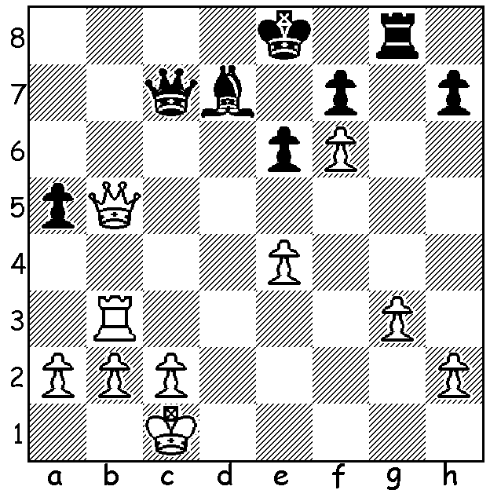

Another in the new series of puzzles 'So Good':
Wesley So v Prasad Arun 2008:
White to play and win (5 moves):

A belated report on two recent WA tournaments. Firstly the Gufeld Cup, A WA Grand Prix event played over Easter with a 60 min + 10 sec time limit. There was a triple tie for first place between Andrew Hardegen, Gordon Dunlop and Ignatius Yap, all on 4.5/6, with 4th place shared between Tim Hare and David Ellis (4). SW junior Ramadu Rathnayake and local junior Sri Krishnan Dharmapuri were the top Under 1700 players and Sebastian Vearncombe received a junior award. The last round saw leaders Dunlop and Yap playing and drawing, enabling Hardegen to draw level with victory over Dharmapuri. Yap has been WA Junior champion for the past three years while Hardegen was WA Junior champion in 2000 and 2001. Here is their game with Yap, after an inferior opening, coming close to victory:

Ignatius Yap vs Andrew Hardegen
2017 Gufeld Cup, Rd 2
Queens Pawn Opening
1.d4 d5 2.Nf3 Nf6 3.e3 c5
4.dxc(a) Nc6 5.Be2(b) e6 6.0-0 Bxc5
7.Nc3(c) a6 8.b3 0-0 9.Bb2 Re8
10.a3 b5 11.Bd3(d) e5 12.e4 d4
13.Ne2 Bg4 14.b4(e) Bxf6 15.gxf3 Ba7
16.Kh1 Nh5 17.Rg1 Qf6 18.Ng3 Nf4
19.Bc1 Re6(f) 20.Bxf4 exf4(g) 21.Nh5 Qh4
22.Nxg7 Rg6 23.Nf5 Qxf2 24.Qf1 Qxf1
25.Raxf1 Kf8 26.Rg4 Ne5?(h) 27.Rxf4 Rc8
28.Rh4 Nxd3 29.cxd3 Rc3 30.Rg1?(i) Rxg1+
31.Kxg1 Rxd3 32.Rxh7 Kg83 3.Rg7+ Kf8
34.Rh7 Kg8 35.Rg7+ DRAW

a) An innocuous move with little chance of gaining an advantage or attacking chances: 4.Nbd2 or 4.b3 (the Colle System) leads to possibilities for both sides.
b) Now 5.c4 seems best, possibly leading to a Queens Gambit Accepted with colours reversed.
c) The knight doesn't belong here as it has no future and impedes the c pawn: better 7.Nbd2, or immediately 7.b3.
d) White now starts playing with some plan, preparing e4 and repositioning the c3 knight to a useful square.
e) Now we are talking! White invites the weakening of his kingside pawn shield to get a useful half-open g file from which to mount an attack.
f) Black wants to attack the h2 pawn with Q & R but 19.g6 preventing an attack on g7 was advisable.
g) 20.Qxf4 may have been better.
h) Black plans to infiltrate the c file but 26...Rxg4 27.fxg4 Bb8 is preferable.
i) White is on top after 30.Rxh7 Rxd3 31.Nh6 (31...Rf6 32.f4).

A week after the Gufeld the WA Lightning Championship (5 mins a player) was held with 34 competitors. Apart from when Perth hosted Australian Championships this tournament almost certainly contained the greatest number of high rated players ever held in WA. The top rated player was 15 year old International Master (IM) Temur Kuybokarov who was joint winner of the 2017 Australian Open. There were also three local FIDE Masters (FMs), Tristan Boyd, Yita Choong and Patrick Gong and a Womens FIDE Master (WFM), Kathryn Hardegen. Local player Adam Kelly caused the upset of the tournament defeating Temur in Rd 8. Winner was WA's top rated player Tristan Boyd (9/11), 2nd Temur Kuybokarov (8.5), 3rd= Tim Hare, Ihsan Ferozkohi, Patrick Gong (8). Kathryn Hardegen (5.5) was Women's champion and Craig Kinsman (6.5) Senior champion. Chirag Saroha (6.5) won the Under 2000 rating award, Sri Krishna Dharmapuri (6.5) the Under 1700 and Neville Shah (6) the Under 1500.

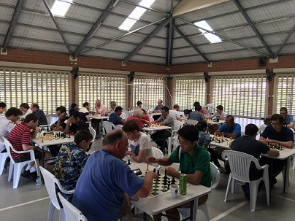
WA Lightning: Foreground Tim Hare v Patrick Gong, Temur Kuybokarov v Adam Kelly,
Tristan Boyd v Shirag Saroha, George Caroline-Unkovich v Ihsan Feozkohi
(picture by Dante Osorio)

SOLUTION: 1.Qb8+ Qd8 (1...Qxb8 loses everything and 1...Qc8 loses to 2.Qd6 Qd8 3.Rb8) 2.Qa7 Bc8 3.Rb8 Rg6 4.Rxc8! (deflection of overworked piece) 4....Qxc8 5.Qe7#.

