Boris Spassky vs Arthur Bisguier (Interzonal 1955):
with White about to queen how does Black win (4 moves):

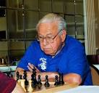
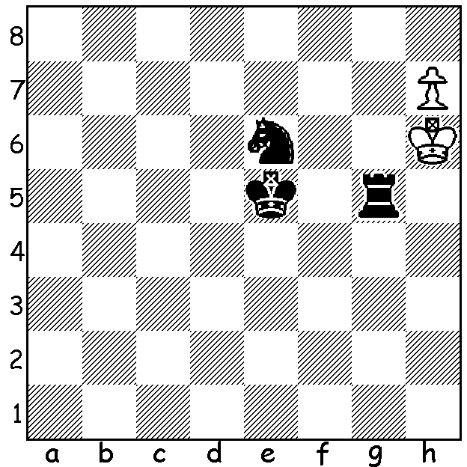
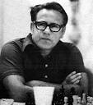

It's back to the America today but it's not about the current US players but a player at his peak in the 1950s and 1960s. I'm referring to GM Arthur Bisguier who died in April this year aged 87. Bisguier was born in 1929 in New York and at four was taught to play by his father, a mathematician. At 17 he gained 5th place in the US Open and followed this up by winning the US Junior championship, a title he retained the following year. In 1950 he won the first of his three US Open titles. He won the the 1954 US Championship and may have won on further occasions if not for the emergence of the prodigy Bobby Fischer. He represented the US at five Olympiads scoring +29, -18, =35 at 56.7%. From the mid 60s his play was limited to America, winning Lone Pines in 1973 and coming second to then world champion Boris Spassky in San Juan, Porto Rico in 1969. He won the US Senior championship in 1989, 1997 and 1998. He also promoted chess giving exhibitions and lectures throughout the country and was a regular contributor to Chess Life. His play was aggressive and he was unafraid to sacrifice for an attack. A quote of his might sum up his attitude: 'I don't know what I'm going to play so how can he (opponent) know what I'm going to play.' Here is his first ever game against Bobby Fischer who was only 13 at the time but already of outstanding ability and who in the same tournament defeated GM Donald Byrne in his celebrated 'Game of the Century':

Arthur Bisguier vs Bobby Fischer
Rosenwald Memorial, NY 1956
Kings Indian Defence
1.d4 Nf6 2.c4 g6 3.Nc3 Bg7
4.e4 d6 5.f4(a) 0-0 6.Nf3 c5
7.Be2 cxd 8.Nxd4 Nc6 9.Nc2 Bd7
10.0-0 Rc8 11.Be3 Na5 12.b3 a6
13.e5 dxe 14.fxe Ne8 15.Nd5 Rc6(b)
16.Nd4 Rc8 17.Nc2 Rc6 18.Ncb4 Re6
19.Bg4 Rxe5 20.Bb6 Qc8 21.Bxd7 Qxd7
22.Bxa5 e6(c) 23.Nd3 Rh5 24.N3f4 Rf5
25.Bb4 exd5 26.Bxf8 Bxa1 27.Qxa1 Kxf8
28.Qh8+ Ke7 29.Re1+ Kd8 30.Nxd5 Qc6
31.Qf8 Qd7 32.Rd1 Rf6(d) 33.Qxe8+! Resigns(e)

a) The Four Pawn Attack, one of the most aggressive lines against the KI and a favourite of Bisguier.
b) A necessity defending against Bb6 but the rook is uncomfortably placed on the 3rd rank.
c) Black will regain the lost piece but the ensuing complications leave White with a winning attack.
d) To interpose 33...Rd6 after 33.Ne3.
e) White will be at least a rook up whichever way Black recaptures. This was Bisguire's only win against Fischer. After drawing their second encounter he lost the next 13.

The South West Open (GP event) will be played this year at Boyup Brook Sat & Sun, 17 & 18 June. Get your entries and bookings completed soon. Details cawa.org.au or contact Norbert 0419950619.

SOLUTION: 1...Kf5 2.h8=Q Rg6+ 3.Kh5 (3.Kh7 Ng5#) 3...Nf4+ 4.Kh4 Rg4#.

