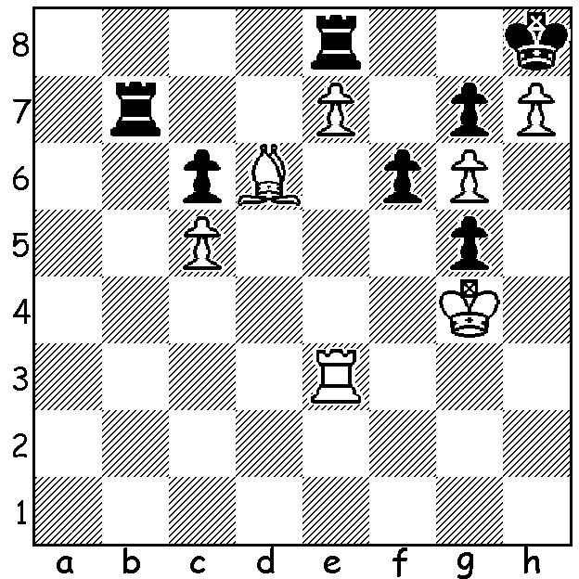

Wesley So vs Sergey Karjakin (Norway 2017):
White seems to have a clear win with his king heading
for f7. Can you find Black's drawing resource?

The current Altibox Chess (Norway) features 10 of the top 12 players in the world. While many draws were expected, Round 4 could well have resulted in 5 wins. Levon Aronian defeated world champion Magnus Carlsen in a sensational game after clever innovative sacrifices on moves 11 & 12, Hikaru Nakamura beat Maxime Vachier-Lagrave and Anish Giri defeated ex-world champion Anand. Another ex-world champion Vladimir Kramnik fought hard to draw an ending a pawn down against Fabiano Caruana who missed chances of clinching the win and Sergey Karjakin, in a seemingly hopeless position, brought off a problem-like draw to split the point with Wesley So (see above).

Levon Aronian vs Magnus Carlsen
Altibox Norway Chess 2017, Rd 4
Queens Gambit Slav (Chebanenko Variation 5...a6)
1.d4 d5 2.c4 c6 3.Nf3 Nf6
4.Nc3 e6 5.e3 a6 6.b3 Bb4
7.Bd2 Nbd7 8.Bd3 0-0 9.0-0 Qe7
10.Bc2 Rd8 11.a3! Bxa3 12.Rxa3! Qxa3
13.c5 b6(a) 14.b4(b) Ne4(c) 15.Nxe4 dxe4
16.Bxe4 Rb8!(d) 17.Bxh7+! Kxh7 18.Ng5+ Kg8(e)
19.Qh5 Nf6(f) 20.Qxf7+ Kh8 21.Qc7 Bd7
22.Nf7+ Kh7 23.Nxd8 Rc8 24.Qxb6 Nd5
25.Qa7 Rxd8 26.e4 Qd3(g) 27.exd4(h) Qxd2
28.Qc7 Qg5 29.dxc Bc8 30.h3(i) Qd5
31.Rd1 e5 32.Rd3 exd 33.Qe7 Bf5
34.Rg3 Bg6 35.Qh4+ resigns(j)

a) Best reply: alternatives (i) 13...a5 14.Bc1 Qa1 (14...Qb4 15.Na2 Qb5 16.Bd3) 15.Qd2 h6 16.Bb2! Qxb2 17.Bh7+: (ii) 13.Nxc5 14.Nb1!: (iii)13...Qa5 14.Nxd5! Qa2 15.Nxf6+ Nxf6 16.Ne5 and the queen will be lost.
b) 14.Nb1 wins the queen but after 14...Qa2 15.Bb4 bxc5 16.Nc3 Qb2 17.Na4 Qa2 18.Bb1 Qxb1 19.Qxb1 cxb4 Black has adequate material for the queen.
c) If 14...Qb2 15.Na4 Qa2 16.Ne5 Nxe5 17.dxe5 Nd7 18.cxb with the easier game,
d) Again the best chance: 16...Bb7 17.Qc2 Nf6 18.cxb Nxe4 19.Qxe4 Qa2 20.Ng5!! Qxd2 21.Qxh7+ Kf8 22.Qh8+ Ke7 23.Qxg7 Rf8 24.Qe5 Qc2 25.Ne4 (with threat 26.Qd6+ 27.Nf6#) 25.Rad8 26.Nc5!
e) 18...Kg6 19.Qg4 f5 20.Qg3 Kf6 21.d5!
f) If 19...Nf8 20.Qxf7+ Kh8 21.Qe7 Bd7 22.Nf7+ wins.
g) If 26...Nf6 27.Bg5 Qxb4 28.e5 Qxd4 29.exf6 gxf6 30.Qc7 Rc8 31.Bxf6! Qxf2+ 32.Rxf2 Rxc7 33.Be5.
h) Still room to lose – 27.Bg5? Qxe4 28.Bxd8 Nf4 29.f3 Qe2 30.Rf2 Qe1+ 31.Rf1 Ne2+.
i) To activate the rook.
j) “The chess world is a better place when Aronian is playing well” (Kasparov).

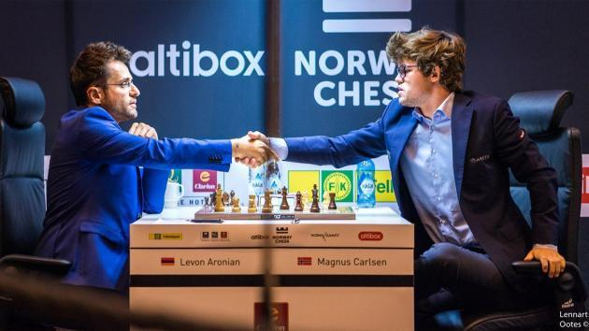

SOLUTION: Black's king's imprisonment provides a surprise drawing chance. He sacrifices all his moveable pieces starting with 1...f5+! and the game concluded 2.Kxg5 Rb1 3.Ra3 Rg1+ 4.Kxf5 Re1 5.Ra2 R8xe7! 6.Bxe7 Re5+ 7.Kxe5 stalemate: if White plays 2.Kxf5 the passed g pawn runs forcing White to capture or block it to prevent promotion.

