Levon Aronian – Stefan Kindermann 2004:

White mates in 4:
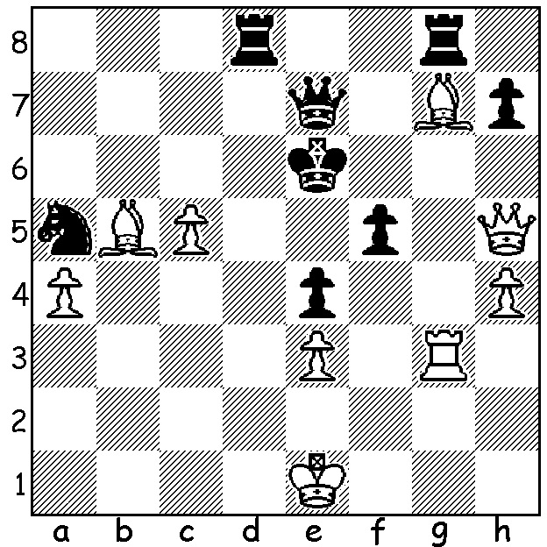
A happy Aronian, winner in Norway

Last week we saw world champion Magnus Carlsen lose to Levon Aronian in the Altibox Norway Chess, a tournament with ten of the current top twelve players in the world. This week another Carlsen loss in the same event, this time against ex-world champion Vladimir Kramnik, leaving the world champion with only 2.5 from his first 7 games. Aronian led for almost all the tournament and went into the final round a half point ahead of Hikaru Nakamura. After a last round draw Aronian gave Nakamura a chance to equal his score but the American was well beaten by compatriot Fabiano Caruana leaving Aronian winner by one point. Final scores: Aronian 6/9 (3 wins), Nakamura 5 (2 wins, 1 loss), Kramnik 5 (3 wins, 2 losses), Caruana 4.5 (1 win, 1 loss), Wesley So (9 draws), Anish Giri 4.5 (2 wins, 2 losses), Maxine Vachier-Lagrave 4 (1 win, 2 losses), ex-world champion Vishy Anand 4 (1 win, 2 losses), Carlsen 4 (1 win, 2 losses), Sergey Karjakin (0 wins, 2 losses).

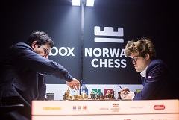
Vladimir Kramnik vs Magnus Carlsen
Altibox Norway Chess 2017, Rd 7
Giuoco Piano
1.e4 e5 2.Nf3 Nc6
3.Bc4 Bc5 4.c3 Nf6
5.d3 d6 6.0-0 a6
7.Re1 Ba7 8.a4 0-0
9.h3 Ne7 10.d4 Ng6
11.Nbd2 c6 12.Bd3 Re8
13.Bc2 h6 14.Nf1 exd
15.cxd c5 16.d5 b5 Kramnik v Carlsen
17.axb axb 18.Ng3 Bd7
19.Be3 Bb6 20. Rxa8 Qxa8
21.b4 Qa7 22.Qa1! Qc7?(a)
23.Bxh6! cxb 24.Bxg7! Qxc2(b)
25.Qxf6 Qxf2+(c) 26.Kh2 Bd8
27.Qxd6 Nh4 28.Nxh4 Bxh4
29.Nh5! Bxh3(d) 30.Rg1(e) Bg5
31.Bf6 Bg4(f) 32.Bxg5 Bxh4
33.Qh6 Rxe4(g) 34.Qxh5(h) Qf5
35.Qh6 b3(i) 36.Qf4+ Qxf4
37.Qxf4 Rxf4 38.d6! Rxf6
39.Rd1 Rh6+ 40.Kg1 resigns

a) An error resulting in a broken kingside. Better both 22...Ra8 (23.Qxa7 Rxa7 24.Rd1 with advantage) and 22...Qxa1 (23.Rxa1 Rb8 24.bxc Bxc5 25.Bxc5 dxc5 26.Ra7 with a positional plus although Black's passed pawns are a danger).
b) If 24...Kxg7 25.Nh5+ Kf8 (25...Kh6 26.Qc1+ Kh7 27.Nxf6+) 26.Qxf6 Bxf2+ 27.Kxf2 Qxc2+ 28.Kg3 with threat 29.Ng5.
c) Better 25...Bxf2+ 26.Kh2 Qc3 (26...Bxe1 27.Bh6 Qc3 28.e5 with mate) 27.Re2 Qxf6 28.Bxf6 Bc5 29.Nh5 with the better pawn structure and piece placement.
d) If 29...Qxe1 30.Qh6 mates.
e) Not 30.Kxh3?? Qxe1 and Black wins.
f) If 31...Bxg2 32.Qg3! (not 32.Rxg2? allowing 32...Qh4+ with a perpetual check) 32...Qxg3+ 33.Kxg3 and both Black's bishops are en prise. If 31...Be3 32.Kxh3 Bc5 33.Rf1! wins (33...Qxf1 34.Qg3+).
g) 33...Bg6 loses to 34.d6 Qd4 35.d7! Qxd7 (35...Rf8 36.Rc1 / 37.Rc8) 36.Bf6 Qd6+ 37.e5.
h) Up a piece, it's now easy for White.
i) If 35...Re5 36.Ra1!

SOLUTION: 1 Rg6+! Black resigns (1...hxg6 2.Qxg6 Kd5 3.Qxf5+ Qe5 4.Qxe5#).

