Maxime Vachier-Lagrave v Vladimir Kramnik
(Norway 2017): White to play and win (3 moves):

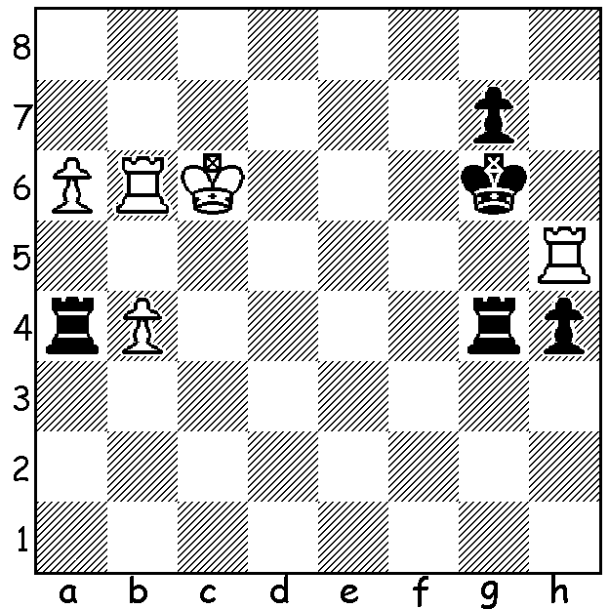

MVL v Kramnik

After losing his second game in Rd 7 of the Altibox Norway Chess to Kramnik and sinking to 2.5/7, Magnus Carlsen was close to losing his place as number 1 in ratings to Kramnik but he scored his first win in the tournament in Rd 8 (and finished 4/9) while Kramnik lost to Maxime Vachier-Lagrave. A number of the players then moved to France for the Paris Grand Chess Tour, playing in Rapidplay (25 min + 10 sec) and then Blitz (double round, 5 min + 3 sec) events. Carlsen went through the Rapid undefeated with 14/18 (win 2pts, draw 1pt), a point ahead of Alexander Grischuk & two points ahead of Hikaru Nakamura. He then started the Blitz with 4 straight wins but with four losses (including one on time when he had knight & pawn v sole bishop) he finished =4th behind MVL (13/18) and Nakamura & Fabiano Caruana (11/13). This gave him and MVL a combined score of 24/36 (Rapid + Blitz) resulting in a play-off (10 min + 5 sec) in which Carlsen emerged victorious with a win and a draw.


Magnus Carlsen - Sergey Karjakin
Altibox Norway Chess 2017, Rd 8
Nimzoindian Defence
1.d4 Nf6 2.c4 e6
3.Nc3 Bb4 4.e3 0-0
5.Bd3 d5 6.cxd exd
7.Nge2 Re8 8.Bd2 Bf8
9.0-0 b6 10.Rc1 c5
11.Nf4 Bb7 12.Qf3 Na6
13.Rfd1 cxd(a) 14.exd Nc7
15.Bc2 Bd6 16.Be3 Ne4 A happier Carlsen after 1st win in Norway
17.Ba4 Re7 18.Bb3 Qd7
19.h3(b) Nxc3 20.bxc3 Bc6
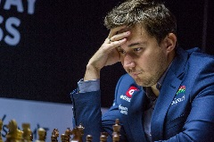
21.Nh5(c) Re6(d) 22.Bc2 Ba4
23.c4 dxc 24.d5 Rg6!
25.Bd4 Bxc2 26.Rxc2 Qa4
27.Rcc1 Qxa2(e) 28.Nxg7 Rxg7
29.Bxg7 Kxg7 30.Qg4+ Kf8
31.Qh4 Qb2 32.Rxc4 Ne8(f)
33.Re1 Qf6(g) 34.Qxh7 Qg7
35.Qc2(h) Qf6(i) 36.Rg4 Bc5
37.Re2 Qh6 38.g3 Nf6
39.Rh4 Qg7 40.Kg2 Qg5 Karjakin (v Carlsen)
41.Qc3 Bd6?(j) 42.Rh8+ Ng8
43.Re4 Qg7 44.Rxg8! Resigns(k)

a) Keeping the tension with 13...Nc7 leads to the inferior position after 14.dxc bxc 15.Na4 Nd7 16.Ba5.
b) Stopping the attack on the h pawn as 19.Nfxd5 Nxd5 20.Bxd5 Bxd5 21.Nxd5 Bxh2+ leaves Black with the better game with knight v bad bishop.
c) 21.Nxd5? Nxd5 22.Bxd5 Bxd5 23.Qxd5? Bh2+ is an elementary blunder to lose the queen.
d) Defending against 22.Bh6! (21...Rae8 also defends – 22.Bh6 Qe6! 23.Bxg7?? Qe1+! mates.
e) Safer was 27...Ne8 preventing White's next.
f) 32...Kg7 heading for the corner was better.
g) If 33...Kg8 White works up threats with 34.Rg4+ Kh8 35.Qh6 (threat 36.Rxe8+!). Now if 34.Rxe8+?? Rxe8 35.Qxf6? Re1#.
h) 35.Qf5 is a better square threatening 36.Rc8 & eyeing d7.
i) 35.Qg6 seems better – 36.Qc3 Nf6 with g7 now available for the king.
j) Black has a possible defence in 41...Qxd5+ (42.Kh2 Qg5 43.Rf4 Nd5! 44.Qf3 Nxf4! 45.Qxa8+ Kg7 46.gxf4 Qxf4+).
k) 44...Qxg8 (44...Kxg8 45.Rg4) 45.Qf6 Bc5 46.Rg4 Qh7 47.d6 with threats of 48.Qe7#, d7 & Rh4.

SOLUTION: 1.Rxh4! Black resigns (1...Kxh4 2.Kb5+ / 3.Kxh4 with an easy win).

