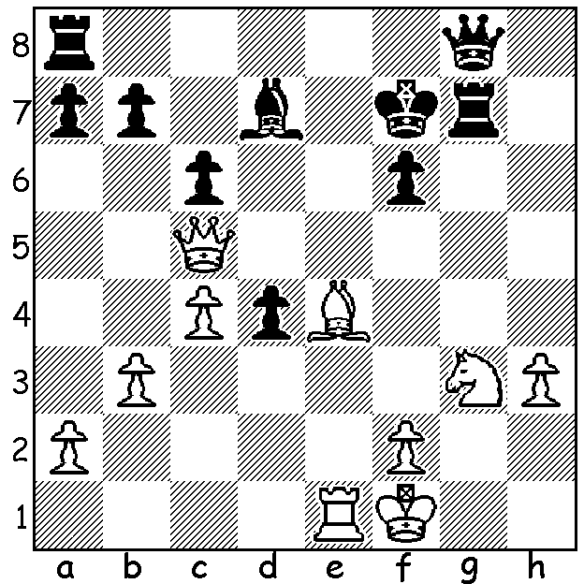
MAGNUS IS COMING! Unfortunately not the
charasmatic young world champion in person but
the film 'Magnus' which will be shown as part of
the Scandinavian Film Festival at the Paradiso
Cinema, Northbridge, on Friday 28 July at 1.30
and Monday 31 July at 6.30. Players and clubs
should not miss the opportunity to see the story
of this incredible young man.

Magnus Carlsen – Helgi Gretarsson 2003:
White to play and win (2 moves)

Magnus Carlsen was born in Norway on 30 November 1990 and learned to play chess aged 5. He became a Grandmaster at the age of 13, the 3rd youngest in history, and became world champion in 2013 after defeating Vishy Anand. He successfully defended his title in 2014 against Anand and against Sergey Karjakin in 2016. His play is marked by a willingness to try many different openings and defences and he has been a consistent winner of the world's major tournaments, been rated World No. 1 almost continually from 2010 in classic, rapidplay and blitz, holding the world title in all three forms of the game simultaneously in 2014. He has been portrayed in The Simpsons, has been a professional model in men's clothing and was included in Cosmopolitan's Sexiest Men of 2013. Here's a recent game from the young world champion:

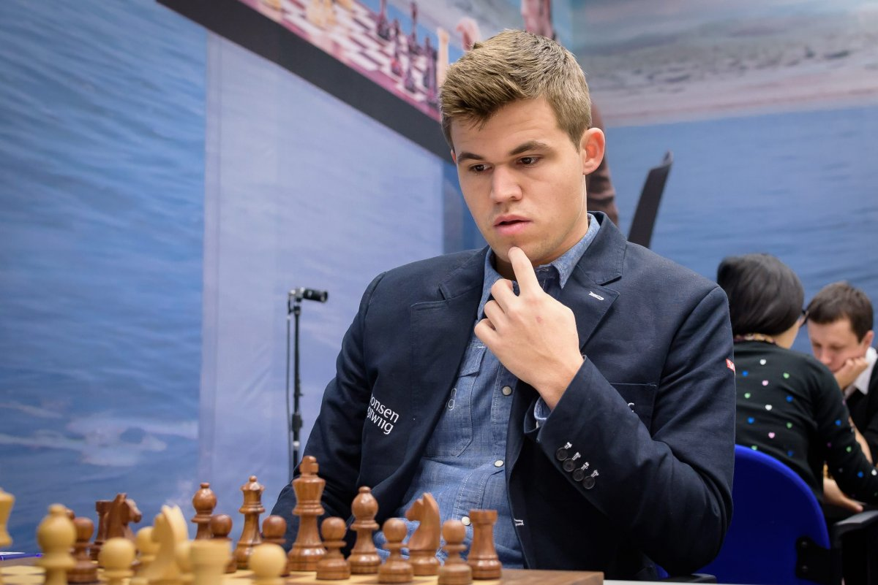
Fabiano Caruana - Magnus Carlsen
2015 Tata Steel Masters, Rd 6
Scilian, Rossolimo Variation
1.e4 c5 2.Nf3 Nc6
3.Bb5 g6 4.Bxc6 dxc6
5.d3 Bg7 6.h3 Nf6
7.Nc3 b6(a) 8.Be3 e5?
9.0-0?(b) 0-0 10.a3 Qe7
11.Qb1 Nh5 12.b4 f5(c)
13.bxc f4 14.Bd2 bxc
15.Qb3+ Be6 16.Qa4 Rac8 Carlsen
17.Qa5 g5(d) 18.Na4 g4
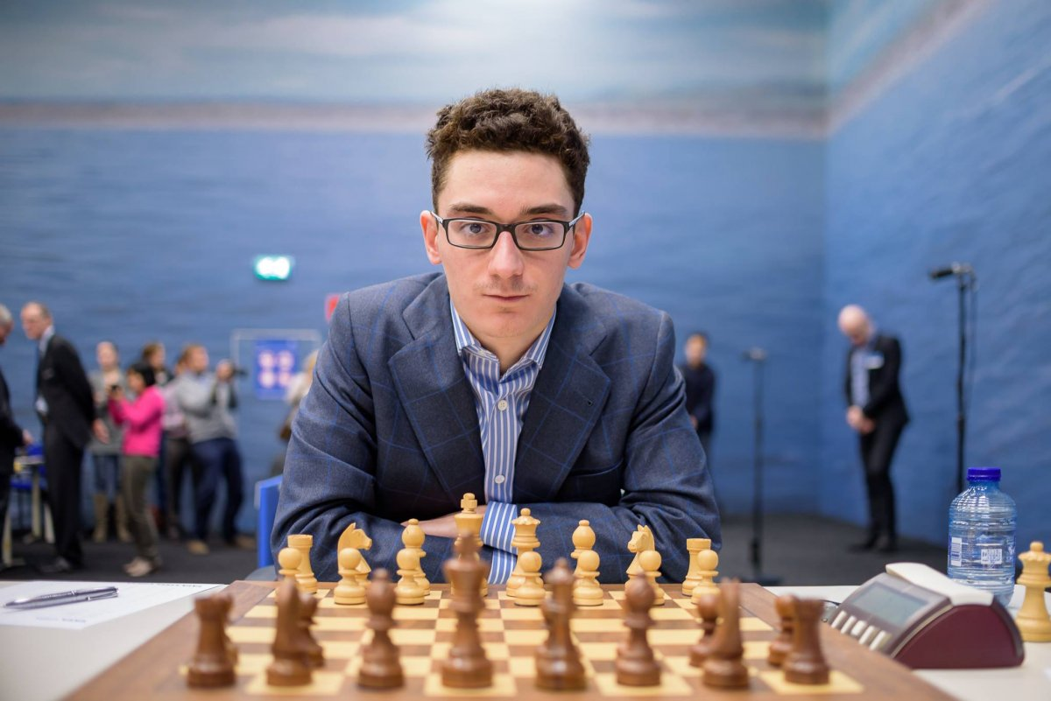
19.hxg Bxg4 20.Qxc5 Qf6
21.Nh2(e) f3! 22.Nxg4 Qg6
23.Qe7!(f) fxg! 24.Rfb1 Qxg4
25.Qg5 Qe2 26.Qe3 Qg4
27.Qg5 Qxg5! 28.Bxg5 Nf4
29.Bxf4?(g) exf4 30.Kxg2 f3+
31.Kf1(h) Rf4!! 32.c3 Rd8
33.d4 Bh6 34.Ke1 Rxe4+
35.Kd1 c5 36.Kc2 cxd
37.Kd3 Re2 38.c4 Rxf2
39.Rd1 Re2 White resigns Caruana

a) Better 8...e5 as this leaves the c pawn unprotected.
b) 9.Nxe5 Nxe4 10.Qf3 wins a pawn (10...Bxe5 11.Qxe4 f6 12.f4 Bf5 13.Qxc6+ Bd7 14.Qd5: nor are other 10th moves any better).
c) Black is prepared for the break-up of his queenside pawns and their likely loss to start a counter attack on the kingside.
d) If 17...c4 18.Na4 c5 19.Rab1 with initiative.
e) Better seems 21.Rfe1 Qg6 22.Kf1 seeking safety on e2.
f) 23.Ne3 loses – 23...Nf4 24.g3 Ne2+ 25.Kh2 Qh5# or 24...Rfb1 Ne2+ 25.Kf1 Qh5 26.gxf Nd4.
g) Hoping to ease his game with an exchange sacrifice but losing – 29.Kh2 (29...h6 30.Bh4 h5 31.Rg1) is best.
h) Still losing but better was 31...Kh3.

SOLUTION: 1.Bg6+! (clearance + deflection or obstruction sacrifice) 1...Kxg6 2.Qh5# or 1...Rxf6 2.Qe7#.

