No apologies for the fifth Carlsen article in as many weeks. Have you marked July 28 (1.30pm) or July 30 (6.30pm) in your calendar to see Magnus at Paradiso Cinema, Northbridge?

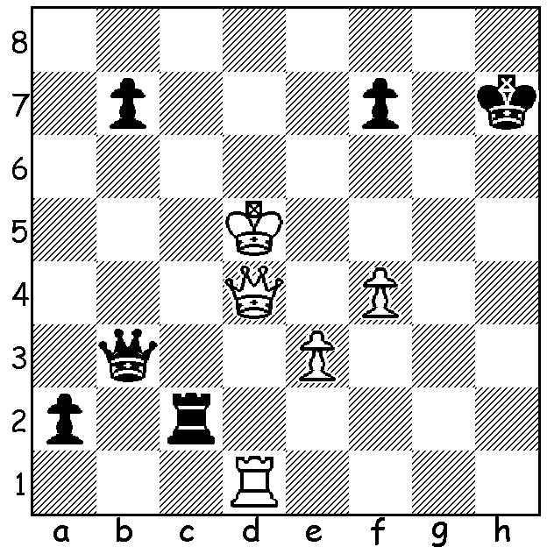
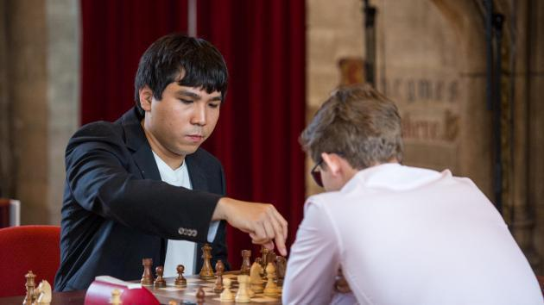
Magnus Carlsen - Wesley So
(Leuven Rapidplay 2017):
White resigns (1.Ke5/ Kd6 Qe6#):
however there is a surprising
draw for White if Black plays
to win the queen:

While Magnus Carlsen stumbled in the Paris Grand Prix, losing four games in the Blitz, including three in a row, before winning a play-off against Maxime Vachier-Lagrave, he was outstanding in the next Grand Chess Tour leg played this month in Leuven, Belgium, scoring 14.5/18 (+12, =5, -1) in the Blitz and easily winning the event despite having trailed Wesley So by three points after the Rapidplay section. Final leading scores: Carlsen 25.5/36, So 22.5, Vachier-Lagrave 22. As I said last week, Carlsen has always been prepared to play unusual openings and defences to get his opponents out of the book. He has been using 1.d4 d5 2.Bf4 quite regularly in these events as well as the Nimzovitsch Attack (1.Nf3 2.b3) and even successfully played the Birds (1.f4) in Leuven. Here is a game from the Blitz where he surprises everyone by an early 'spike', 6.g4.

Magnus Carlsen - Maxime Vachier-Lagrave
2017 Grand Chess Tour, Leuven, Rd 21
(Time limit 5 min + 3 sec per player)
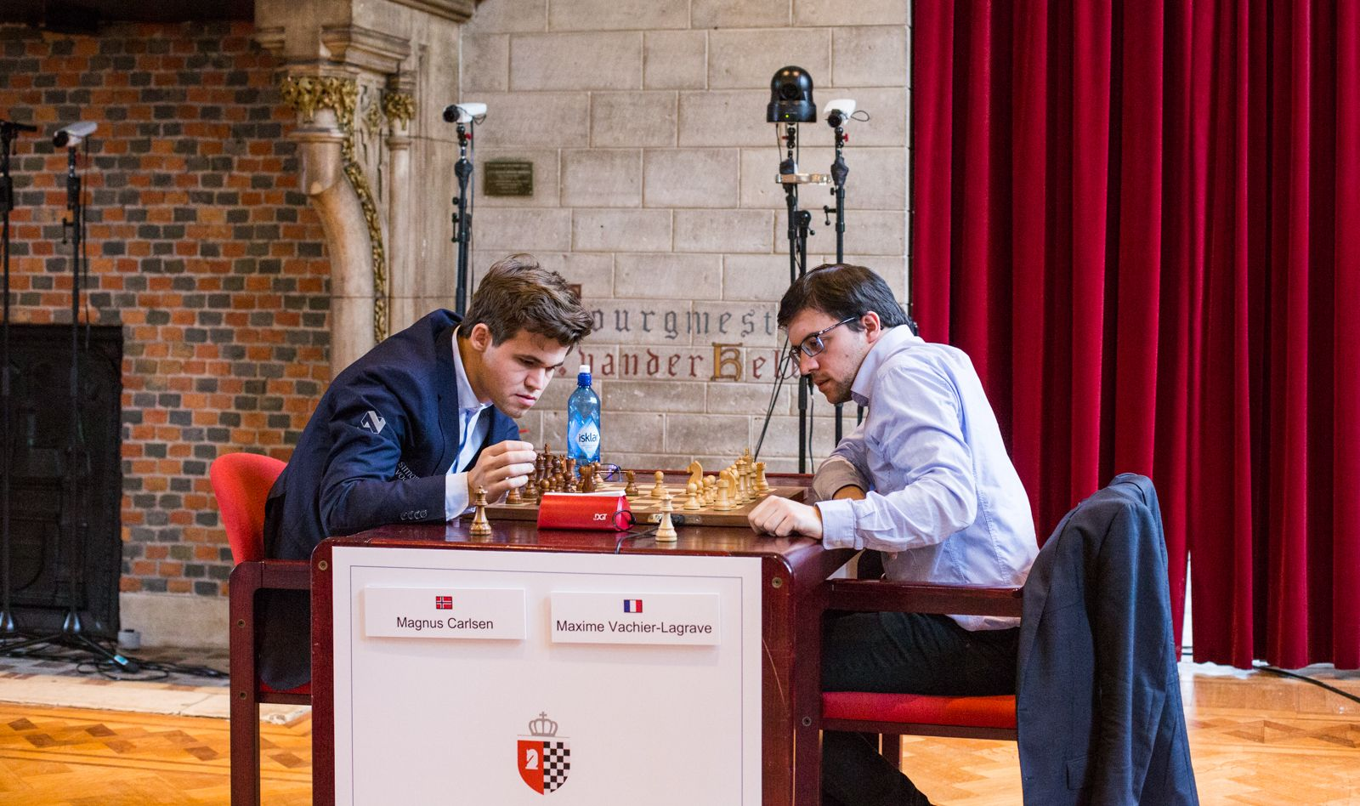
English Opening
1.c4 e5 2.e3 Nf6
3.Nc3 Nc6 4.g4!? Bb4
5.g5 Bxc3 6.bxc3 Ng8
7.d4 Qxg5 8.d5 Nd8
9.d6 c6 10.Nf3 Qf5
11.Rg1 Ne6 12.e4 Qxe4+
13.Be3 Qf5 14.Ng5 Nf4
15.Bxf4 Qxf4 16.Rg4 Qf6
17.Ne4 Qh6(a) 18.Qf3 Nf6
19.Rxg7!? Qxg7(b) 20.Nxf6+ Kd8
21.Qf5 Re8 22.Nxe8 Kxe8 Carlsen & MVL restarting their clock after it stopped.
23.c5 b5(c) 24.Bd3 f6(d)
25.Ke2 Kf7 26.Rh1 Rb8 27.Kf1 Qg6
28.Qf3 Qh6 29.Rg1 Ba6 30.Qg4 Rd8
31.Rg3 e4 32.Qxe4 Re8 33.Qg4 Bc8
34.Kg2 Qg5 35.Qf3 Qd5(e) 36.Qxd5+ cxd5
37.Bxh7 Re5 38.f4 Re2+ 39.Kf1 Rxh2
40.Bg8+ Kf8 41.Bxd5 Rh8 42.Kf2 Ba6
43.Ke3 Ke8 44.Kd4 Kd8 45.Rg7 Bc8
46.c6 dxc 47.Bxc6 a5 48.Kc5 resigns(f)

a) White has chased the queen around, gained a useful lead in development and has, through the pawn on d6, severely cramped his opponent, albeit at the cost of 2 pawns.
b) Rather than accept the exchange sacrifice Black should play 19...Kf8! (20.Rg3 Nxe4 21.Qxe4 Qxd6).
c) One unfortunate result of this move is the bishop never gets into play.
d) Not 24...Qg1+ 25.Kd2 Qxa1?? 26.Qxe5+ & mate next move.
e) Forced but it leads to a lost ending.
f) 'Brilliant game! Loved every second of it.' (Nigel Short).

SOLUTION: White could draw after 1.Ke4! if Black then plays1...Rc4? pinning the queen: 2.Rh1+ Kg6 (2...Kg8?? 3.Rh8#) 3.Rg1+ Kh5 4.Rh1+ Kg4 5.Rg1+ and if 5...Kh3?? 6.Kf3! Wins.

