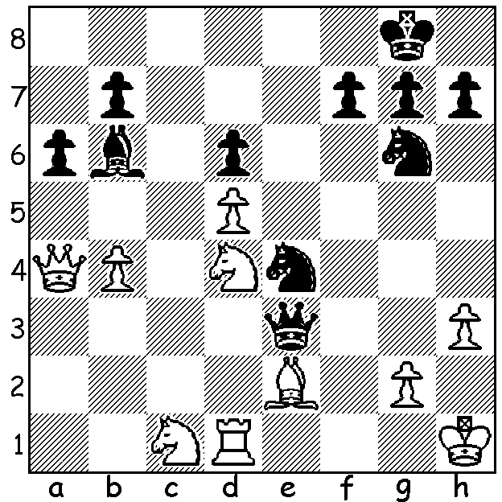

Published analysis of Lautier v Topalov
(1998 Olympiad) gave 25.Qe8+ Nf8 as
losing for White. However Vern Stannard
maintained the check would save White.
Can you see how?

I was saddened to hear this week of the death of Vern Stannard at the age of (I think) 93. Vern's father was an enthusiastic player and Vern learnt the game aged 12. He was at one time ranked in the top 20 players in Australia and for a number of years was a regular prize winner in the WA championship, winning the title in 1959. Health problems as a result of lung disease brought about by his four years service in the RAAF caused him to retire from the game (apart from a brief return in 1992 where he reached 6/7 in the state championship before losing his last two games). However he retained his interest in the game, regularly providing sets of puzzles for the CAWA newsletter. He was also renowned for questioning publicised analysis (see above) and I received a number of communications over the years pointing out errors or suggesting improvements in play in my articles. His ability is clearly seen in the inclusion of one of his games in the very popular 100 Games of Modern Chess by Tartakower & du Mont (1954):

V Stannard - S Nikolenko
1950 WA Championship: French Winawer
1.e4 e6 2.d4 d5 3.Nc3 Bb4
4.e5 c5 5.a3 Bxc3+ 6.bxc3 Ne7
7.Nf3 Nbc6 8.Bd3 c4 9.Be2 Bd7
10.Bd2 Qc7 11.Qc1 0-0-0 12.a4(a) h6(b)
13.Ra2 Kb8 14.Qa1 Qa5 15.0-0 Nc8
16.Rfb1 Nb6(c) 17.Bc1 Ne7 18.Ba3 Nc6
19.Bd6+ Kc8 20.Bb4! Qa6(d) 21.Bc5 Na8
22.a5 Rde8 23.Bd6(e) Nc7 24.Nd2! Nd8
25.Nb3! cxb3(f) 26.Bxa6 bxa2 27.Bxb7+ Nxb7
28.Qxa2 Nxd6 29.exd6 Nb5 30.Qb3 Kb7
31.c4 dxc 32.Qxc4 Rc8 33.Rxb5+ Bxb5
34.Qxb5+ Ka8 35.a6 resigns(g)

a) With his two kingside minor pieces seemingly unable to become active on the queenside, White will need considerable ingenuity to develop an attack against Black's king.
b) 12....f6 to attack White's centre is better.
c) Shielding the b pawn on the half-open b file but depriving the queen of an escape to c7.
d) 20...Nxb5 appears no better.
e) Threat 24.Rb6! axb6 25.axb6 Qxb6 26.Rxa8+ mating.
f) If 25...Qc6 26.Nc5 and White's attack is overwhelming.
g) 35...Rb8 36.Qc6+. The brilliant attacking play by White contrasted sharply with the inept defence of Black, a former WA champion, whose haphazard knight moves contributed substantially to his defeat.


And which showing of 'MAGNUS' are
you going to see at Paradiso, Friday 28
at 1.30pm or Monday 31 (not 30th as I
previously stated) at 6.30pm?

SOLUTION: 28.Qe8+ Nf8 29.Ne6! fxe6
30.dxe6 when Black is forced to play either
30...Qf4 (31.Qf7+ Qxf7 32.exf7+ Kxf7) or
30...Nf2+ (31.Kh2 Qxe6 32.Qxe6 Nxe6
33.Re1) with White better in both variations.

