
Here's a win by world champion Magnus Carlsen
when only 10 years old against Glenn Gaasland in 2001:
Black exploits White's failure to complete his development.

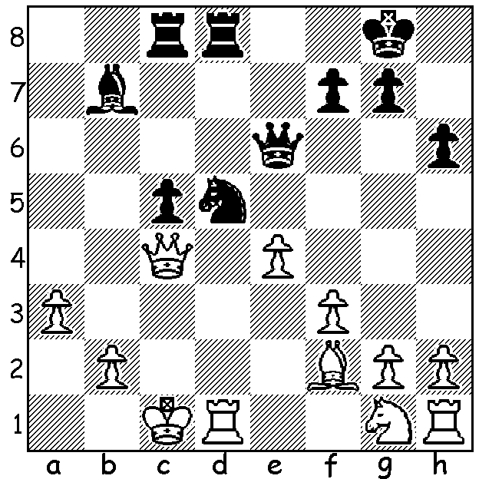

TEMUR KUYBOKAROV is a 17 year old International Master from Uzbekistan who was a joint winner of the Australian Open held in Brisbane in January. Temur became a FIDE Master in 2010 at the Asian Youth Championship (Under 10) and an IM last year. Temur is at present resident in Perth and has played in one state event, the WA Allegro Championship, where he came second to Tristan Boyd. He recently scored 4.5/9 in the Aeroflot Open in Moscow, an event with about 75% of players GMs. He has expressed a willingness to give a Simultaneous Display of up to 30 boards at 2pm on Sunday 13 August at the Rhein Donau Club, the venue where Nigel Short gave his Simul last year. If you would like to pit your wits against one of the world's leading juniors, please contact Yita Choong asap (theknyght@gmail.com).

Temur Kuybokarov - Ahmed Adly
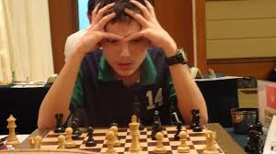
2017 Australian Open, Rd 10
Sicilian Najdorf
1.e4 c5 2.Nf3 d6
3.d4 cxd 4.Nxd4 Nf6
5.Nc3 a6 6.Bg5 Nbd7
7.Qe2 h6 8.Bh4 g6
9.f4 e5 10.fxe dxe
11.0-0-0! Qc7(a) 12.Nb3 b5
13.Kb1 Be7 14.g4 b4
15.Bxf6 Nxf6 16.Nd5 Nxd5
17.exd5 h5 18.gxh5 Rxh5
19.Bg2 Bd6 20.h4 Qe7 21.Na5 Kf8(b)
22.Nc4 Bf5 23.Bf3 Rh6 24.h5(c) e4
25.Bg4 Bxg4 26.Qxg4 f5 27.Rdf1 e3
28.Qe2 f4 29.hxg6 Rxh1 30.Rxh1 Be5
31.d6 Qb7 32.Rh4 Qe4 33.Nxe5 Qxe5
34.Qc4 Ra7 35.Qc8 resigns(d)

a) The acceptance of the sacrifice leads to a speedy loss - 11...exd4? 12.e5! dxc3 13.exf6+ Be7 14.Bg3! cxb+ 15.Kb1 wins (threat 15.Bc7) or 11...g5 12.Bf2 exd4 13.Bxd4 and Black is unable to cope with the threats stemming from e4-5.
b) Not 21...Rxh4 22.Nc6 Qf6 23.Nxe5! Rxh1 24.Nc4+ with a winning attack.
c) White now opens up the kingside to expose Black's king.
d) 35...Kg7 36.Qh8+

The WA CHAMPIONSHIP has been won by Igor Butsenko with 5.5/7 with Derwent Maggs second on 5. The Reserves Championship was won by Craig Kinsman, a former state champion, with 6.5/7, followed by Gordon Dunlop and Alex Janceski on 5.5 while Fred Maris (4/7) gained the Under 1600 rating award and Natalie Taylor the women's title. Some games in forthcoming weeks.

SOLUTION: 1...Ne3! White resigns (2.Bxe3 Qxc4+ or 2.Qxe6 Rxd1# or 2.Rxd8+ Rxd8 3.Qe2 Rd1+). And which showing of 'MAGNUS' are you going to see at Paradiso, tonight, Friday 28 at 1.30pm or Monday 31 (not 30th as I previously stated) at 6.30pm? If Monday please let me know as we might be able to get a group booking (0439798607).

