Ned Tomic – Ihsan Ferozkohi (2017 WA Championship): Black to play and win (5 moves):
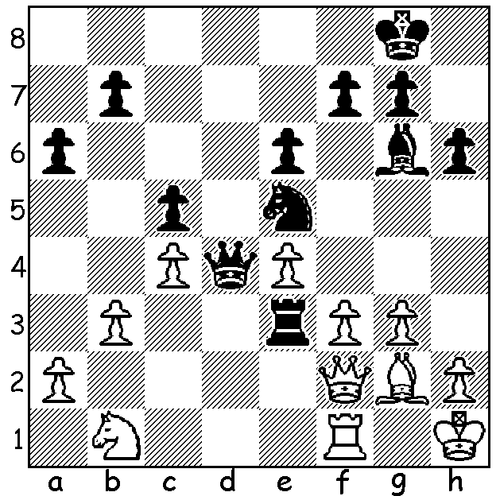

This week very much a local flavour with the puzzle and two short games from this year's state championship, both with successful attacks against the king. Final scores: Igor Butsenko 5.5/7 (+4 =3), Derwent Maggs 5/7 (+5 -2, to Butsenko & Hare), Yita Choong 4.5, champion five of the previous six years, (loss to Maggs), Tim Hare 4.5 (loss to Maris), Andrew Hardegen 3.5, Ihsan Ferokzohi 3, Rob Maris 1, Ned Tomic 1. There were certainly many very interesting games with an exciting finish as surprise leader Maggs lost to 2010 champion Hare, allowing Butsenko to leapfrog into first place.

2017 WA Championship, Round 3
Igor Butsenko - Derwent Maggs
Dutch Defence
1.d4 e6 2.c4 f5 3.Nf3 Nf6
4.g3 d6 5.Bg2 Be7 6.O-O O-O
7.b3 c6 8.Bb2 Qc7 9.Nbd2 Ne4
10.Nxe4 fxe4 11.Ne1 d5 12.f3 exf3
13.Nxf3 Bf6 14.Qc2 Na6 15.e4 Bd7
16.Ba3 Rfe8 17.e5 Be7 18.Bd6!(a) Bxd6
19.exd6 Qxd6 20.Ng5 g6 21.Nxh7! Re7
22.Qxg6+ Rg7 23.Nf6+ resigns

a) A fine pawn sacrifice to give the knight access to g5: 18...Qd8 would prevent this but Black's position is bleak.

2017 WA Championship, Round 4
Ihsan Ferozhohi - Robert Maris
Nimzoindian Defence
1.d4 Nf6 2.c4 e6 3.Nc3 Bb4
4.Nf3 b6 5.Bg5 Bb7 6.e3 h6
7.Bh4 O-O 8.Bd3 d5 9.Ne5 dxc4
10.Bxc4 g5 11.Bg3 Bxg2(b) 12.Rg1 Bd5
13.Bd3 Ne4 14.Bxe4 Bxe4 15.Qh5 Qf6
16.Bf4 Bg6 17.Qxh6 Rc8 18.Nxg6 Bf8
19.Ne7+ resigns

b) This allows White to quickly build up a winning attack against Black's castled king.

JUNIOR CHESS: The recent Primary Schools Championship finals have been won by Mount Lawley Primary who defeated Deanmore Primary and Anzac Tce Primary. Congratulations to all teams and especially Mt Lawley's team of Ethan Richards, Minh Nguyen (both 100% in all games), David Richards & Zachary Pendragon. Mt Lawley will be travelling to Sydney in December to take part in the national championships. I have been tardy in reporting on the WA Primary Schools individual championships held in April at Leeming
Primary where 57 youngsters competed enthusiastically. Winner was Pranav Senthil Kumar (9/9) with Kundan
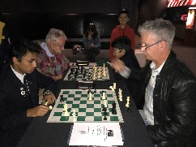
Dharmapuri (8/9) runner-up.

The LOFTUS COMMUNITY CENTRE CHESS CLUB
which has been catering for mainly inexperienced players
and beginners on Thursdays 9-1 is now in addition planning
to open on Mondays 11-3 for rather more experienced and
serious players (particulary Seniors). Info Martin Curtis
92710605 or 0424746607.

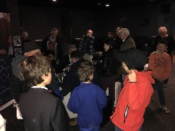
Those who went to the film MAGNUS on Monday
evening were given a fascinating insight into the character
and development of world champion Magnus Carlsen
from his earliest years to his winning of the title in
Chennai against Vishy Anand. Thanks to Cinema Paradiso
for enabling CAWA to put on an hour's diplay of Blitz
Chess in the foyer before the film and for providing a
number of free tickets for members. Blitz participants
Alan Wolstencroft, Gordon Dunlop and juniors Ben
Hurst, Sri Krishnan and Kundan Dharmapuri offered
intriguing interest to film goers. It was pleasing to see
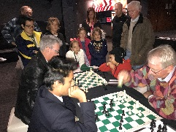
the showing well supported despite the atrocious weather
and to see a number of no longer active players attending,
especially Graham Bell with whom I locked horns a number
of times in the 70s.

SOLUTION: 1...Nxf3! & if 2.Bxf3 Rxf3 3.Qxd4 (3.Qxf3?
Bxe4) 3...Rxf1+ 4.Kg2 cxd4 5.Kxf1 Bxe4 and with 2 extra
pawns Black has an easy win.

