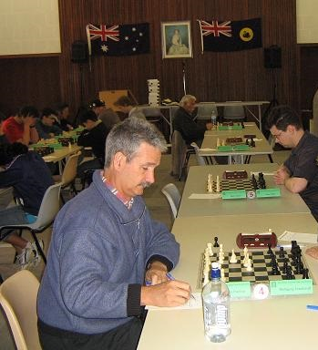
Lennard Mechlowski - Gordon Dunlop
(2017 WA Reserves):
Black finishes off smartly:
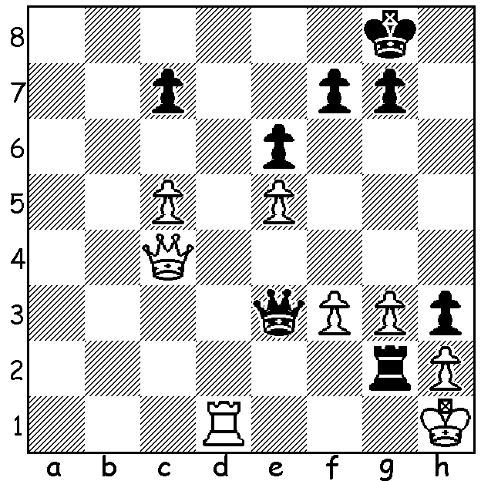

Gordon Dunlop

After last week's report on the 2017 WA Chanpionship, won by Igor Butsenko, we move to the Reserves championship. Winner was Craig Kinsman with 6.5/7, followed by many times Reserves winner Gordon Dunlop (+2 =5) and Alex Janeski (+3 =3 -1) with 4.5. Craig was WA Champion in 1984 and, after an absence of a number of years from the game, returned to chess last year and is clearly regaining his undoubted flair.

Craig Kinsman - Brian Gale
2017 WA Reserves Chess Championship, Round 1
Caro-Kann Defence
1.e4 c6 2.d4 d5
3.Nc3 g6 4.e5 Bg7
5.Be3 h5 6.Qd2 Nh6
7.0-0-0 Nd7 8.Bd3 e6
9.Kb1 b5 10.Nf3 Nb6
11.Bg5 Qc7 12.Qf4 Ng4
13. Nh4 Bh6 14.Bxh6 Nxh6
15.Nxg6! fxg6 16.Bxg6+ Nf7
17.Rd3 Qe7 18.Rf3 Rf8
19.h4 Bd7 20.Rhh3 Kd8
21.Bxh5 Kc7 22.Qf6 Qxf6
23.Rxf6 Nh8 24.Rhf3 Rxf6
25.exf6 Nc4 26.Kc1 Nd6
27.g4 Be8 28.Bxe8 Rxe8
29.Ne2 Rf8 30.Nf4 Kd7
31.Nd3 Ndf7 32.g5 Ng6
33.Rh3 Rh8 34.h5! Nxg5
35.hxg6 Rxh3 36.Ne5+ Ke8
37.b3 Rh8 38.f4 Nh7
39 g7 Rf8 40.f7+! Ke7
41.g8=Q resigns

Alex Janceski - Natalie Maris
2017 WA Reserves Chess Championship, Round 2
Queens Gambit Declined
1.d4 Nf6 2.c4 e6
3.a3 b6 4.Nc3 d5
5.Bg5 Be7 6.e3 Nbd7
7.Nf3 O-O 8.b4 c6
9.Qc2 dxc4 10.Bxc4 h6
11.Bf4 Bb7 12.Rd1 b5
13.Ba2 a5 14.Bb1 Re8
15.Ne5 axb4 16.axb4 Bxb4
17.O-O Bxc3 18.Nxd7 Qxd7
19.Qxc3 Nd5 20.Qc2 Nxf4?
21.Qh7+ Kf8 22.exf4 f5
23.Qg6 Qd5 24.Rfe1 Ra4
25.Re5 Qb3 26.Rde1 Rxd4
27.Rxf5+! Ke7 28.Qxg7+ Kd6
29.Qxd4+ Kc7 30.Rf7+ resigns

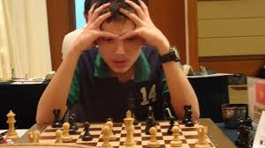
Have you enrolled to play teenage sensation
Temur Kuybokarov, joint winner of the 2017
Australian Open, in a Simul this coming
Sunday 13 August at the Rhein-Donau Club,
N Lake Rd, at 2pm? Entry to Yita Choong,
theknyght@gmail.com

The following weekend, 19 & 20 August, the
Willetton Open (WA GP) will be played at
Leeming Primary. Entries to me
(ellisd19@bigpond.com or 0439798607) Temur Kuybokarov

Details of all events cawa.org.au

SOLUTION: 1...Rg1+! (clearance sacrifice) White resigns (2.Rxg1 Qxf3+ 3.Rg2 Qxg2#).

