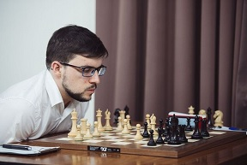
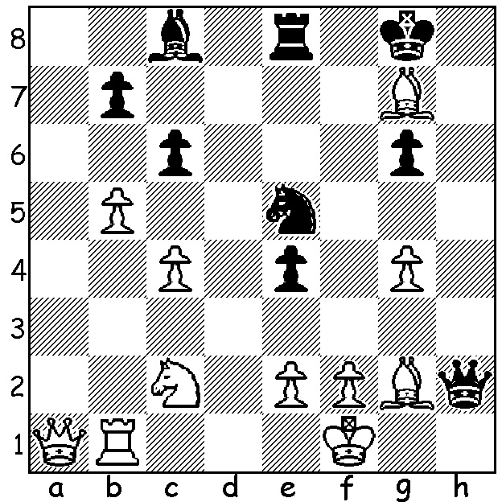
Alberto David vs Maxime MVL at the Sinquefield
Vachier-Lagrave 2014:
Black to play and win (5 moves):

The recently completed Sinquefield Cup, played in St Louis, featured 10 of the top players in the world with prize money of US$300,000 and points going towards the Grand Chess Tour. The winner was expected to come from world champion Magnus Carlsen, Wesley So, Fabiano Caruana, Maxime Vachier-Lagrave and Levon Aronian. Early rounds saw MVL defeat both Carlsen and So to take the lead while in Round 5, after four successive draws, former world champion Vishy Anand came into contention with the following sparkling win:

Viswanathan Anand - Fabiano Caruana
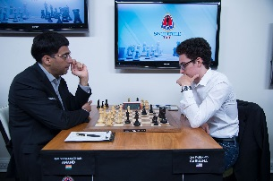
2017 Sinquefield Cup, Rd 5
English Four Knights
1.c4 e5 2.Nc3 Nf6
3.Nf3 Nc6 4.g3 d5
5.cxd Nxd5 6.Bg2 Bc5
7.0-0(a) 0-0 8.d3 Bb6
9.Bd2 Bg4 10.Rc1(b) Nxc3
11.Bxc3 Re8 12.b4 Qd6
13.Nd2(c) Qh6 14.Nc4 Qh5
15.Rc2 Rad8 16.Nxb6 cxb6
17.f3(d) Be6 18.Qd2 b5(e)
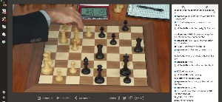
19.f4 Bg4(f) 20.Bxc6! bxc6
21.fxe f6(g) 22.exf6!! Rxe2
23.f7+ Kf8 24.Bxg7+! Kxg7
25.Qc3+ Re5(h) 26.Qd4!! Qg5(i)
27.Rc5 Rxd4(j) 28.f8=Q+ Kg7
29.Qf7+ resigns
……………………………………………………………..Vishy makes his brilliant queen sacrifice

a) Inadvisable is 7.Nxe5 Nxc3 8.Bxc6+ (8.bxc3 Nxe5 9.d4 Bd6) 8...bxc6 9.bxc3 Qd5 10.Nf3 Bh3.
b) Again 10.Nxe5 does not work – 10...Nxc3 11.Bxc3 Nxe5 12.Bxe5 Re8.
c) Not 13.h3? Bxf3 14.Bxf3 e4! & 15... Qxg3(+).
d) An ugly defensive move to make leaving a gaping hole on e3.
e) Better 18...Nd4 or 18...h6.
f) If 19...Bh3 20.Bxh3 Qxh3 21 fxe Nxe5 22.Bxe5 Rxe5 23.Rc7 winning.
g) Black had banked on this move to solve his problems.
h) If 25...Qe5 26.Rxe2! Qxc3 27.Re8 Qd4+ 28.Rf2 Qxb4 29.f8=Q+ Qxf8 30.Rfxf8 Rxd3 31.Rg8+ Kf7 32.Ref8+ Ke7 33.Ra8.
i) If 26...Rxd4 27.f8=Q+ Kg6 28.Qf6#.
j) If 27...Qe3+ 28.Qxe3 Rxe3 29.Rg4+ wins

The Willetton Open (WA Grand Prix) will be played at Leeming Primary this weekend, Sat 19 & Sun 20 August, (10.30am – 5.45pm). Further details cawa.org.au and entries to me, ellisd19@bigpond.com or 043979860.

SOLUTION: 1...Nf3! (threat of mate forcing opening of e file) 2.exf3 exf3 3.Bxf3 Bxg4! (deflection) 4.Bxg4 Qh1# or 4.Ne1 Bh3+ 5.B/Ng2 Qh1#.

