Maxime Vachier-Lagrave v Peter Svidler
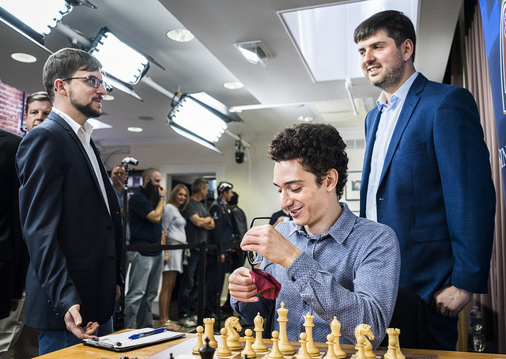
(Sinquefield 2017): a pawn up, White now
errs with 1.Kh2? allowing Black to gain a
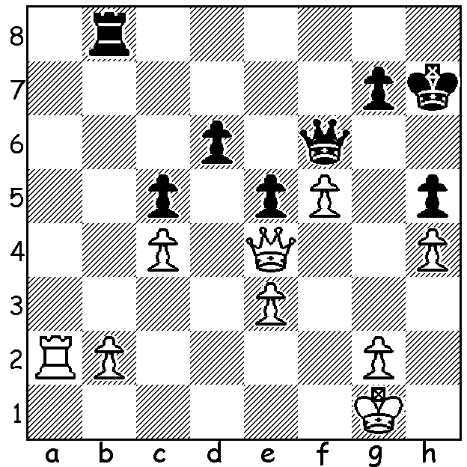
quick draw:

MVL & Peter Svidler before game
(Fabiano Caruana seated)

Last week I reported on the first half of the Sinquefield Cup, played in St Louis. After five rounds Maxime Vachier-Lagrave led with 3.5, followed closely by world champion Magnus Carlsen and his predecessor Vishy Anand. After 8 rounds five of the ten contestants were still in the running, MVL, Levon Aronian and Anand, all on 5, and Carlsen and Sergey Karjakin on 4.5. In the final round Anand could do no more than draw with back marker Wesley So while Aronian lost to Carlsen, leaving MVL, who defeated Ian Nepomniachtchi, clear winner with 6/9 (+3 =6). Equal second were Anand (+2 =7) and Carlsen (+3 =5 -1) with 5.5, followed by Karjakin and Aronian (5), Peter Svidler (4.5), Fabiano Caruana (4), Hikaru Nakamura (3.5 – the only player not to win a game), Nepomniachtchi and So (3). Here's the final round MVL win, a classic example of play with knight against 'bad' bishop:

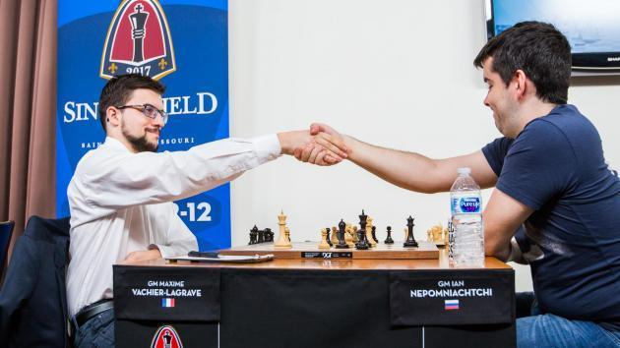
Maxime Vachier-Lagrave v Ian Nepomniachtchi
2017 Sinquefield Cup, Rd 9
Sicilian Najdorf
1.e4 c5 2.Nf3 d6
3.d4 cxd 4.Nxd4 Nf6
5.Nc3 a6 6.Be2 e5
7.Nf3 Be7 8.Bg5 Nbd7
9.a4 0-0(a) 10.Nd2 Nc5(b)
11.Bxf6 Bxf6 12.Nc4 Be7
13.a5 Rb8 14.Nb6 Nd7
15.Ncd5 Nxb6 16.Nxb6 Be6 MVL v Ian Nepomniachtchi
17.Bc4 Qc7 18.Qd3(c) Bd8 19.c3 Qc6(d)
20.Bd5! Qe8 21.Bxe6 Qxe6(e) 22.Nd5 f5
23.0-0 Rc8 24.Rfd1 fxe 25.Qxe4 Qf5
26.Qe2(f) Kh8 27.c4 Bh4 28.g3 Bg5
29.Ra3 Rce8 30.h4 Bd8 31.b4 Qg6
32.h5 Qf5 33.Ne3 Qe6 34.Rad3 Be7
35.Nd5 Bd8 36.Rf3 Rxf3 37.Qxf3 Kg8
38.Kg2 e4 39.Qe2 Qe5 40.Ne3 Bg5?(g)
41.Rd5 Qf6 42.Nf5 Re6 43.c5! dxc
44.Qc4! Qf7 45.Rxc5 h6(h) 46.Rc8+ Kh7
47.g4 Re7 48.Qd4(i) Re6 49.Qd5 g6(j)
50.hxg+ Kxg6 51.Rf8! Qxf8 52.Qxe6+ resigns(k)

a) 9...b6 was very playable, avoiding the hole that White will occupy.
b) Black could get rid of his backward d pawn with 10...d5 - 11.exd Nxd5! 12.Bxe7 (12.Nxd5 Bxg4 13.Ne4 Nf6!) 12...Nxe7 13.Nc4 Nc6.
c) 18.Bxe6 would be wrong, as 18...fxe6 prevents White from placing his knight on d5.
d) 19...Qe7 is preferable when 20.Nd5 Bxd5 21.Bxd5 leaves White somewhat better but gives Black the option of passive defence or sacrificing for counter play with 21...b6!? 22.axb Bxb6 23.Qxa6 Bxf2+! 24.Kxf2 Rxb2+ 25.Ke1 Qg5 26.Qd3 Qxg2 27.Rf1 (threat 28.Rxf7!) with chances for both sides.
e) 21...Bxb6 22.Bd5 is also unpleasant for Black as White has the much stronger (active) bishop.
f) Exchanging leaves White much the better ending but keeping queens on enables White to build pressure on all areas of the board.
g) 40...Qe6 prolongs the struggle.
h) Not 45...Re8? 46.Qxf7+ Kxf7 47.Nd6+.
i) 48.Nxe7? allows a perpetual with 48...Qf3+.
j) If 49...Re7 50.Qd8 wins.
k) Black loses a host of pawns.

SOLUTION: 1...d5! 2.Qxd5 (2.cxd5 Rb4) 2...Qxh4+ and draws by perpetual check.

