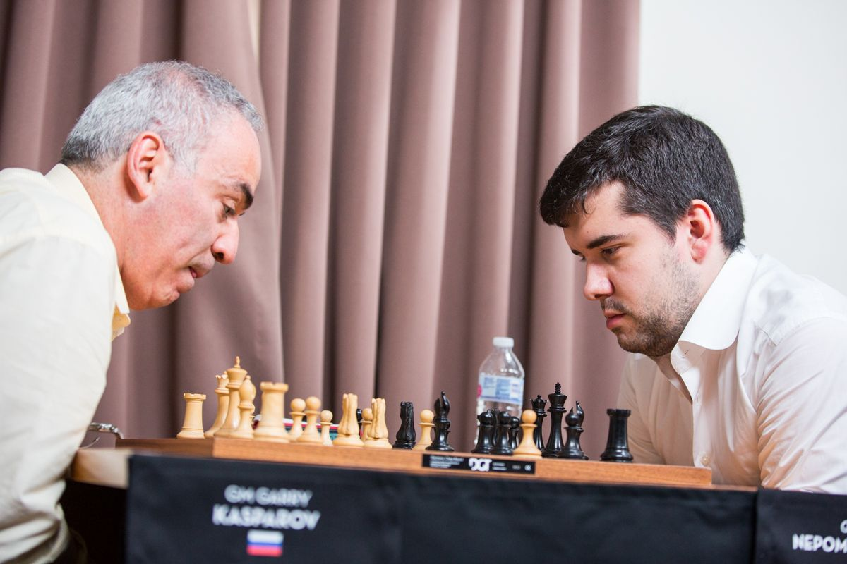
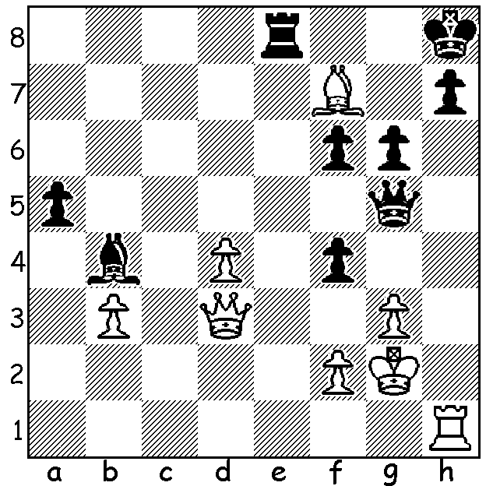

Gary Kasparov – Ian Nepomniachtchi (St Louis Rapidplay 2017):
White seems to be pressing, threatening both the rook and the g pawn but Black finds a stunning move to win (4 moves):

It is well over 11 years since the great Gary Kasparov played a rated game but last month saw him back at the board in a one-off as a wild card in the St Louis Rapid and Blitz tournament which followed the Sinquefield Cup. Time limits were 25min + 10 sec increments in Rapidplay and 5min with 3sec delay in Blitz. The field contained many of the top players, excluding world champion Magnus Carlsen and Sinquefield winner Maxin Vachier-Lagrave, who were both ineligible, having already played their allowed two rapid/blitz tournaments. Kasparov scored five successive rapidplay draws before losing to leader Ian Nepomniachtchi (see above) and on the final day lost two and won one, giving him 7/18 (win = 2pts, draw = 1pt) leaving him =8/10th in the ten player event. He improved in the Blitz winning 4, drawing 10 and losing 4, placing him 5th with 9/18 and overall 8th with 16/36. He would have surprised everyone in Rd 1 of the Blitz against Sergey Karjakin by played the Kings Gambit, and not just a normal line but the all but defunct Steinitz Gambit (1.e4 e5 2.f4 exf 3.Nc3 Qh4+ 4.Ke2) – the game was drawn. Although out of practice he certainly showed he could mix it with the big boys of today and it is thought his score could have been much higher but for atrocious clock management. Today's game is a might-have-been for Kasparov, losing a game he was clearly winning but containing an amazing calculation by his opponent to win the game:

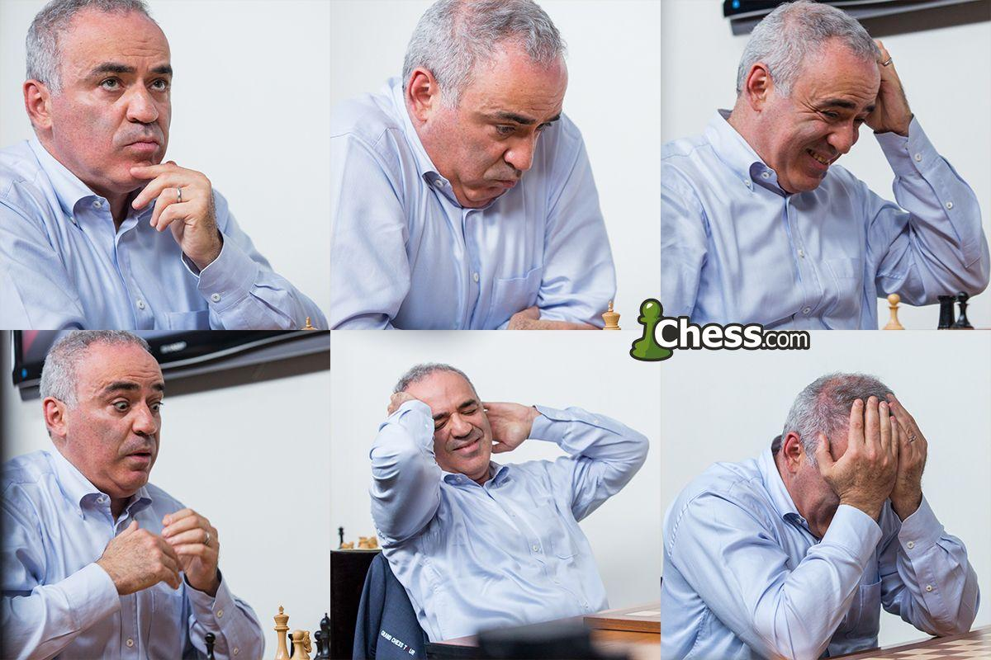
Gary Kasparov has never been one to hide his emotions at the board

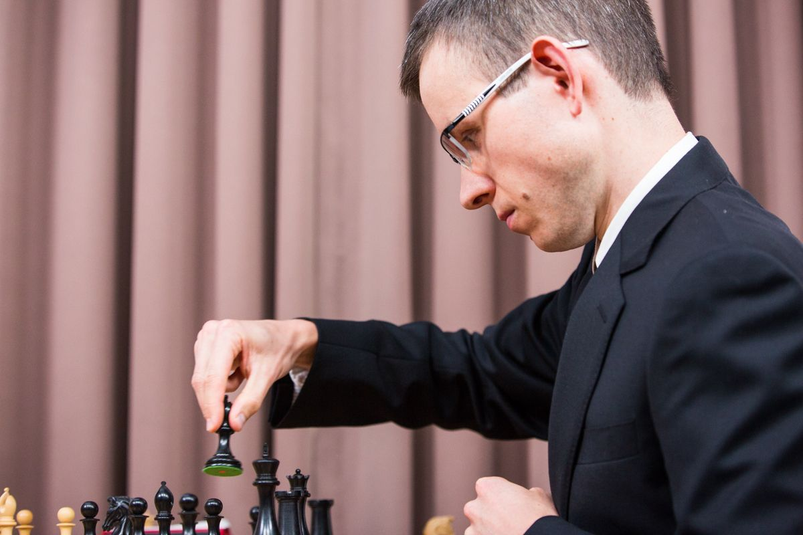
Gary Kasparov - David Navara
2017 St Louis Rapidplay
Caro-Kann, Advance Variation
1.e4 c6 2.d4 d5
3.e5 Bf5 4.Nc3 e6
5.g4 Bg6 6.Nge2 c5
7.Be3 Ne7 8.f4 h5
9.f5! exf 10.g5 Nbc6
11.Nf4 a6 12.Bg2 cxd
13.Bxd4 Nxd4 14.Qxd4 Nc6
15.Qf2 Bb4 16.0-0-0 Bxc3
17.bxc3 Qa5 18.Rxd5 Qxc3 David Navara
19.Qc5 Qxc5 20.Rxc5 0-0 21.Bxc6 bxc6
22.Rd1 Rab8 23.c4!(a) Rfd8 24.Rd6 Kf8
25.Rcxc6 Rdc8 26.Kc2 h4 27.Rxc8+ Rxc8
28.Kc3 a5 29.Ra6 Rb8 30.Rxa5 Rb1
31.c5 Re1 32.Ra8+ Ke7 33.Ra7+ Ke8
34.Nd3(b) Re3 35.Kd2 Rh3 36.c6 Rxh2+
37.Ke3?(c) Rc2 38.e6 h3 39.Nb4 f4+!
40.Kd4 h2 41.Ra8+ Ke7 42.Rh8 Rd2+(d)
43.Kc5 Be4 44.c7 Bb7 45.Kb6 Bc8
46.Rxc8! h1=Q 47.Re8+ Kxe8 48.c8=Q+ Ke7
49.Nc6+?(e) Qxc6+!! 50.Qxc6 Rd6 White resigns

a) Preventing 23...Rb5 & an attack on his dominating knight with 23...Rb4.
b) White is winning but more forceful was 34.e6.
c) Giving Black chances: better 37.Kc3 preventing ...Rc2 and if 37...Kd8 38.e6! fxe 39.Nf4.
d) Navarara said he'd already seen the trap White falls into on move 49.
e) White believes he's mating.

SOLUTION: 1...Re3!! 2.exf3 (the rook must be taken) Qxg3+ 3.Kf1 f3 & with mates threatened on g2 and e1 White resigns (his only defence 4.Rxh7! Kxh7 5.Qxg6+ Qxg6 6.Bxg6+ Kxg6 leaves him a piece down).

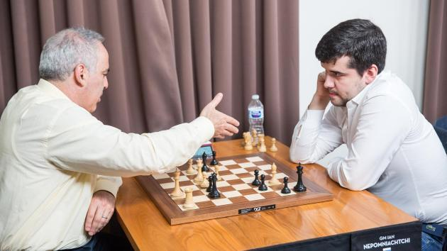

Kasparov resigning v Nepomniachtchi

