Levon Aronian – Ibragim Khamrakulov 1992: White to play and win (3 moves):
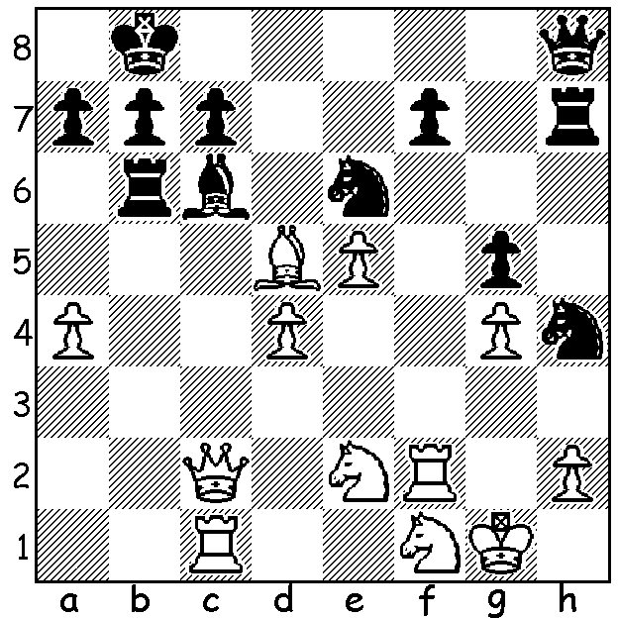
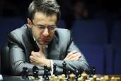

Last week the spotlight was on Gary Kasparov and his one-off return to chess at the St Louis Rapidplay and Blitz tournament. Winner of the event was Levon Aronian, the 34 year old Armenian GM. Aronian, who reached second in world ratings in 2014, has had a distinguished career, winning a host of major tournaments. At St Louis, after the Rapid (double points), Aronian led with 12/18 (+5 =2 -2), a half point ahead of Hikaru Nakamura and Fabiano Caruana and in the Blitz he survived a run of eight wins from nine games from Sergey Karjakin, and, although trailing Karjakin 12.5 to 13.5 at the end of the Blitz, won the event with a combined total of 24.5/36, comfortably ahead of Nakamura and Karjakin (21.5). Aronian will return later to Armenia to marry his partner of eight years Philippine born Australian WIM Arianne Caoili in October.
Other scores: Ian Nepomniachtchi 20, Leiner Dominguez Perez, Caruana & Le Quang Liem 16.5, Kasparov 16, Vishy Anand 14, David Navara 13. Here's Aronian getting off to a good start in the Rapidplay:


Levon Aronian - David Navara
2017 St Louis Rapidplay, Rd 1
Queens Indian Defence
1.d4 Nf6 2.c4 e6
3.Nf3 b6 4.g3 Ba6
5.b3 Bb4+ 6.Bd2 Be7
7.Nc3 0-0 8.Bg2 d5
9.cxd exd 10.0-0 Re8
11.Ne5 Bb7 12.Qc2 c5
13.dxc bxc 14.Rad1 Qc8 Aronian & Arianne Caoili
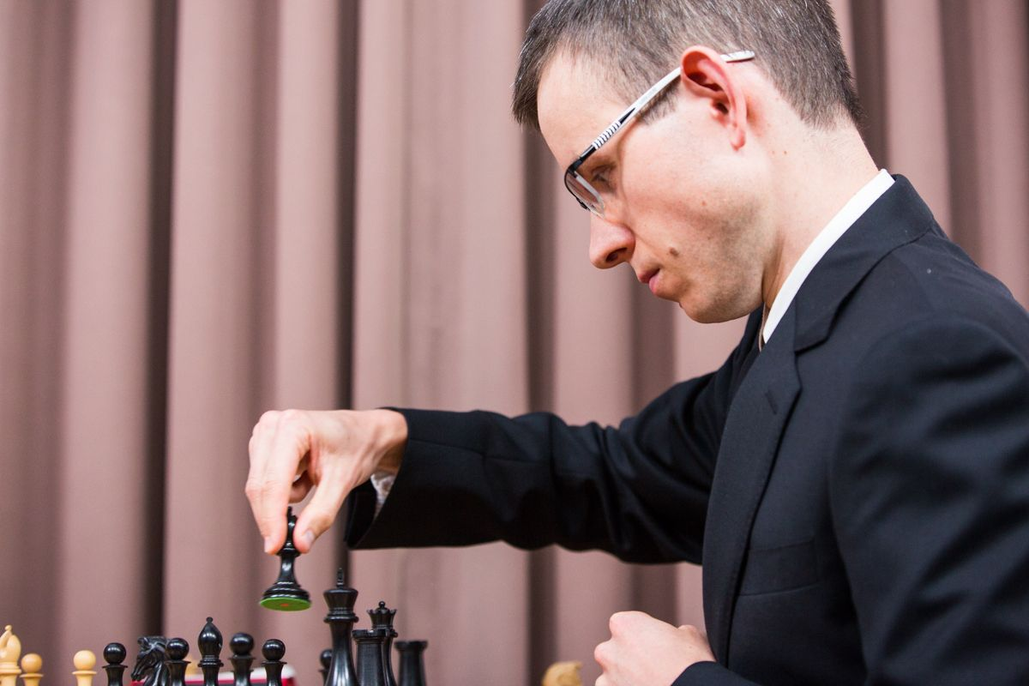
15.e4 Bf8 16.f4 d4
17.Nd5 Nxd5 18.exd5 f6
19.Rde1! fxe5 20.fxe5 Nd7
21.e6 Nf6 22.Rxf6! gxf6
23.Qf5 Qd8?(a) 24.Re4 Re7
25.Rg4+ Kh8 26.Be4 Rc8
27.Rh4 Kg8 28.Rxh7 Bxd5
29.Qg6+ Rg7 30.Qh5 Bxe4
31.Rh8#

a) A very difficult position to defend. 23...Qc7 was David Navara
the only move – 24.Re4 h5!

WA NEWS:

17 year old IM Temur Kuybokarov went through undefeated in his Simultaneous Display, at the Rhein Donau Centre, winning 20 games and drawing against Yita Choong, Andrew Hardegen & Peter de Yaak.

The Willetton Open was won by Patrick Gong (5.5/6), followed by Adam Kelly & Kathryn Hardegen (4.5). Brent Geronimo (4.5) took out the first Under 1850 award and Sebastian Vearncombe (3) was first among the Under 1200 grouping. All three top awards went to juniors with 12 year old Brent, who with his younger brother Harry has recently come to Perth from the Philippines, in particular having an outstanding tournament.

SOLUTION: 1.Bxe6 (opening the f file) 1...exf6 (if 1...Nf3+ 2.Rxf3 Bxf3 3.Qxc7+ Ka8 4.Qc8+) 2.Qxh7! Qxh7 3.Rf8+ mating.

