Vachier-Lagrave v Svidler (World Cup 2017):
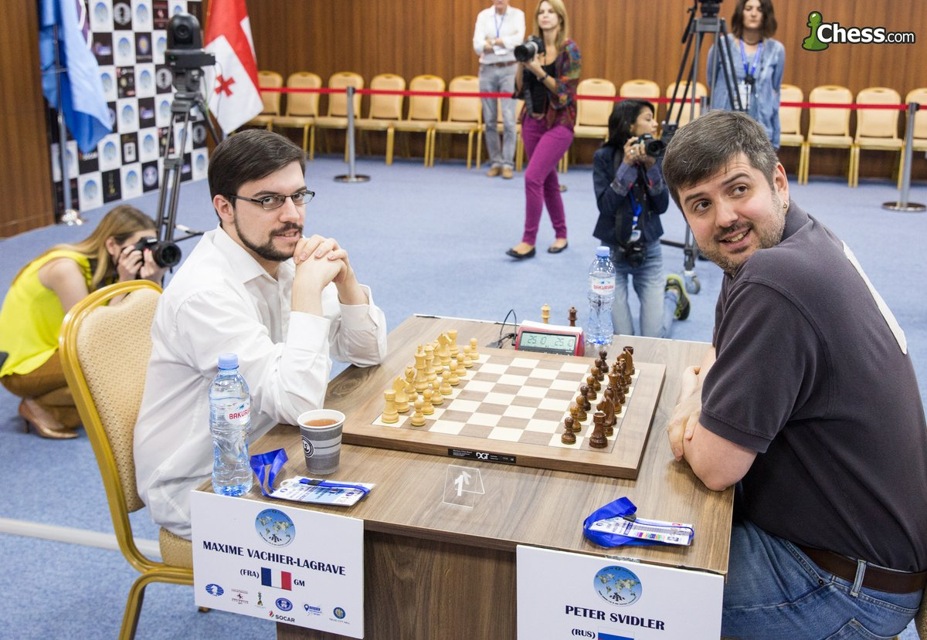
White is pressing but Black finds
an easy draw (3 moves):
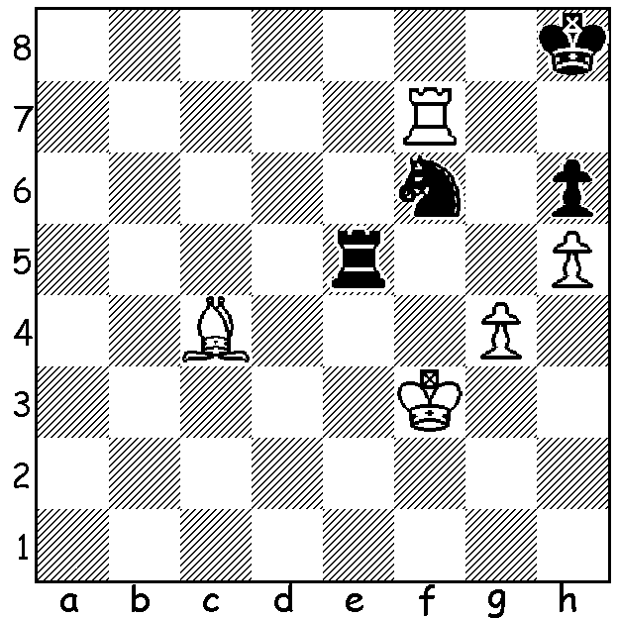

The World Cup (3 – 27 Sept), being played in Tiblisi, Georgia, is a 128 player Knock Out (2 games Classic followed by – if necessary – 2 Rapidplay and then pairs of Blitz games). The tournament naturally contained many surprise results but at the Semi Final stage all four survivors are among the world's 14 top rated players. In Round 2 Shakhriyar Mamedyrov (world no 6) and ex-world champion Vishy Anand (world no 9) were eliminated. In Rd 3 another ex-world champion Vladimir Kramnik (world no 5) met the same fate, as did Hikaru Nakamura (no 10) and Fabiano Caruana (no 4) and, in the surprise of the event, world champion Magnus Carlsen (no 1) also went out as did Carlsen's last challenger Sergey Karjakin (no 11). In Rd 4 Anish Giri (no 12) lost to the erratic veteran Vassily Ivanchuk and Alexander Grischuk (no 8) to Maxime Vachier-Lagrave (no 3). In Rd 5 MVL went through defeating Peter Svidler (no 14), a previous winner, losing finalist last year and seven times Russian champion, 2.5 – 1.5, while Levon Aronian (no 2) defeated Ivanchuk 1.5 – 0.5 to join Wesley So (no 7) and Ding Liren (no 13). Here is Carlsen's surprising loss after winning his first four games (Bu comfortably drew the second game):

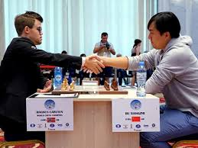
Magnus Carlsen - Bu Xiangzhi
2017 World Cup, Rd 3, Game 1
Bishops Opening
1.e4 e5 2.Bc4 Nf6
3.d3 Nc6 4.Nf3 Be7
5.0-0 0-0 6.Bb3(a) d6
7.c3 Be6 8.Re1 Qd7
9.Nbd2 Rab8 10.Bc2 d5(b)
11.h3(c) h6 12.exd Nxd5
13.Nxe5 Nxe5 14.Rxe5 Bd6
15.Re1(d) Bxh3! 16.gxh3 Qxh3
17.Nf1(e) Rbe8 18.d4(f) f5!
19.Bb3(g) c6 20.f4 Kh7 21.Bxd5?(h) cxd5
22.Re3 Rxe3 23.Bxe3 g5! 24.Kf2(i) gxf
25.Qf3(j) fxe3+ 26.Nxe3 Qh2+ 27.Kf1 Rg8
28.Qxf5+ Rg6 29.Ke1 h5(k) 30.Kd1(l) Kh6
31.Nc2 h4 32.Ne1 h3 33.Nf3 Qg2
34.Ne1 Qg4+ 35.Qxg4 Rxg4 36.Nf3 Rg1+!
37.Nxg1 h2 White resigns.

a) Prophylaxis against 6...d5.
b) Offering the e pawn.
c) White declines for now & threatens 12.Ng5.
d) Better 15.Re4 allowing a later Nf3 / Rh4 making Black's piece sacrifice unsound. Black would choose between 15...Nf6 & 15...f5.
e) 17.Qf3 would draw but White plays for a win
f) Planning Be4, Bg2. Bu thought 18.Bd2 was best (18...g5 19.Rxe8 Rxe8 20.d4 c6 21.c4 Nf6 22.Be3 Ng4 23.Bf5 Bh2+ drawing is a possible continuation).
g) 19.f4 Bxf4 20.Bb3 Bh2+! would also lead to a perpetual.
h) An inaccuracy in increasing time trouble: 21.Re2! was best (21...Nxf4 22.Rh2 forcing queen exchange).
i) If 24.fxg f4 25.Bf2? (25.Qc2+ Rf5! 26.Bxf4 returning piece was better) 25...f3 winning.
j) If 25.Bd2 Qh4+ 26.Ke2 f3+! 27.Kxf3 Rg8 mates.
k) 29...Kg7 escaping the pin would win.
l) 30.Rd1 gave White chances.

SOLUTION: 1...Nxg4! 2.Kxg4 Re4+ 3.Rf4 Rxf4 4.Kxf4 and White, with wrong bishop, cannot promote even if he wins Black's pawn.

