In the World Cup Semi Final the Aronian – MVL match went to a decisive Armageddon Game after eight games failed to split the two contestants (1 win each and 6 draws). MVL won the toss and chose Black (Black 4min + 3sec, White 5min + 3sec), thus needing only a draw to go through to the final. Here is a position from the game: what is Black's best move?
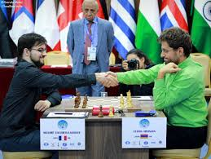
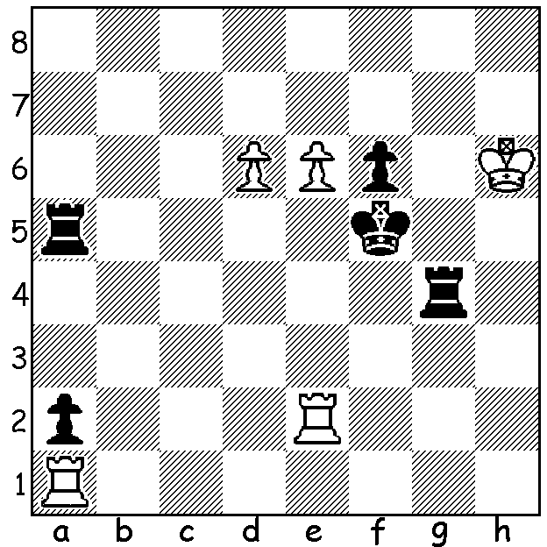

MVL (Black) v Aronian

In Game 4 (Rapidplay) Aronian, a game behind, essayed a speculative piece sacrifice to avoid elimination:

Levon Aronian - Maxime Vachier-Lagrave
2017 World Cup, Semi Final, Game 4
Benoni Defence
1.d4 Nf6 2.c4 g6
3.f3 c5 4.d5 d6
5.Nc3 e6 6.e4 Bg7
7.Nge2 0-0 8.Ng3 a6
9.a4 h5 10.Bg5 Qc7
11.Qd2 exd 12.cxd Nh7
13.Bh6 h4 14.Bxg7 Kxg7
15.Bc4!? hxg3 16.hxg3 Rh8
17.e5 Qe7 18.0-0-0 Nd7
19.exd Qxd6 20.Ne4 Qe5
21.d6 g5 22.Rhe1(a) b5
23.Bd5 Rb8(b) 24.f4 Qd4?(c)
25.Qe2 Qb4 26.Qh5 resigns(d)

a) 22.Rde1 appears more logical, keeping one rook on the open h file.
b) Hoping for an attack on the b file but better was 23...Ra7 giving latent protection to f7.
c) The decisive error: both 24...Qd4 & 24...gxf 25.gxf5 Qh5 gave Black good chances of drawing or even winning.
d) 26...Rf8 27.Rh1.

In the other Semi Final Wesley So was elimated by Ding Loren who won Game 5 in their encounter (the other 5 games were drawn). In Game 1 So missed a chance to go ahead.

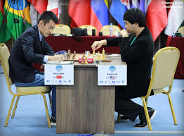
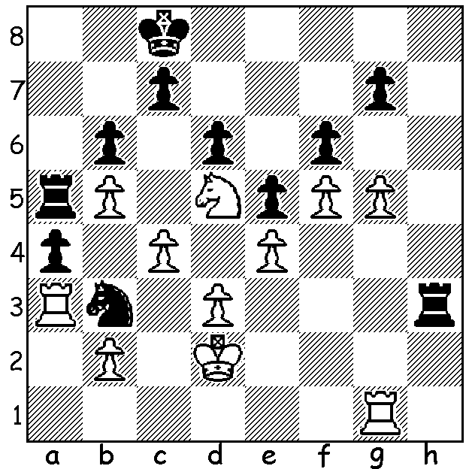
Ding (Black) v So

After a short thought So rejected 1.Rxb3! which should have won. Computer analysis gives 1...axb3 2.gxf gxf 3.Kc3 (So thought this too slow analysing 3.Rg7 Rh2+ 4.Kc3 Ra2 5.Rxc7+, and now not So's 5....Kb8 but 5...Kd8 keeping away from White's king when after 6.Rc6 Raxb2! 7.Rxd6+ Ke8 8.Re6+ Kf7 9.Rxf6+ Kg7 10.Rxb6 Rb1 11.Kb4 b2 12.Rg6+ Kf7 13.Rf6+ Kg7 14.Rg6+ White must take the perpetual) 3....Rh7 4.Nxf6 Rf7 5.Nd5 Ra8 6.Kxb3 Kd7 7.Kc3 Rh8 8.Ra1 Rhh7 9.Ra7 Kd8 10.Nb4 Ke8 11.Ra8+ Ke7 12.b3 Rhg7 13.Ra7 Kd7 14.Nd5 Ke8 15.f6 Rh7 16.b4 Kd8 17.c5! & White can win by infiltrating with his king. The game concluded 1.Kc3 Nd4 2.gxf Rh2 3.Nxb6+ cxb6 4.fxg Rc2+ 5.Kb4 Rxb2+ 6.Kc3 Rc2+ 7.Kb4 Rb2+ draw.

The WA Junior Championships will be played Mon 2 to Fr 6 October at Leeming Primary. Details and Entry cawa.org.au (Information/Calendar). Enter ASAP.

SOLUTION: 1...Raa4 with mating threats should draw and send MVL into the final (2.e7?/d7? Rh4+ 3.Kg7 Rag4+ 4.Kf8 Rh8+ 5.Kg7 Rg7# or 2.Rf1+ Rgf4 3.Rxf4+ Rxf4 4.Re1 a1=Q! 5.Rxa1 Kxe6). Instead Black played 1...Ra8? & lost after 2.Rf1+ Rf4 3.Rxf4+ Kxf4 4.Rxa2! Rxa2 5.e7 winning with queen v rook.

