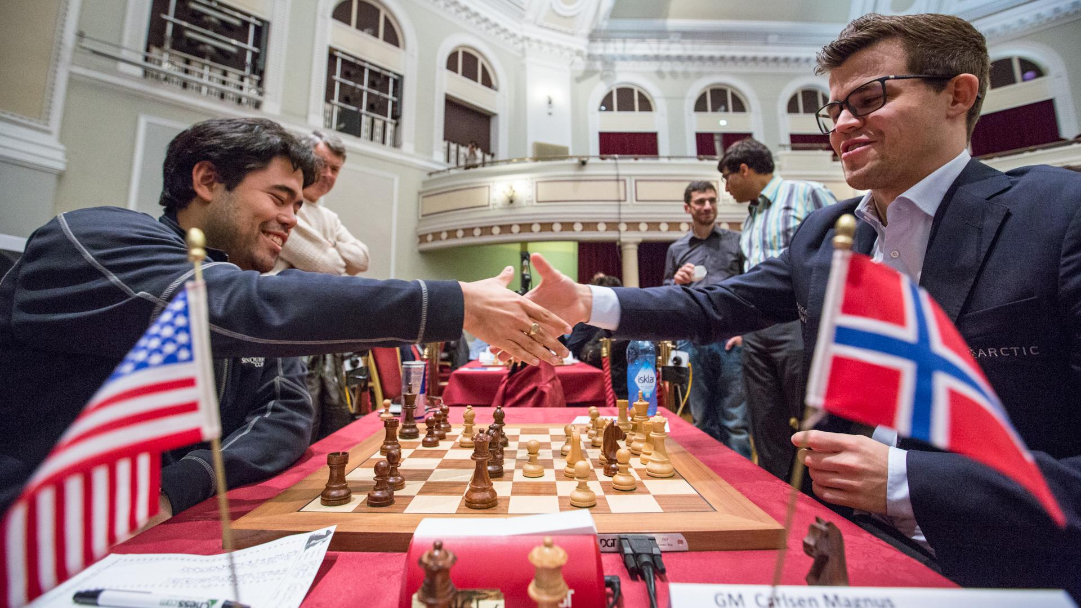
Hikaru Nakamura (Black v Neelatpal Das)
has sacrificed two pawns to reach this position:
how does he now win (3 moves)?
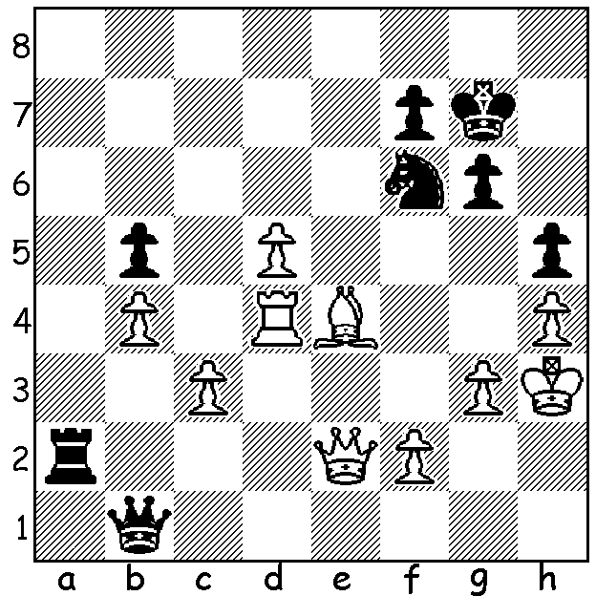

Isle of Man final round: Carlsen has steered
Nakamura into a position where Black has to take a repetition to avoid loss

The World Cup, a 128 player Knock-Out played in Tblisi, Georgia, concluded with victory for Levon Aronian who defeated Ding Loren 2-0 in the Rapidplay games after all their four classic games (double the number of all other rounds) finished in draws. The early demise of a number of leading players was a boon for the Isle of Man International which secured entries from Magnus Carlsen, Fabiano Caruana, Vladimir Kramnik, Vishy Anand and Hikari Nakamura among its 140 contestants. The tournament started unusually with a random first round draw which brought together Caruana and Kramnik (Caruana win). World champion Magnus Carlsen was near his best, adventurous in using irregular defences, 1...g6, 1...b6 & 1...Nc6, and winning the event with 7.5/9, with Nakamura and Anand (7) second, followed by nine players on 6.5, including Kramnik, Caruana and top British player Michael Adams. Top woman was Hou Yifan with 6. For his success Carsen earned £50,000.
Everyone likes to see a sacrificial kingside attack so here's one from the I of M:

Nils Grandelius - Anna Zatonskih
2107 Isle of Man International, Rd 2
Kings Pawn, Petroff Defence
1.e4 e5 2.Nf3 Nf6 3.Nxe5 d6 4.Nf3 Nxe4 5.d4 d5 6.Bd3 Nc6 7.0-0 Bg4 8.c4 Nf6 9.Nc3 Be7 10.cxd Nxd5 11.h3 Be6 12.Re1 0-0 13.a3 Re8 14.Bc2 h6(a) 15.Qd3 Nf6 16.Bxh6! gxh6 17.Rxe6!! Qd7(b) 18.Rae1(c) fxe6 19.Qg6+ Kf8 20.Qxh6+ Kg8 21.Ne5(d) Nxe5 22.dxe5 Bf8
23.Qxf6 Bg7 24.Qg6 Qd2 25.Re3 Re7 26.Ne4 Qc1+ 27.Kh2 Qxb2 28.Nf6+ Kf8 29.Nd7+ Rxd7 30.Rf3+ resigns

a) The losing move preventing him from playing 15...g6 (the h pawn is now unprotected).
b) If 17...fxe6 18.Qg6+ Kf8 19.Qxh6+ Kg8 20.Qg6+ Kh8 (20... Kf8 21.Ng5) 21.Ng5 Rf8 22.Qh6+ Kg8 23.Bh7+ Kh8 24.Bf5+ Kg8 25.Bxe6+.
c) Unnecessary – 18.Ree1 and the attack still wins without the further sacrifice.
d) 21.Qg6+ first is even quicker.

WA JUNIOR ALLEGRO was played 17 Sept with Patrick Gong 1st with 9/9. Next were Brent Geronimo (7.5, who took out the Under 16 title) and Sri Krisna Dharmapuri (6.5). Under 14 winner was Chas Underwood followed by Ethan Richards: Under 12 title was shared between Harry Geronimo and Kundan Dharmapuri: Under 10 was won by Alex Pimenov: Girls champion for the second year running was Safiyya Aljunied (5.5) with Wenham Qui (5) again runner up.

The KINGSLEY OPEN is the next WA Grand Prix event. Dates are Sat 20 and Sun 21 October with venue being N Woodvale Primary. Check details on cawa.org.au (Information/Calendar).

SOLUTION: 1...Qg1 2.Qxa2 (if 2.Rd2 Rxd2 3.Qxe2 Nxe4 - or 3...Ng4 - 4.Qd4+ Nf6) 2...Nxe4 & White resigns (3.Rxe4 Qh1# or 3.f3 Qxg3#).

