A brilliant finish by Gawain Jones (White v Mehdi Hasan 2007):
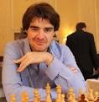
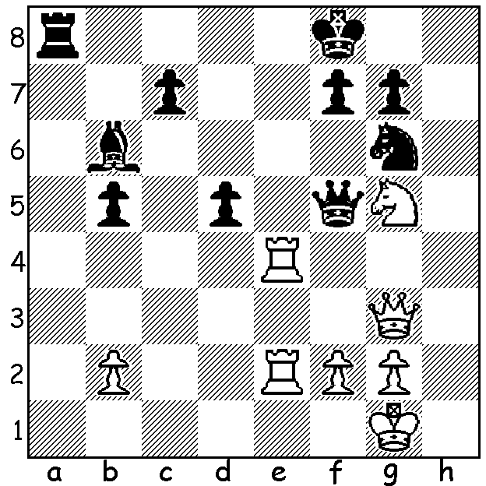

The 2017 British Championship (103 players) was played in July/August in Llandudno, Wales. As usual there was a strong field although it was missing two of the UK's two strongest players, Michael Adams and Nigel Short. Four players tied in top place with 7/9, Gawain Jones, Luke McShane, Craig Hanley (all +5 =4) and David Howell (+6 =2 -1). In a rapidplay play-off Jones defeated Hanley while McShane defeated Howell. In the two-game final Jones won the first and, with a draw in the second, secured the title.
Here are two games from the championship, both victories by Black after sacrificing a central pawn.

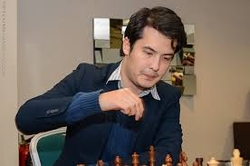
David Howell vs Luke McShane
2017 British Championship Playoff
Kings Indian Defence
1.d4 Nf6 2.c4 g6
3.g3 Bg7 4.Bg2 0-0
5.Nc3 d6 6.Nf3 Nbd7
7.0-0 e5 8.e4 exd
9.Nxd4 Re8 10.h3 a6
11.Be3 Rb8 12.b3 Ne5 David Howell
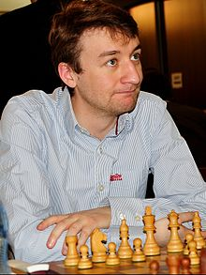
13.f4 Ned7 14.Bf2 c5
15.Nc2 b5! 16.Qxd6 b4
17.Na4 Nxe4! 18.Bxe4 Bxa1
19.Rxa1 Rxe4 20.Nxc5 Re7
21.Nxb4(b) Rxb4 22.Nxd7 Qxd7
23.Qxb4 Bb7 24.Qb6 Qxh3
25.Qd8+ Kg7 26.Bd4+ Kh6
27.Qf8 Kh5 White resigns.

a) Black could defend with 20...Re2 (21.Rd1 Qe7).
b) Winning material but leaving himself vulnerable
on the white squares.
Luke McShane

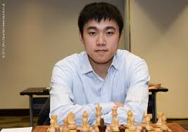
Zhou Yang-Fan vs Craig Hanley
2017 British Championship
Sicilian Najdorf
1.e4 c5 2.Nf3 d6
3.d4 cxd 4.Nxd4 Nf6
5.Nc3 a6 6.Qd3 Nbd7
7.Be2 Nc5 8.Qe3 e5
9.Nb3 Be6 10.Nxc5 dxc5
11.Qg3 Be7 12.Qxe5 0-0
13.Qg3 Re8 14.0-0 Qb6 Zhou Yang-Fan

15.f4 Rad8 16.f5 Bd6!?
17.Bf4(a) Bxf4 18.Rxf4 Bc4!!
19.Bxc4?(b) Nh5 20.Qg4 Nxf4
21.Rb1 Qf6 22.Bf1 Qd4+
23.Kh1 Nd5! 24.Nxd5 Rxd5
25.Re1 Qf2 26.Rc1 h5
27.Qf3 Qd2 28.Ra1 Rd4
29.Qxh5 Rdxe4 30.f6 g6
31.Qxc5 Qf4 32.Qc3 Qh4
33.h3 Re1 34.Rxe1 Rxe1
35.Kh2 Qf4+! White resigns

a) If 17.e5 Bxe5 18.Qxe5 Bc4 19.Qxe8+ Rxe8 20.Bxc4 Qb4 Craig Hanley
(or 20...Qd6) 21.Be2 Qd4+ 22.Kh1 b5 with initiative for the
lost material.
b) White should play 19.Rf2= (19...Nxe4 20.Nxe4 Bxc4 21.Rxc4 f6).

The KINGSLEY OPEN is the next WA Grand Prix event. Dates are Sat 20 and Sun 21 October with venue being N Woodvale Primary. Check details on cawa.org.au (Information/Calendar).

SOLUTION: 1.Qa3+!! Black resigns (1...Rxa3 2.Re8# or 1...Kg8 2.Qxa8+ Nf8 3.Qxf8+! Kxf8 4.Re8#).

