William Lombardy - Larry Kaufman 1972:
find how White mates in 3
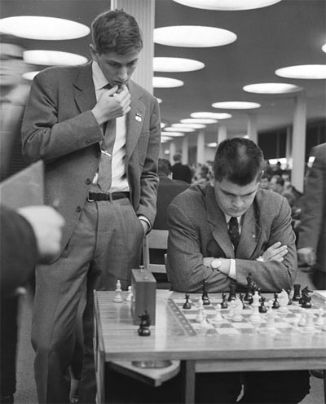
(it's not the more obvious move):

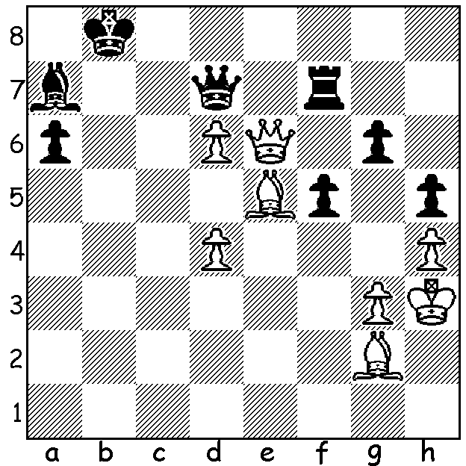

Lombardy at 1960 Olympiad
(Fischer looking over his shoulder)

I recently saw news of the death of Grandmaster William Lombardy (1937-2017). If the name is familiar to you it is probably because he was Bobby Fischer's second in Fischer's successful world championship match against Boris Spassky in 1972. However Lombardy was a very successful player in his own right. He is most famous for his picket fence 11/11 in the 1957 World Junior Championship in 1957, a record never equalled. In 1960 he helped USA win the World Student Championship in St Petersburg, beating Spassky in the USA – USSR clash. In the same year he finished second to Fischer in the US championship. He became a catholic priest but remained active in chess, winning three US Open championships and playing for USA in seven Olympiads from 1958 to 1980. After leaving the priesthood he married and had one son, but later divorced.
The last year of his life was marked by a legal dispute with his landlord and he was evicted from his apartment.

Mathias Gerusel vs William Lombardy
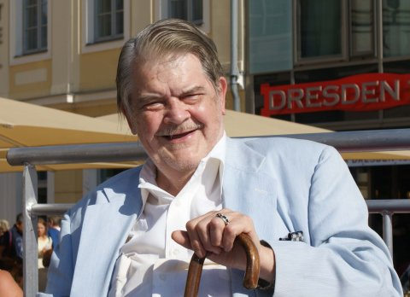
1957 World Junior Championship
Nimzoindian Defence
1.d4 Nf6 2.c4 e6
3.Nc3 Bb4 4.Qc2 Nc6
5.Nf3 d5 6.a3 Bxc3+
7.Qxc3 Ne4 8.Qc2 e5!
9.dxe Bf5 10.Qa4 0-0
11.Be3 d4 12.Rd1 dxe3!
13.Rxd8 exf+ 14.Kd1 Rfxd8+
15.Kc1 a6 16.Qb3 Nc5
17.Qc3 Na5! 18.e4 Nab3+ recent picture of Lombardy
White resigns
(19.Kb1 Bxe4+ 20.Ka2 Bb1+! 21.Kxb1 Rd1+ 22.Kc2 Rc1# or 22.Ka2 22.Ra1#)

William Lombardy vs George Kramer
1957/8 US Championship
Reti, Reversed Grunfeld
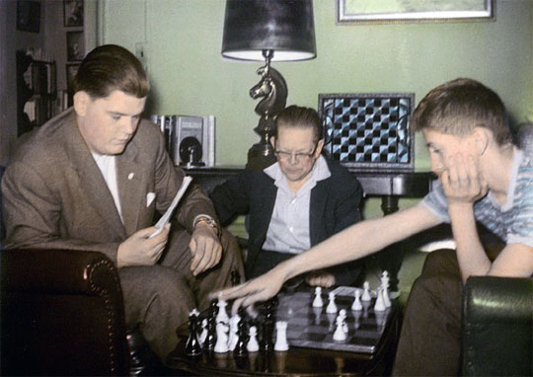
1.Nf3 d5 2.g3 c5
3.Bg2 Nc6 4.d4 cxd
5.Nxd4 Nf6 6.c4 Qb6
7.Nxc6 bxc6 8.Nc3 e6
9.0-0 Be7 10.cxd cxd
11.e4! 0-0(a) 12.exd Ba6
13.Re1 Bc5 14.Be3 Bxe3
15.Rxe3 Rad8 16.Qb3 exd
17.Nxd5 Nxd5 18.Bxd5 Qf6
19.Rae1 Rd7 20.Qa3!(b) Qd6
21.Bc6!(c) Bc8 22.Bxd7 Qxd7 Lombardy (L) & Fischer
23.Rd3 Qc7 24.Qd6 resigns

a) Uncastled and in danger on the h1-a8 diagonal, Black sacrifices a pawn to complete his development.
b) Threat 21.Qxf8+! and if 20...g6 21.Re8 is very strong.
c) Winning – 21...Qxa3 22.Rxa3 leaving rook and bishop attacked and if 21...Qxc6 22.Qxf8+!

The Kingsley Open (WA Grand Prix) starts tomorrow at North Woodvale Primary and continues on Sunday (both days start 10.30). Details cawa.org.au and entries to Gordon Dunlop
g-dunlop64@bigpond.com or 93686412.

SOLUTION: Perhaps, like me, you saw 1.Qxf7 Rxf7 2.d7# but although Black would resign after the rook capture he is not forced to capture White's queen if the game continued. Lombardy played 1.Qe8+!! which mates after 1...Qxe8 2.e7+ Qxe5 3.d8=Q#.

