Levon Aronian vs Sergei Beshukov 2001:
White to play and win (4 moves):
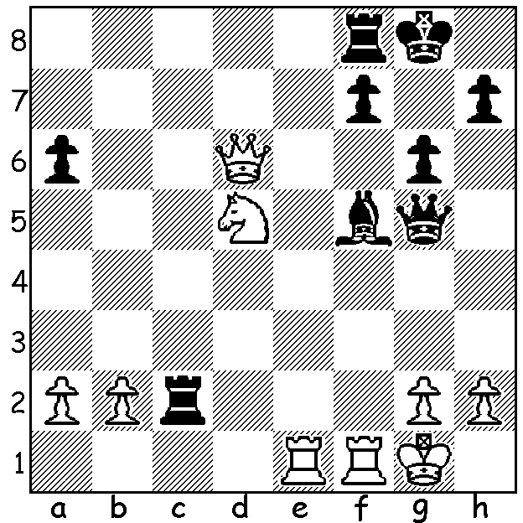
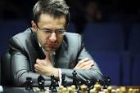

The present lull in top Grandmaster events around the world gives me a chance to concentrate on local chess, in particular the Championships and Opens played in our main clubs. In the Metropolitan club, based in Nedlands, the joint Championship winners were Ihsan Ferozkohi and Adam Kelly (4.5/7) while in the Open (25 players) Ihsan came out on top with 6.5/7. At Southern Suburbs, based in Leeming, Championship winner was Andrew Hardegen (6.5/7) while there were joint winners in the Open (37 players), WA champion Igor Butsenko and previous WA champion Yita Choong (6.5/7). At the Perth club, based in Whitfords, Robert Maris and Derwent Maggs shared the Championship top spot with 6/7. If any reader is interested in joining or visiting a local club please check on cawa.org.au (information / chess clubs). Here is a game from the Metro Championship:

Peter Roza vs Adam Kelly
2017 Metro Championship, Rd 1
Caro-Kann Defence, Panov Attack
1.e4 c6 2.d4 d5
3.exd cxd 4.c4 Nf6
5.Nc3 e6 6.Nf3 Bb4
7.Bg5 0-0 8.Bd3 dxc
9.Bxc4 Qc7 10.Qd3 Bxc3+
11.bxc3 Nbd7 12.0-0 Nd5
13.Bd2 Nf4 14.Bxf4 Qxf4
15.Rfe1 h6 16.Re3 b6
17.Rae1 Qd6? 18.Rxe6!!(a) Qf4
19.g3 Qg4 20.Re8 Bb7
21.Bxf7+! Kh8(b) 22.Nh4 Raxe8
23.Bxe8 Rf6 24.Bxd7 Qxd7
25.Ng6+ Kg8 26.Ne5 Qd5
27.Qc4 Qxc4 28.Nxc4 Rc6
29.Re7 Bc8 30.Ne5 Rxc3
31.Kg2 a5 32.d5 Bf5
33.d6 and Black resigns on move 43.

a) A brilliant sacrifice – if 18...fxe6 19.Rxe6 Qf4/Qa3 (19...Qxe6 avoids mate) 20.Rxh6+ Rf7 21.Qh7+ Kf8 22.Qh8+ Ke7 23.Re6#.
b) 21...Kxf7? Ne5+.

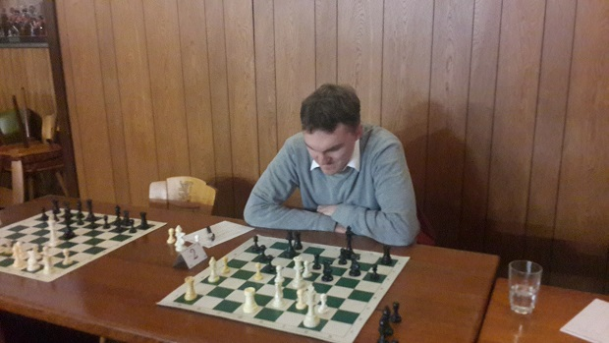
The Kingsley Open (WA Grand Prix,
22 players) was played last weekend at
the Perth Chess Club in Whitfords and
included some as well as a number of
developing younger players. WA's top
two rated players, FMs Tristan Boyd
and Patrick Gong, were expected to
fight out for top place and at the end of
Day 1 Patrick led with 3/3. However
Andrew Hardegen defeated Patrick in Andrew Hardegen
Rd 5 to take the lead which he held onto
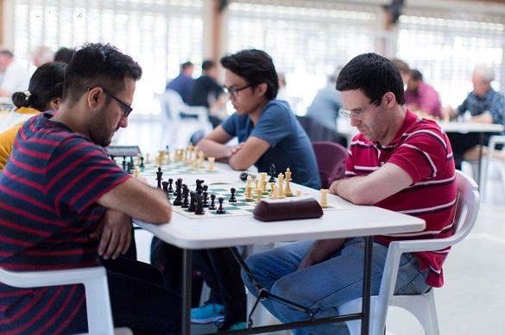
with a draw with Tristan in the final round,
finishing with 5/6, just ahead of Tristan
and Patrick on 4.5. The next Grand
Prix event will be the Christmas Open
on Nov 18/19 at Leeming.

AUSTRALIAN JUNIOR CHAMPIONSHIPS
will be played in Melbourne from 13 to 21 January 2018. Intending players should contact the WA Chess Association (cawa.org.au) to request financial assistance.
Tristan Boyd (rt) v Ihsan Ferokzohi
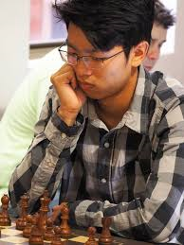
SOLUTION:
1.Nf6+ Kg7 2.Qxf8+! Kxf8 3.Nxh7+ Kg7 4.Nxg5.

Patrick Gong

