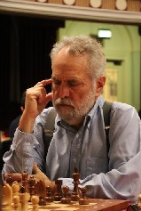
Tarjan vs Gilden 1973:
White to play and mate in 4:
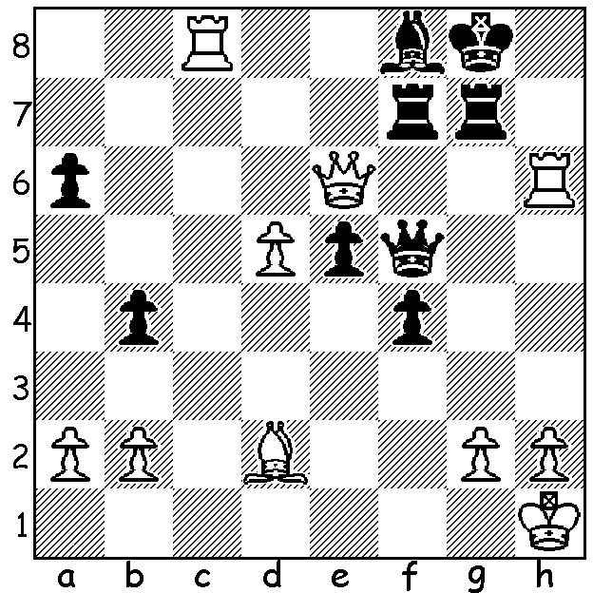
While wins by someone rated over 300 points less than one's opponent are extremely rare, they do happen. In the majority of these cases it is likely to be an up-and-coming young player whose prowess is leaping ahead with his improving rating having difficulty keeping up. However the game today features the world's number 5 player losing to an opponent rated nearly 400 points behind him and, far from being a rapidly improving youngster, is a veteran thought to be well past his prime who had returned to chess in the past three years after a break of 20 years.

James Tarjan (2412) vs Vladimir Kramnik (2803)
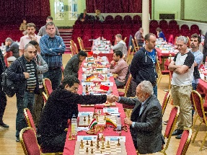
2017 Isle of Man Open, Rd 3
Reti Opening
1. c4 Nf6 2.g3 c6
3.Nf3 d5 4.b3 Bg4
5.Bg2 e6 6.0-0 Nbd7
7.Bb2 Bd6 8.d3 0-0
9.Nbd2 Re8 10.h3 Bh5
11.Re1 a5 12.a3 e5
13.cxd cxd 14.Nh4 Nc5
15.Qc2 Ne6 16.Rac1 Nd4
17.Qd1 Nb5 18.Nb1 Qd7
19.Kh2 Ra6 20.Nf3 e4
21.dxe Nxe4 22.Rf1 Bb8
23.Nc3 Nbxc3 24.Bxc3 Rae6 Kramnik resigns to Tarjan
25.Be1 h6 26.Rc2 Ba7
27.Qc1 Bb6 28.e3 Qb5(a) 29.Nd4 Bxd4
30.exd4 Bf3?(b) 31.Bxf3! Nxg3?(c) 32.fxg3 Qxf1
33.Bf2(d)

a) Black has outplayed White and gained a dominating position.
b) Thinking the bishop cannot be captured as the rook f1 would be unprotected.
c) Realising 31...Qxf1 gets the queen trapped by 32.Be2. However 31...Qxf1! should have been played when Black can draw – 32.Be2 Nxg3! 33.Bxf1 Nxf1+ 34.Kg2 Rxe1 35.Qb2 (if 35.Qf4 R8e6! is strong) 35...R8e6 36.Rc1 Rg6+ 37.Kh1 Ng3+ 38.Kh2 Nf1+ 40.Kh1 Ng3+ drawing (40.Kg2 loses to 40...Ne2+ / 41...Nxc1).
d) Now White wins comfortably – 33.Qd3 34.Rc3 Qf5 35.Kg2 Rf6 36.Qc2 Qd7 37.g4 Rc6 38.Rc5 Rd8 39.Qf5 Rxc5 40.Qxd7 Rxd7 41.dxc5 d4 42.Kf1 d3 43.Ke1 d2+ 44.Kd1 Kf8 45.Bg3 Ke7 46.Bd6+ Ke6 47.Kxd2 b6 48.Ke3 bxc 49.Bxc5 Rd8 50.b4 axb 51.axb f5 52.b5 fxg 53.hxg g6 53.b6 h5 55.g5 Kd7 56.b7 resigns

Tarjan, 65, was one of USA's best players in the 1970s and won several Olympiad team and individual medals. Kramnik, 42, was world champion from 2000 to 2007 after defeating Gary Kasparov 8.5 – 6.5 without losing a game.

The final WA Grand Prix of 2017 will be the Christmas Open on Sat 18 & Sun 19 Nov at Leeming Primary. This is usually one of the most popular weekenders so do try to get along (cawa.org.au for details).

CORRECTION: The Perth Club meets at North Woodvale Primary School, Woodvale, not in Whitfords as I stated last week.

SOLUTION: 1.Rxf8+ Kxf8 2.Rh8+ Rg8 3.Bxb4+ Kg7 4.Qh6#.

