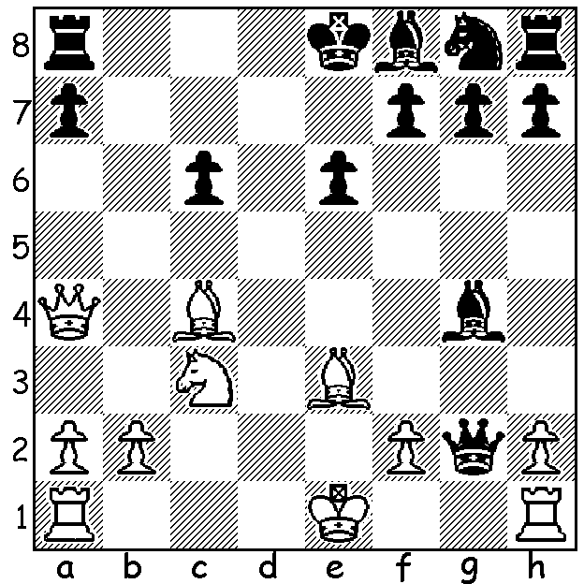

Janowski vs Schallopp 1896:
White to play and win (3 moves):

In our alphabetical series on players who have openings or defences named after them we come to J for Janowski whose name is given to an obscure defence to the Queens Gambit, Janowski's Variation, 1.d4 d5 2.c4 e6 3.Nc3 a6. David Markelovich Janowski (1868-1927), a Franco-Polish grandmaster was, apart from Tarrasch, the only player to have defeated four World Champions, namely Steinitz, Lasker, Capablanca and Alekhine. He was a frequent prizewinner in the early years of the 20th century but was twice crushed by Emanuel Lasker in World Championship matches, +1 =2 -7 in 1908 and +0 =3 -8 in 1910. He was also addicted to gambling, winning and losing small fortunes at the casino. A story relates how, with only half the money raised for his first match v Lasker, he doubled the amount with a single stake on red at roulette. He was a master of attack, winning many brilliancy prizes but lost many half points through a stubborn refusal to accept draws.
His play deteriorated after WW1 and he died on the way to a tournament on the French Riviera.

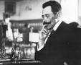
David Janowski vs Siegbert Tarrasch
Ostend 1905
Queens Pawn Opening
1.d4 d5 2.Nf3 c5
3.c3 e6 4.Bf4 Qb6
5.Qb3 Nc6 6.e3 Nf6
7.h3 Be7 8.Nbd2 Bd7
9.Be2 0-0 10.0-0 Rfc8
11.Ne5 Be8 12.Bg3 Nd7
13.Ndf3 Nf8 14.Rfd1 Na5 Janowski
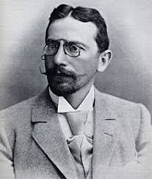
15.Qc2 c4 16.Nd2 f6
17.Nef3 Bg6 18.Qc1 h6
19.Nh2 Qd8 20.Bf3 b5
21.e4 Nc6 22.exd exd
23.Re1 b4 24.Ndf1 bxc
25.bxc Qa5 26.Ne3 Bf7
27.Qd2 Ba3 28.Rab1 Nd7(a)
29.Rb7!!(b) Nb6 30.Nf5 Qa6
31.Nxh6+! gxh6 32.Rxf7 Kxf7
33.Qxh6 Kg8(c) 34.Qg6+ Kh8
35.Qxf6+ Kg8 36.Qg6+ Kh8
37.Re5 resigns(d)
Tarrasch

a) 28...Rab8 & ...Nd8 would prevent the White rook invasion.
b) Tempting Black into trapping the rook.
c) Despite his extra rook, Black, with all his pieces massed on the queenside, is helpless.
d) One of Janowski's many Brilliancy Prize games.

The final WA Grand Prix of 2017 will be the Christmas Open on Sat 18 & Sun 19 Nov at Leeming Primary. This is usually one of the most popular weekenders so do try to get along (cawa.org.au for details and entry or contact Godon Dunlop – gordondunlop@gmail.com, 0409 812129 or 93686412 ).

REMINDER: Intending entrants to the Australian Junior Championships (Jan 13-21, Melbourne) should contact WA Chess Association (cawa.org.au) to enquire about possible financial assistance.

SOLUTION: 1.Bd5! (interference) 1...exd5 2.Qxc6+ Kd8 3.Qxa8+: the game concluded 3...Kd7 4.Qb7+ Ke6 5.Qc6+ Bd6 6.Bf4! Resigns.

