David Janowski vs Karl Schlechter 1899: a stunning win for White (5 moves):

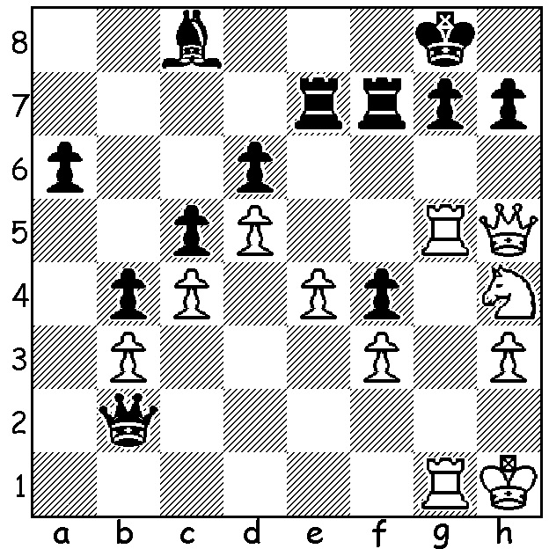
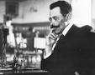

After a brief biography of David Janowski (1868-1927) last week, we can look at a game featuring his rarely played defence to the Queens Gambit. And who better to try it out than world champion Magnus Carlsen against a fellow super GM? The game was played in the inaugural Norway Blitz last year but the standard of play is exceptional for a game where each player has 5 mins and a short increment each move.


Levon Aronian vs Magnus Carlsen
2016 Norway Blitz, Rd 7
Queens Gambit, Janowski Defence
1.d4 d5 2.c4 e6
3.Nc3 a6(a) 4.cxd exd
5.Nf3 c6 6.e4 dxe
7.Ng5 Be7 8.Bc4 Nh6(b)
9.Ngxe4 Nf5 10.d5 0-0(c)
11.0-0(d) cxd 12.Nxd5 Nc6
13.Qh5 Be6 14.Nxe7(e) Qxe7
15.Ng5 h6 16.Nxe6 fxe6(f)
17.Bd2 Nfd4 18.Rad1 Rf5
19.Qh3(g) Rd8 20.Be3 b5(h) Carlsen (L) & Aronian
21.Bxd4 Nxd4 22.Rxd4(i) Rxd4
23.Qxf5 Rxc4 24.Qd3 Qc5 25.b3 Rc2
26.a4 Rc3 27.Qe4 Qd5 28.Qg6(j) Qxb3
29.axb axb 30.Ra1(k) Qa2! 31.Rd1 Qd5
32.Qb1 Qb3 33.Rd8+ Kf7 34.Qe1 Qc4
35.Rd7+ Kf6 36.Rd1 b4 37.h3 b3
38.Qd2 Kg6 39.Re1 Rc2 40.Qd7 b2
41.Rxe6+ Kh7 42.Re1 Rc1 43.Qf5+ Kh8
White resigns

a) With Black making a non-developing move White needs to exploit his lead in development to gain the advantage. The forthright 4.e4 is premature - 4...dxe 5.Nxe4 Bb4+ 6.Nc3 c5 7.a3 Bxc3+ 8.bxc3 Qa5 9.Bd2 Nf6=: 4.c5 creating a space advantage invites a counter in the centre – 4...Nc6 5.Bf4 e5! 6.Bxe5 Nxe5 7.dxe5 d4 8.Qa4+ c6 9.Ne4 Qd5 10.Nd6+ Bxd6 11.exd6 Qxc5 12.Rd1 Qxd6 13.Rxd4 Qc5: the insipid 4.e3 plays into Black's hands – 4...dxc 5.Bxc4 b5 6.Be2 Bb7.
b) If 8...Bxg5 Qh5 regains the piece.
c) Best for Black is 10...b5 11.Bb3 b4 10.Ne2 Bb7.
d) 11.Bf4 is more forceful – 11...cxd 12.Bxd5 Nc6 13.Bxc6.
e) White could try 14.Rd1 Nfd4 15.Ng5 Bxg5 16.Bxg5 Qd6 17.Bf4 Qd8 18.Bc7 Qd7.
f) White appears to have an advantage with 2 B vs 2 N and better pawn formation but Black's centralised knights maintain the balance.
g) Slightly better is 19.Qg4 h5 20.Qh3 Rd8 21.Rfe1 Qf6.
h) Safer was getting out of the pin with 20...Kh8.
i) This is where White loses his small advantage: better 22.Qe3 bxc4 23.Rxd4 Rxd4 24.Qxd4 Qc5. Now Black is better with more active pieces and White in possible danger of a back-row mate.
j) Rather than face an inferior rook ending (28.Qxd5 exd5 29.axb axb 30.Rb1 with Black having the active rook & passed pawn) White gives up a pawn, hoping for an attack and possibly a perpetual check.
k) Clearly 30.h4 was better.

Janowski also gave his name to a variation in the main line of the Four Knights opening, 8.Re1 and also to a line in the Old Indian, 1.d4 Nf6 2.c4 d6 3.Nc3 Bf5.

CHRISTMAS OPEN (tomorrow & Sunday 10.30 at Leeming Primary): Still time to enter
(gordondunlop64@gmail.com, 0409 812129 or 9368 6412).

SOLUTION: 1.Qxh7+!! Kxh7 2.Rh4+ Kg8 3.Ng6 resigns (3...Rf6 4.Rh8+ Kf7 5.Rf8#).

