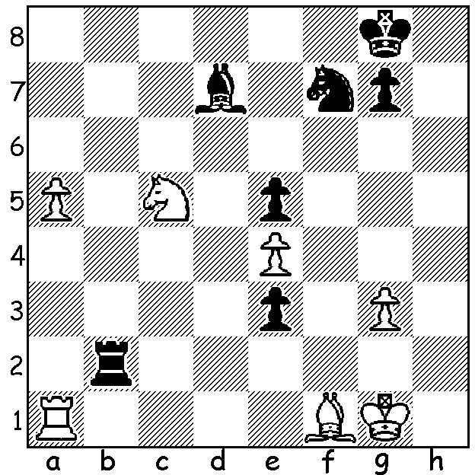
Successive surprise moves give young
Hungarian star Richard Rapport a quick
finish (Black v Riazantsev, Palma GP 2017):

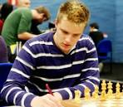

The Palma GP tournament with 18 players concluded earlier this week with joint winners Dmitry Jakorenko & Levon Aronian (5.5/9). But even more important than winning the event to Timour Radjabov and Maxime Vachier-Lagrave was the scoring of sufficient GP points to gain one of the two places from the GP to qualify for the forthcoming Candidates to find a challenger to Magnus Carlsen. Radjabov had made a strong late surge and needed to win his final game but sadly could only draw. MVL also failed to win his important final game (in fact losing through trying to avoid a draw) and also missed out, leaving the two GP qualifying places to Shakhriyar Mamedyanov and Alexander Grischuk, both of whom had already played their allowable three GP events. Other Candidate places have gone to Aronian & Ding Liren (qualified from the World Cup), Sergey Karjakin (last losing challenger to Carlsen), Fabiano Caruana & Wesley So (from rating), Vladimir Kramnik (wildcard selection).
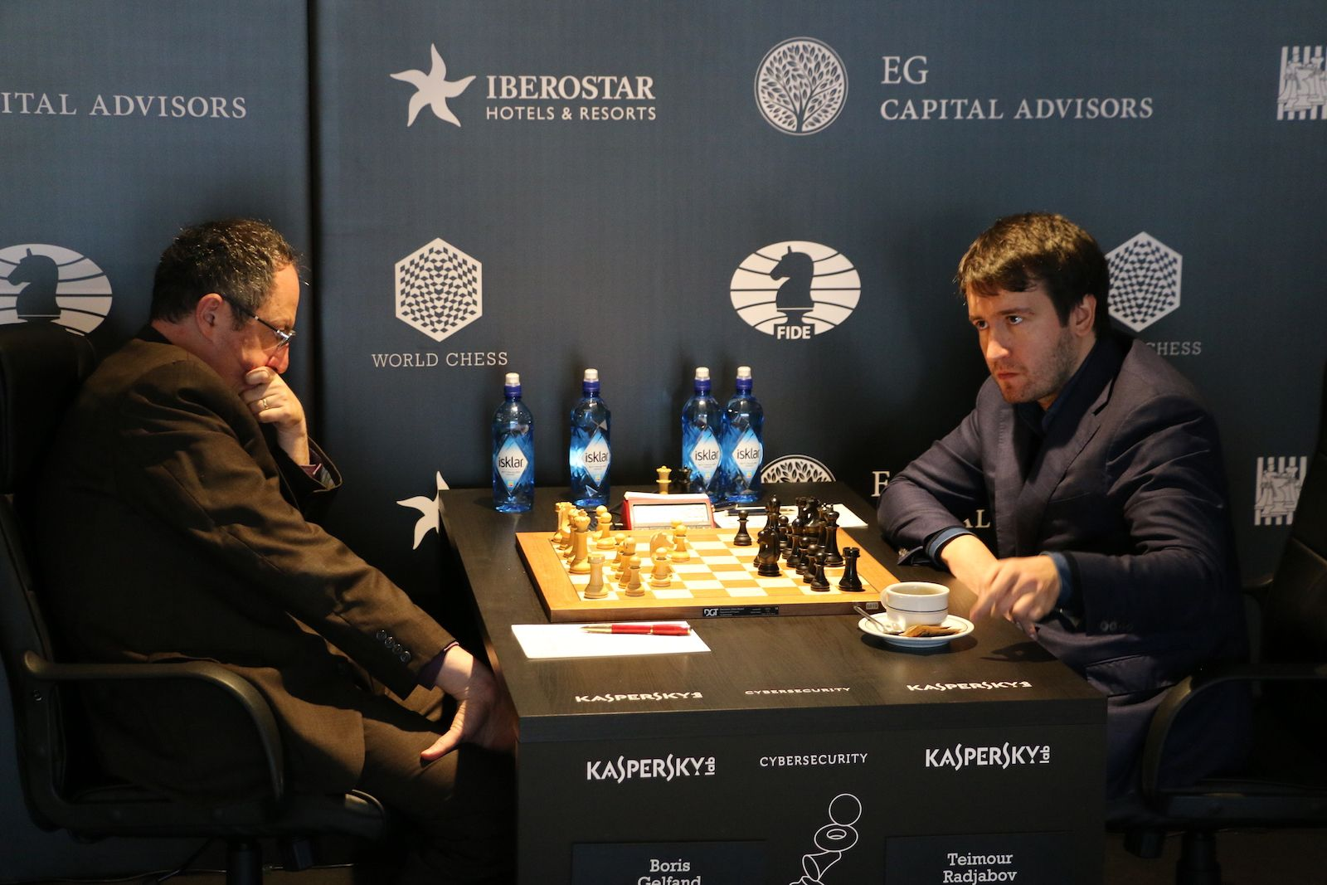
Boris Gelfand vs Timour Radjabov
2017 Palma GP Tournament, Rd 8
Queens Indian Defence
1.d4 Nf6 2.c4 e6
3.Nf3 b6 4.g3 Bb7
5.Bg2 Be7 6.0-0 0-0
7.Nc3 Ne4 8.Bd2 Nxd2
9.Qxd2 d6 10.Rad1 Nd7
11.Rfe1 c5 12.e4 a6
13.d5 e5(a) 14.b3 g6
15.Rf1 Bc8 16.Ne1 Rb8
17.a4 f5 18.f4 exf Gelfand v Radjabov
19.gxf(b) fxe 20.Nxe4 b5 21.a5(c) bxc
22.bxc Rb4 23.Rc1 Nf6 24.Ng5 Qxa5
25.Nd3 Ra4 26.Qe3 Qd8 27.Rce1 Bf5!(d)
28.Bh3(e) Nxd5! 29.cxd5 Bxg5 30.Bxf5(f) Rxf5
31.Qe6+ Kg7 32.fxg Qxg5+ 33.Kh1 Ra2
34.Qe7+(g) Qxe7 35.Rxe7+ Kf8! 36.Ree1 Rxf1+
37.Rxf1+ Ke7 38.Re1+(h) Kd7 39.Re3 a5
40.Rh3 h5 41.Nf4 a4 42.Nxg6 a3
43.Rf3 c4! 44.Nf4 Ra1+ 45.Kg2 a2
46.Ra3 c3! 47.Ne2 c2 48.Kf2(i) Rh1
White resigns(j)

a) Creating a Czech Benoni type position with both players looking for pawn breaks on the b &/or f files.
b) This isolated pawn deprives Black of a knight outpost on e5.
c) A pawn sacrifice to deflect Black's pieces allowing an attack through the centre.
d) Blocking the f pawn. Not 27...Re8 28.f5! gxf 29.Ne6 Bxe6 30.Qxe6+ Kh8 31.Rxf5
e) If 28.Ne6 Qc8! 29.Nxf8 Bxf8 with a better game for Black.
f) Safer is 30.fxg5 Re4 31.Qg3 Rxe1 32.Nxe1 Bxh3 33.Qxh3 Qg5 with a likely draw.
g) Defending against 34...Rxh2+! mating but 34.Qe4 is best (34...Qd2 35.Qe7+ Kh6 36.Qh4+ draw).
h) 38.Nf2 making e4 available would probably draw.
i) If 48.Kh3 Re1 49.Rxa2 Rxe2 50.Ra1 Kc7 & wins..
j) 49.Rxa2 Rxh2+ 50.Ke3 Rxe2+! wins.

SOLUTION: 1...Ng5! 2.Bg2 (2.Nxd7 Nf6+ 3.Kh1 Rh2#) 2...Bh3! 3.Bxh3 Nf3+ White resigns (4.Kh1 Rh2# or 4.Kf1 Rf2#): if 3.Bh1 Bg5 4.Bg2 Bf3 5.Bf1 e2 wins.

