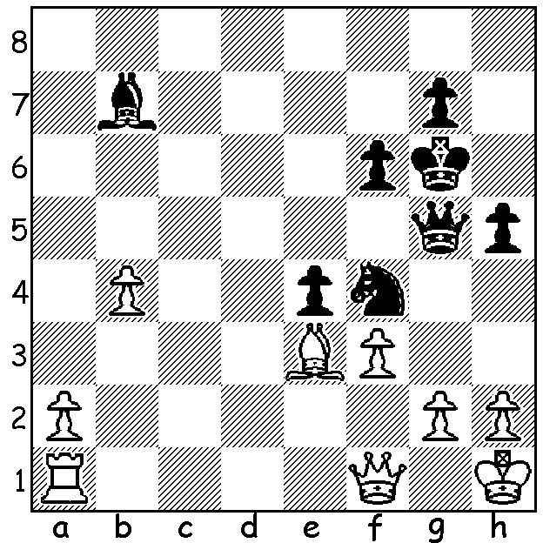

Despite being material down Carlsen

(Black v Naiditsch 2006) wins quickly:

Magnus Carlsen will defend his world title next November in London against the winner of the forthcoming Candidates Tournament. The match will be of 12 classic games with firstly rapidplay and then blitz games to decide in the event of a 6-6 result. At the official announcement Carlsen, who is playing in the London Classic which begins today, said that London was the venue for his toughest tournament ever, the 2013 Candidates to find a challenger to world champion Vishy Anand. At the last round Carlsen and Vladimir Kramnik were level on 8.5/13 with Carlsen assured of top spot on tiebreak (more wins) if they finished level. However things did not go well for Carlsen, losing to Peter Svidler. Fortunately for him Vassily Ivanchuk defeated Kramnik (his first loss) ensuring Carlsen of first place (Carlsen +5 =7 -2, Kramnik +4 =9 -1). Svidler & Levon Aronian tied for 3rd with 8/14.
London has been the venue for a number of world championships with the first being in 1886 between Wilhelm Steinitz and Adolf Anderssen (8-6, no draws). In 1993 Gary Kasparov defeated Nigel Short 12.5 – 7.5 but lost his title in 2000 to Kramnik 6.5 – 8.5, failing to win a single game.

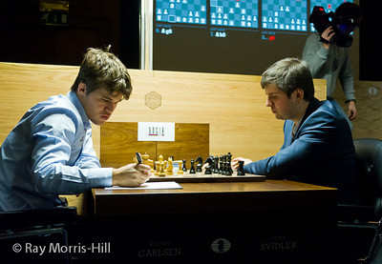
Magnus Carlsen vs Peter Svidler
2013 Candidates, Rd 14
Ruy Lopez,
1.e4 e5 2.Nf3 Nc6
3.Bb5 a6 4.Ba4 Nf6
5.0-0 Be7 6.d3 b5
7.Bb3 d6 8.a3 0-0
9.Nc3 Bb7 10.Bd2 Qd7
11.a4 Nd8 12.axb axb
13.Rxa8 Bxa8 14.Ne2 Ne6
15.Ng3 c5 16.Nf5 Bd8
17.c4 bxc 18.Bxc4 Bc7
19.Re1 Re8 20.Qc1 Nh5 21.g3(a) g6
22.Nh6+ Kg7 23.Ng5 Nxg5 24.Bxg5 d5
25.exd Bxd5 26.Ng4(b) Bf3 27.Bf6+! Kg8
28.Nh6+ Kf8 29.Qe3 Bb7 30.Bh4(c) Qh3
31.f3(d) Nf4 32.gxf4 Qxh4 33.Nxf7 Bxf3
34.Qf2 Qg4+ 35.Qg3 exf 36.Rxe8+ Kxe8
37.Qxg4 Bxg4 38.Ng5 h6 39.Nf7 h5
40.Nh6 Bd1 41.Kf2 f3 42.h3 Bf4
43.Nf7 g5 44.Ke1 g4! 45.hxg hxg
46.Kxd1 g3 47.Ke1 g2 48.Kf2 Bh2
White resigns

a) 21.b4 would open up the game advantageously.
b) 26.Bxd5 is best: 26...Qxd5 27.Ng4.
c) White can maintain a small advantage with 30.Bh8!, a difficult move to envisage, especially as White was getting into serious time trouble.
d) Losing: 31.Bd5! Bxd5 32.Qxc5+ Kg7 33.Qxd5 (breaking Black's attack and if 33...Kxh6 34.Qxf7 Rc8 35.Qe7 with strong threats or 34...Ba5 36.Qxe8 Bxe1 37.Qxe5 and White is better).

SOLUTION: 1...exd & if 2.gxf3 Qg4! 3.h3 Qg3.

