Aryan Tari vs Matthieu Midonet
(2017 World Junior Championship):

White to play and win (6 moves):
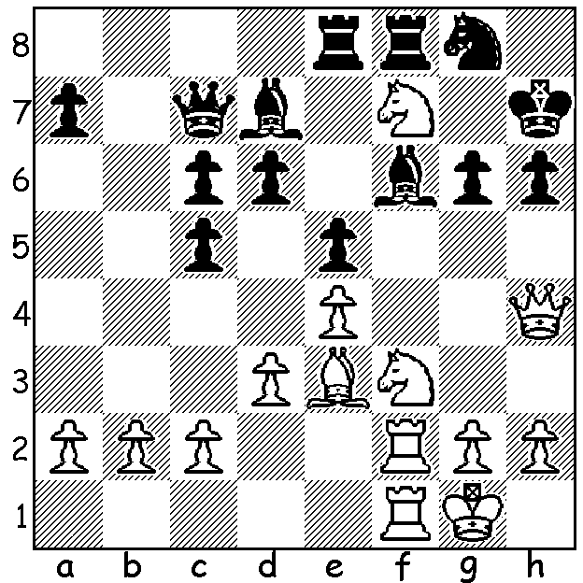

On November 25 Norway had a second world champion in the person of GM Aryan Tari who won the World Junior (Under 20) Championship played in Italy with 8.5/11. Tari, whose parents emigrated to Norway from Iran, learnt the game at five and became Norwegian champion in 2015 and a GM in 2016. Of interest was the score of Indian prodigy Praggnanandha who would have gained the title of GM automatically if he had won the championship. He went through undefeated scoring 8/11, gaining a GM norm, and he now needs two more norms within the next three months to become the world's youngest GM, a record held by Sergey Karjakin at 12 years 7 months. Australia had two entrants, Kevin and Rowan Willthgamuwa, who both scored 4.

Grigory Oparin vs Aryan Tari
2017 World Junior Championship
Caro-Kann, Advance Variation
1.e4 c6 2.d4 d5 3.e5 Bf5
4.g4 Bg6(a) 5.e6 Qd6(b) 6.exf+ Bxf7
7.f4 Nf6 8.Nc3 Nbd7 9.Bh3 g5!(c)
10.fxg Ne4 11.Nge2(d) Bg7 12.0-0 0-0
13.Be3 Nb6 14.Bf4(e) Nxc3! 15.bxc3 e5!
16.Bg3 Nc4 17.Rf5 Bg6 18.Qd3 Qe7!(f)
19.dxe Nxe5 20.Qe3 Bxf5!(g) 21.gxf Qxg5!
22.Nf4 Rae8 23.Qe2 Ng6! 24.Ne6 Nf4!
25.Qg4 Nxh3+ 26.Qxh3 Qxf5 White resigns

a) Alternatives are 4...Be4 & 4...Bd7.
b) Accepting the pawn would make development difficult.
c) Black's counter gambit of a pawn will give him control of the centre.
d) If 11.Nxe4 dxe4 12.Ne2 0-0-0 with the initiative (...e5 to come).
e) Better 14.Nxe4 dxe4 15.Bg2 Nc4 16.Bc1=.
f) Clearly 18...Bxf5 19.gxf5 hands the initiative back to White.
g) Black has seen a winning pseudo-sacrifice.

I read recently that possibly up to 1 billion play chess worldwide with the number of chess websites numbering about 600,000 with chess.com alone having 20,000,000 followers.

SOLUTION: 1.N3g5+ (it's important to open the f file) 1...Bxg5 (1...Kg7 2.Rxf6! Nxf6 - 2...hxg5 3.Qh8# - 3.Qxh6+ Kg8 4.Qh8#) 2.Nxg5+ Kg7 3.Rxf8 Rxf8 4.Rxf8 Kxf8 5.Qf2+ Ke8 (5...Kg7 6.Qf7+ Kh8 7.Qh7#) 6.Qf7+ wins everything.

