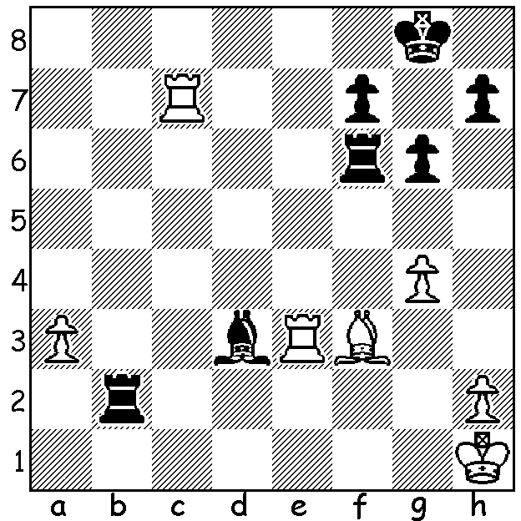

Herman Pilnik vs Bobby Fischer 1959:
Black to play & win (4 moves):

With the festive season upon us and Christmas legends in our minds, including the story of the Three Kings or Magi, I'll try to go one better with a story of the Four Queens. Set in the 20th Century in the then country of Yugoslavia it features a mighty struggle between champions of two great empires with a 16 year old American loner facing one of the established heroes of the Soviet Union:

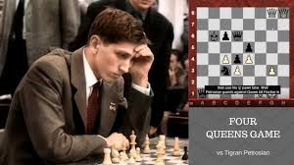
Bobby Fischer vs Tigran Petrosian
1959 Candidates Tournament
Caro-Kann Defence
1.e4 c6 2.Nc3 d5
3.Nf3 Bg4 4.h3 Bxf3
5.Qxf3 Nf6 6.d3 e6
7.g3 Bb4 8.Bd2 d4
9.Nb1 Bxd2+ 10.Nxd2 e5
11.Bg2 c5 12.0-0 Nc6
13.Qe2 Qe7 14.f4 0-0-0
15.a3 Ne8 16.b4! cxb(a)
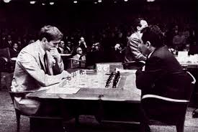
17.Nc4(b) f6 18.fxe fxe
19.axb Nc7 20 Na5 Nb5
21.Nxc6 bxc6 22.Rf2 g6
23.h4 Kb7(c) 24.h5 Qxb4
25.Rxf7+ Kb6 26.Qf2 a5
27.c4 Nc3(d) 28.Rf1(e) a4(f)
29.Qf6 Qc5 30.Rxh7 Rdf8
31.Qxg6 Rxh7 32.Qxh7 Rxf1+
33.Bxf1 a3 34.h6 a2
35.Qg8 a1=Q 36.h7 Qd6(g)
37.h8=Q Qa7 38.g4 Kc5
39.Qf8 Qae7(h) 40.Qa8 Kb4!(i) 41.Qh2 Kb3!
42.Qa1 Qa3(j) 43.Qxa3+ Kxa3 44.Qh6 Qf7
45.Kg2(k) Kb3 46.Qd2 Qh7 47.Kg3? Qxe4!
48.Qf2 Qh1 Draw

a) This exposes Black's king: safer is 16...f6.
b) Giving Black time to consolidate: White should play 17.fxe (17..Qxe5 18.Rxf7 Qxg3 19.e5! or 17...Nxe5 18.axb or 17...bxa 18.Nc4 Rf8 19.Rxa3 or 17...Kb8 18.axb Nxb4 19.Nc4 Nc6 20.Qf3 Rf8 21.e6! Qxe6 22.e5! all leading to strong White attacks).
c) Black with his knight superior to White's bishop should simplify with 23...Rhf8.
d) 27...Nd6 was safer.
e) 28.Qf6 puts White on top – 28...Rhf8 29.Rf1! Rxf7 30.Qxd8+ Rc7 31.Rf7 wins or 28...Rdf8 29.Qxe5 Rxf7 30.Qxh8.
f) Risky: 28...Qd6 would prevent 29.Qf6.
g) In time trouble Black overlooks 36...Ne2+ 37.Kf2 Nxg3!
h) Forced to stop 40.Qxe5+.
i) The king seeks safety in enemy territory.
j) Preventing mate on b2.
k) 45.Qxc6 is met by 45...Nd1.
l) Perhaps Black should continue (49.g5 e4! or 49.Bg2 Qh6). Both players went on to become World Champions, Petrosian 1963-69 and Fischer 1972-75.

SOLUTION: 1...Rxf3! 2.Rxf3 Be4 3.Rxf7 Rf2 wins piece.

ADDITIONAL PUZZLE: Place 8 White queens on the board so that no queen protects another. There are 12 solutions which are not rotatations or reflections of another (answer next week).

