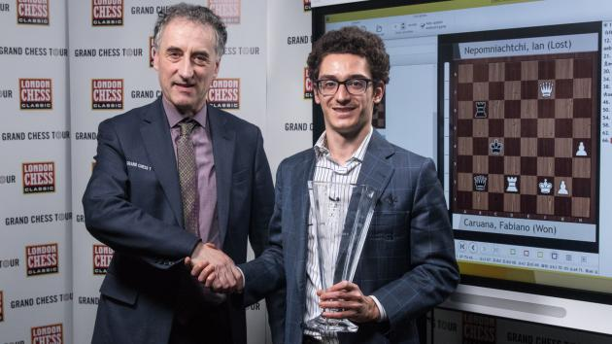
Fabiano Caruana vs Javier Vallejo Diaz 2006:
White has a winning attack with a move 2
zwischenzug (in between move) bringing
up reinforcements – 4 moves):
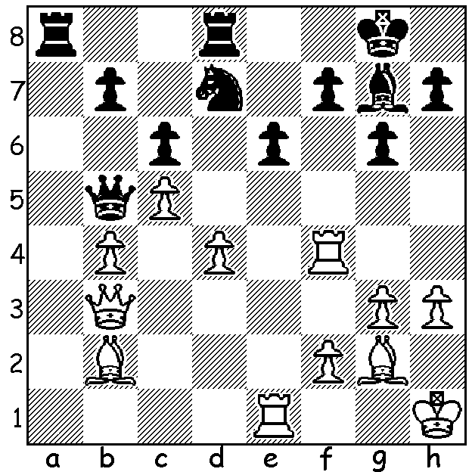

Caruana presented with London Classic Trophy
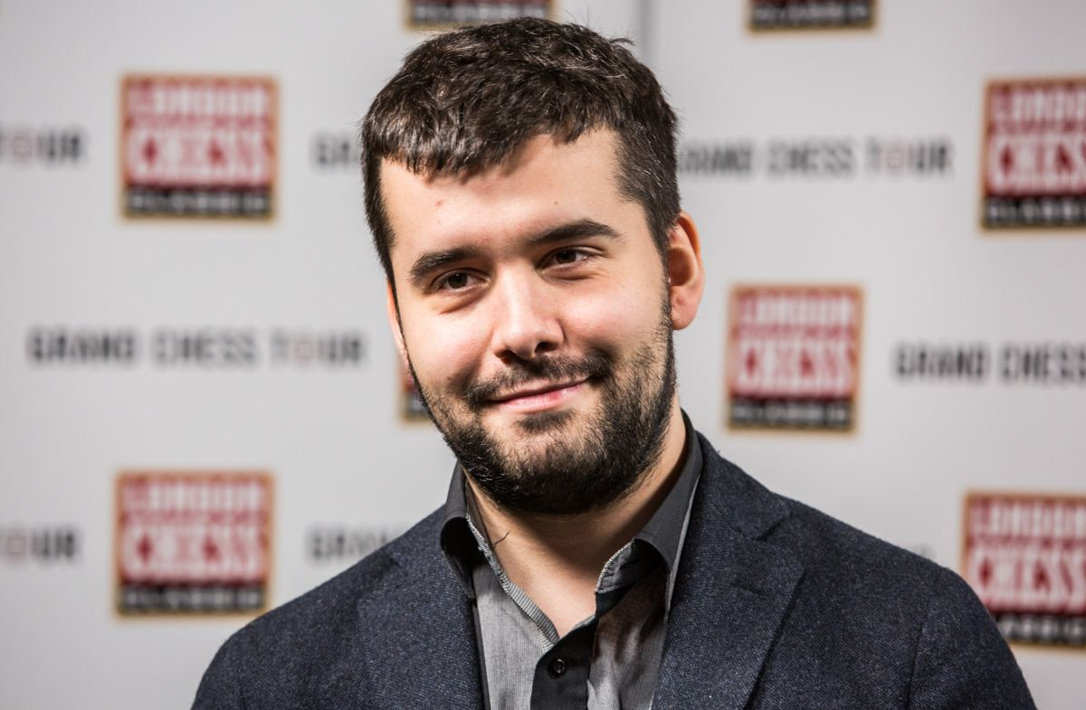

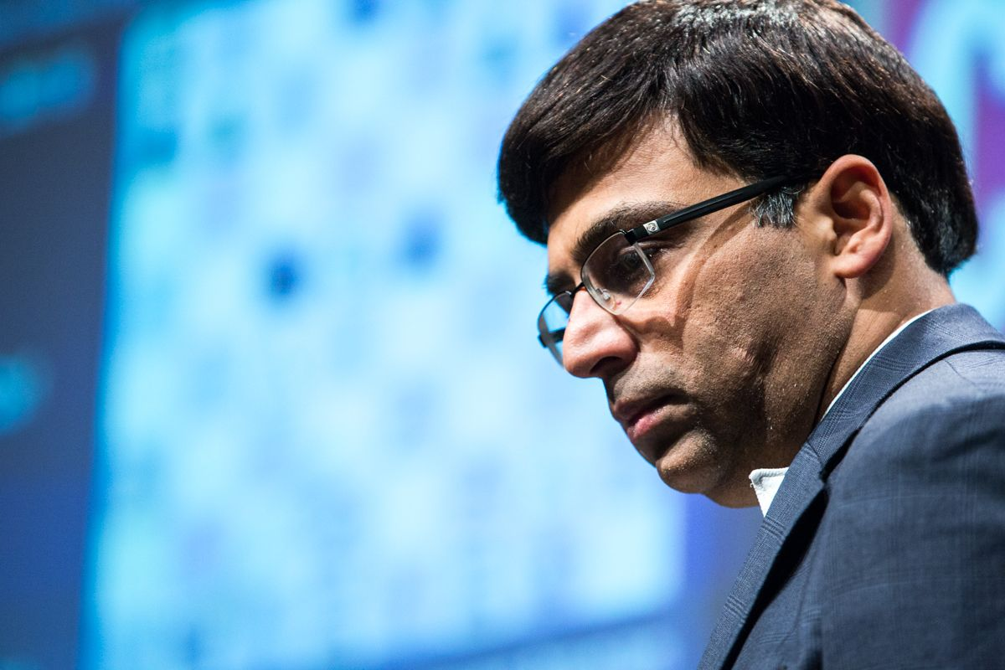
………….Carlsen holding Grand Chess Tour Trophy.

Nepomniachtchi and Anand

The last major tournament of 2017 was the London Classic played from December 1st to 11th with 10 of the world's top players competing. While winning the event was the prime ambition of most of the contestants, for two players, world champion Magnus Carlsen and Maxime Vachier-Lagrave, perhaps even more important was their aim to be the winner of the Grand Chess Tour, a series of five tournaments played throughout the year with a prize fund of US$1.2 million.While Carlsen seemed off form he nevertheless shared 3rd place with MVL and Wesley So to finish three points ahead of MVL and maintain his lead in the GCT, winning the main prize for the 5th time in nine years. Winner in London was Fabiano Caruana who defeated Ian Nepomniachtchi in a play-off blitz 2.5-1.5 (winning the 4th game after three draws) after both had finished on 6/9. In the final round Caruana, by defeating Michael Adams in a long game, had caught up leader Nepomniachtchi who had had a quick draw with MVL. Of concern was the prevalence of draws with Caruana being the sole winner in the first three rounds and five players finishing without a win – perhaps showing the need for wins to be 3 pts and draws 1 pt. Other scores: Carlsen, MVL, So 5, Hikaru Nakamura 4.5, Levon Aronian 4, Sergey Karjakin 3.5, Vishy Anand, Adams 3.

Ian Nepomniachtchi vs Viswanathan Anand
London Classic, Rd 7
Nimzovitsch Attack
1.c4 Nf6 2.Nc3 e6
3.Nf3 d5 4.e3 a6
5.b3 Bd6 6.Bb2 0-0
7.g4!?(a) Nxg4 8.Rg1 f5
9.cxd e5 10.h3 Nf6
11.Ng5 Qe7 12.Qf3 Kh8
13.Ne6 Bxe6 14.dxe6 Qxe6
15.Qxb7 Nbd7 16.Bc4 Qe7
17.Qg2 Nb6 18.Be2 a5
19.Bb5 Rad8 20.Qg5 g6
21.Qh6 Ng8 22.Qg5 Nf6
23.Rd1 e4 24.Qh6 Rg8
25.Ne2 Be5 26.Bxe5 Qxe5
27.Nf4 g5(b) 28.Rxg5 Rxg5
29.Qxg5 Rg8 30.Qh6 Rg7
31.Bc4 Nxc4 32.bxc4 Qb2
33.Ke2 a4 34.Ne6 Rf7
35.Nf4 Rg7 36.a3(c) Ne8
37.Qc6 resigns

a) This spike or bayonet attack shows White's attacking intentions.
b) Not 27...Qxb5 28.Nxg6+ Rxg6 29.Rxg6 Rg8 30.Rxg8+ Nxg8 31.Qe6.
c) If 36.Ne6 Black survives with 36...Rf7 38.Nd8 Rg7 39.Rg1! Ng5! 40.hxg4 Qc2. White now hoped for 36...c5 when he has the brilliant win with 37.Ne6 Rf7 38.Nd8 Rg7 39.Rg1! Rxg1 (39...Ng4 Qd6!) 40.Qf8+ Rg8 41.Nf7#.

SOLUTION: 1.Rxf7! Kxf7 2.Bf1! Qa4 3.Qxe6+ Kf8 4.Bc4.

