WORLD RAPIDPLAY CHAMPIONSHIP December 2017

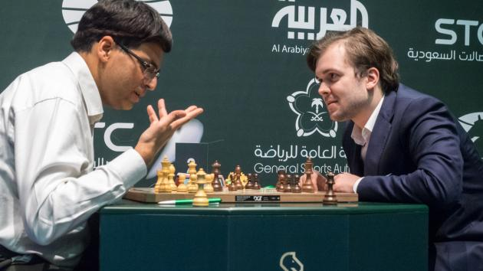
'Out with the old and in with the new' is a common but not always correct popular phrase at the turn of the year. In sport we can think of players who now might seem in the twilight of their careers but have managed to turn the clock back with unexpected success. Two players in Australia now that spring to mind are Roger Federer who won two of the four majors in 2017 and Alastair Cook who after a succession of failures made a record breaking 244 not out in the MCG Test. In chess it's the 48 year old ex-world champion Viswanathan
Anand who has over the past few years only
just managed to remain in the top ten. However
he achieved a surprise but well deserved win in
the recent World Rapidplay Championship
defeating Vladimir Fedoseev 1.5-0.5 in a blitz
play-off after both players finished on 10.5/15.
(Ian Nepomniachtchi also scored 10.5 but was
eliminated on count-back). Of considerable
significance was the finalists' games against
world champion Magnus Carlsen:
Anand & Fedoseev after their earlier draw

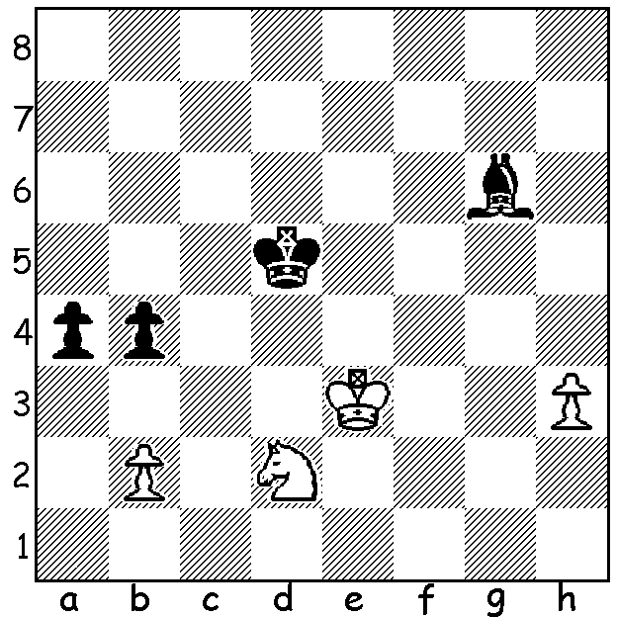

Fedoseev vs Carlsen: Play continued 74.Ke2 a3
75.bxa bxa 76.Kd1 a2 77.Nb3 Kc4 78.Na1 Kc3
79.Kc1 Bf5 80.h4 Bg6 81.h5 Bxh5 82.Nc2 Be8
83.Na1 Ba4 84.Nc2 Kb3 White resigns. At the
initial position White has a brilliant and completely
unexpected move to draw. Can you find it?

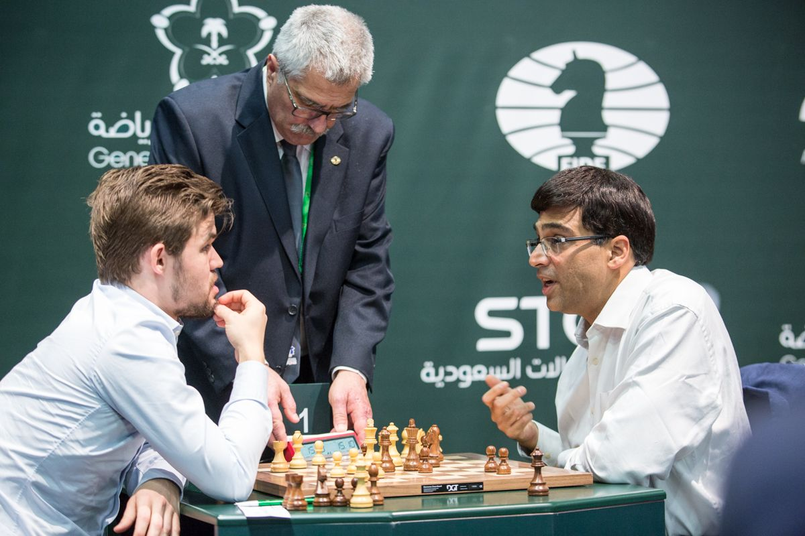
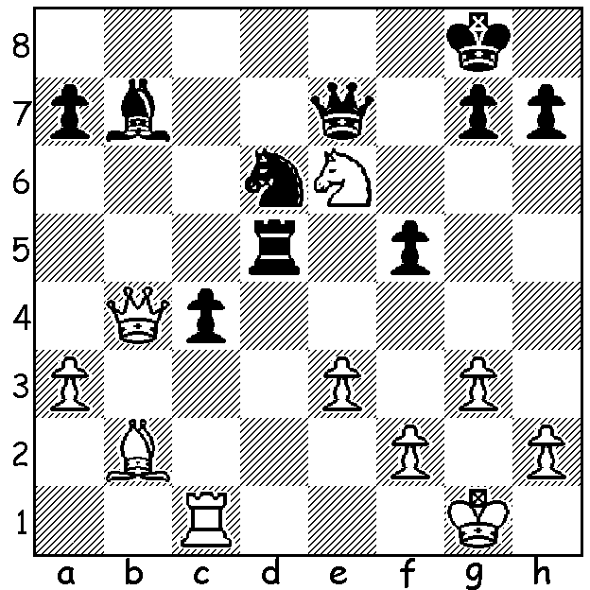

Carlsen vs Anand: White should play
33.Nf4 but errs with 33.Nc5: How does
Black now win (7 moves)?

Our game shows the defending World Blitz champion losing sensationally to a 15 year old Russian prodigy:

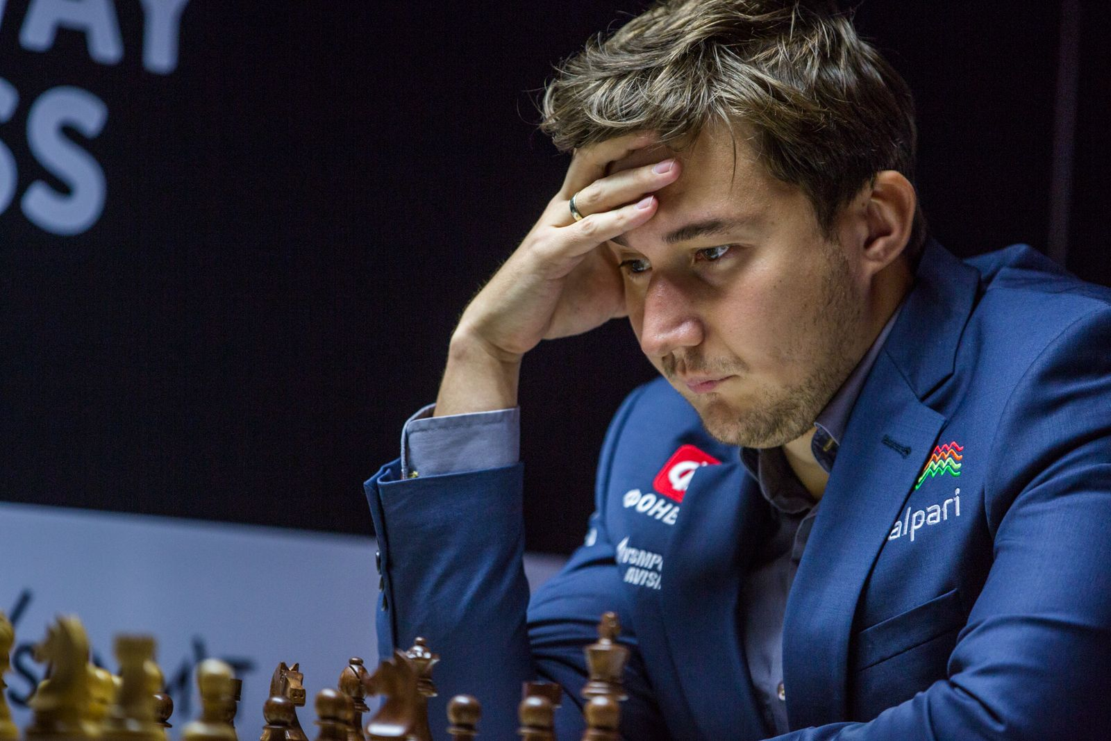
Sergey Karjakin vs Andrey Esipenko
2017 World Rapidplay
Caro-Kann Defence, Two Knights Variation
1.e4 c6 2.Nf3 d5
3.Nc3 Bg4 4.h3 Bxf3
5.Qxf3 Nf6 6.d3 e6
7.Bd2 Qb6 8.0-0-0 d4
9.Ne2 c5 10.e5 Nd5
11.Nf4 Nb4 12.Kb1 Nd7
13.Qe4 Nc6 14.Nh5 0-0-0
15.f4 c4! 16.dxc Ba3
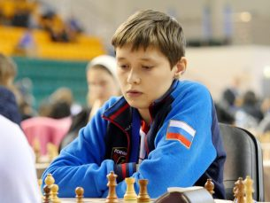
17.Bc1 Nc5 18.Qf3 d3!
19.cxd Na4 20.Rd2 Nd4
21.Qf2 Nc3+ 22.Ka1 Qb3!!
23.bxc3 Qxc3+ 24.Bb2 Bxb2+
25.Rxb2 Qc1+ 26.Rb1 Nc2+
27.Qxc2 Qxc2 28.g3 b5
29.cxb Rd4 White resigns

SOLUTION 1: 74.Nb3!! a3 (74...axb3 75.Kd2
is a known fortress position with White unable
to win the b pawn) 75.bxa bxa 76.Kd2 Kc4 77.Nc1=
(77...Bg1 78.Kd1 Kc3 79.Ne2+ Kg2 80.Nc1 Bc2+
81.Kd2 Kg1 82.Na2! or 82.Ne2) (I've ignored the irrelevant h pawn).

SOLUTION 2: 33...Rxc5! 34.Qxc5 Qe4 White resigns (35.Kf1 Qh1+ 36.Ke2 Bf3+ 37.Kd2 Ne4+ 38.Kc2 Nxc5 or Qxc1+.

