2017 World Blitz Championship

The all-Chinese game between Li Chao
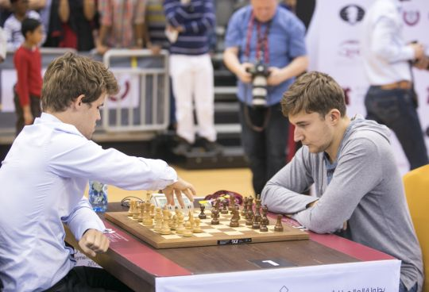
and Wang Hao in the 2017 World Blitz
Championship finished with a
spectacular win to Black (2 moves):
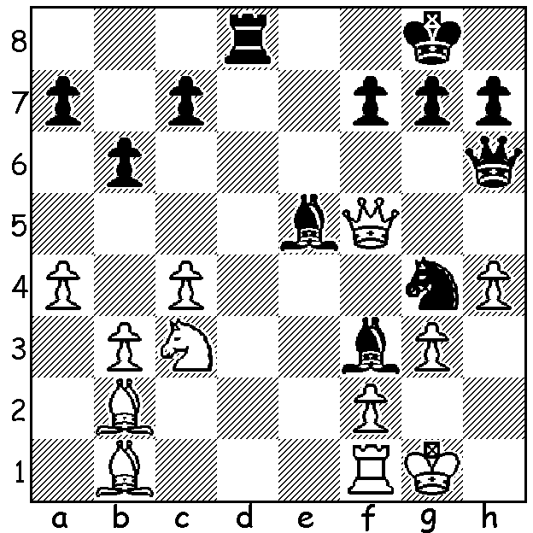

Carlsen v Karjakin (World Blitz)

World champion Magnus Carlsen had failed to impress at the World Rapidplay Championship and in the World Blitz Championship which followed finished the first day 8th= on 7/11, 2 points behind defending champion Sergey Karjakin and 1.5 pts behind Maxime Vachier-Lagrave. However on the second day he scored 9/10 (+8 =2) to gain the first prize of $64,000US with Karjakin 2nd and Rapidplay winner and ex-wotld champion Vishy Anand, who ended up the most successful player overall, 3rd . The tournaments were played in Riyadh, Saudi Arabia, a controversial venue with Israeli players unable to obtain visas and some players boycotting the events for either political or social reasons relating to laws which would effect participants in the Women's championship. Most prominent were Blitz expert Hikaru Nakamura and women's double title holder Anna Muzychuk.
Here's Carlsen's win against the overnight leader and defending champion.

Magnus Carlsen vs Sergey Karjakin
2017 World Blitz, Rd 15
Ruy Lopez, Berlin Defence
1.e4 e5 2.Nf3 Nc6
3.Bb5 Nf6 4.d3 Bc5
5.Bxc6 dxc6 6.Nc3 0-0
7.Be3 Bd6 8.Bg5 Re8
9.h3 c5 10.Nd5 Be7
11.Nxe7+ Qxe7 12.0-0 h6
13.Be3 Nd7(a) 14.Nd2 Nb8
15.f4 exf 16.Rxf4 Nc6
17.Qh5 b6 18.Raf1 Rf8
19.Nf3!(b) Be6 20.Rh4 f6
21.Qg6 Qf7(c) 22.Qg3 Nb4
23.Bxh6 Nxc2 24.Ne5 fxe5(d)
25.Rxf7 Rxf7 26.Qg6 Bxa2
27.Bg5 Rff8 28.Rh7 Rf7
29.Bf6 resigns

a) 13...c4!
b) Inviting Black to trap the rook with 19...g5 which loses to 20.Rh4! gxh4 21.Bxh6 Bd7 22.Bg7!! f5 (22...Kxg7 23.Ng5 f5 24.Qh7+ Kf6 25.Qf6+ Ke5 26.Nf3#) 23.Qh8+ Kf7 24.Qh6 Kg8 25.Bc3 Qh7 26.Qg5+ Kf7 27.exf with 28.Qf6+ Ke8 29.Re1+ (27...Qxf5 28.Ne5+!)
c) Now Karjakin had only a few seconds left while Carlsen had about a minute. Better 21...Bf7 not placing the queen on the same file as the f1 rook.
d) If 24...Qe7 25.Ng6 is decisive.

SOLUTION: 1...Qxh4!! White resigns (2.gxh4 Bh2# or 2.Qxe5 Qh1/2#. White could only stave off mate with 2.Qxh7+ Qxh7 3.Bxh7+ Kxh7 losing a piece).

