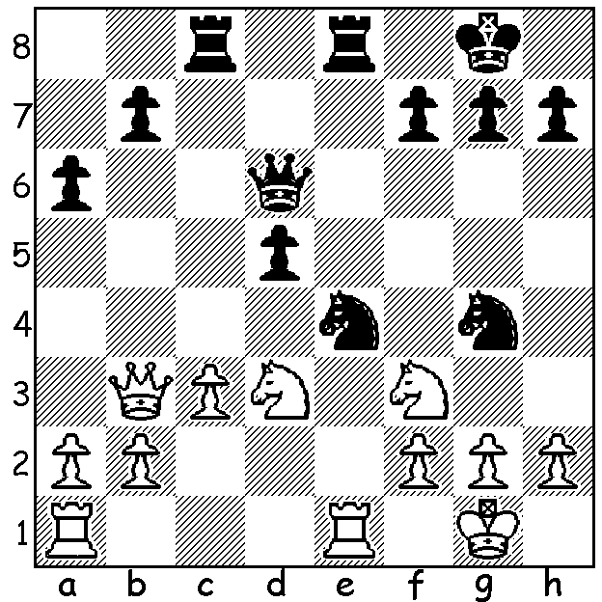

At the recent Australian Championship WA's
Ihsan Ferozkohi and Andrew Hardegen scored
5/11 and 4.5/11 respectively. Here is Andrew's
position as Black vs Neil Wright: White plays
1.h3 (1.g3 should be played) and Andrew finds
an immediate winning move. Can you see it?

I recently was asked to be on a panel deciding on the Australian player of the year with the two outstanding candidates being Max Illingworth and Anton Smirnov. I shall be interested to see if my fellow panelists agreed with my choice, a very difficult one with both players having a very successful 2017: Illingworth won the 2017 Australian Open, the NSW Open, the NSW Championship and the Queensland Championship and became Australia's top rated player: Smirnov won the Oceania Zonal, represented Oceania at the World Cup where he drew his two Classic games against Sergey Karjakin before losing in the Rapidplay, was 1st= in the 2nd Capablanca Memorial where he gained his Grandmaster (GM) title (at 16 the youngest ever Australian) and was selected to play in the Match of the Millenials in USA where against GM opposition he scored 3.5/6.

At the Australian Open Championship, played in Sydney
earlier this month, these two players were the pace setters with
Illingworth winning the event with the exceptionally high score
of 10/11 (+9 =2). Smirnov was also unbeaten but conceded 4
draws to finish on 9, a score that would have gained top spot in
many previous years. Here is Illingworth's final round game,
playing the unfashionable French Defence and winning with
a blistering attack:

Gene Nakauchi vs Max Illingworth
2018 Australian Championship, Rd 11
French Defence, Steinitz Variation
1.d4 e6 2.e4 d5 Illingworth
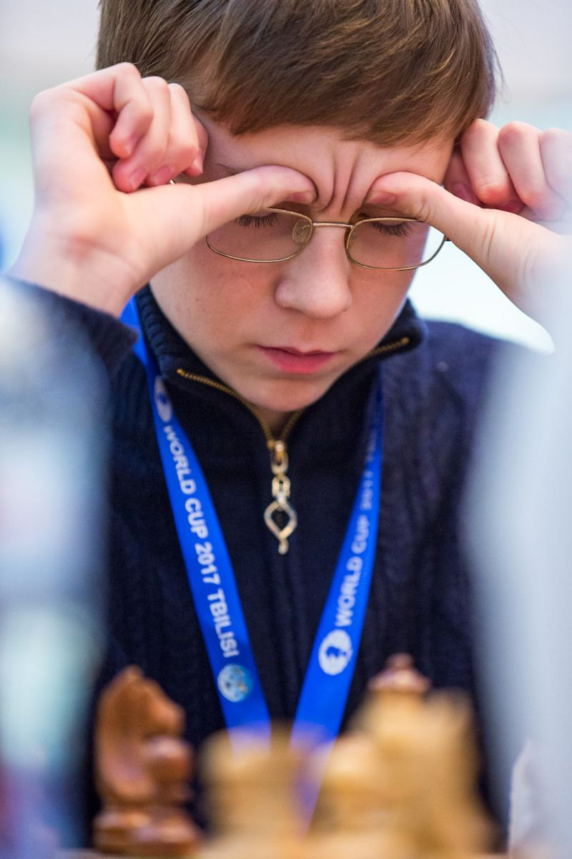
3.Nc3 Nf6 4.e5 Nfd7
5.f4 c5 6.Nf3 Nc6
7.Be3 Be7 8.Qd2 0-0
9.0-0-0(a) c4 10.Qf2 b5!
11.Kb1 b4 12.Ne2 Qa5
13.f5!(b) exf 14.Qg3 Kh8
15.Nf4 b3! 16.cxb cxb
17.a3 Bxa3! 18.bxa3(c) Qxa3
19.Rd2 Nb4 20.Ng5(d) Na2
21.Ne2 Ba6 22.Bf4 Rac8
23.Rb2 Bxe2 24.Bd2 Bd1
25.Bd3 Rc1+! White resigns Smirnov

a) Castling long is very risky as Black immediately unleashes a pawn storm against the king.
b) An excellent pawn sacrifice, opening up lines against Black's king.
c) White should instead further his own attack, which would have demanded very accurate play from Black. A computer line goes – 18.Nh5 g6 19.Nd2 Rb8 20.Bh6 Nxd4! 21.Qh4 Bb4 22.Bxf8 Bxf8 23.Qxd4 gxh5 24.Nxb3 Rxb3 25.e6+ Bg7 26.e7! Nf6 27.Qxf6! Bxf6 28.e8=Q+ Kg7 29.Qe2 Qb4 30.Rd2 f4 winning.
d) Better would be 20.Nh5 when Black again needs accuracy to triumph: 20...g6 21.Bh6 Nc2 22.Rxc2 bxc2+ 23.Kxc2 Qa2+ 24.Kd1 Rb8 25.Nd2 Qa1+ 26.Ke2 Re8+ 27.Kf2 Qxd4+ winning.

SOLUTION: 1.h3? Nd2!! winning the queen as 2.Nxd2 loses to 2...Qh2+ 3.Kf1 Qh1# and 2.Qmoves lose to 2.Nxf3+ 3.gxf3 4.Qh2+.

