Kuzobov vs Sanal 2017: Can you find Black's best move?

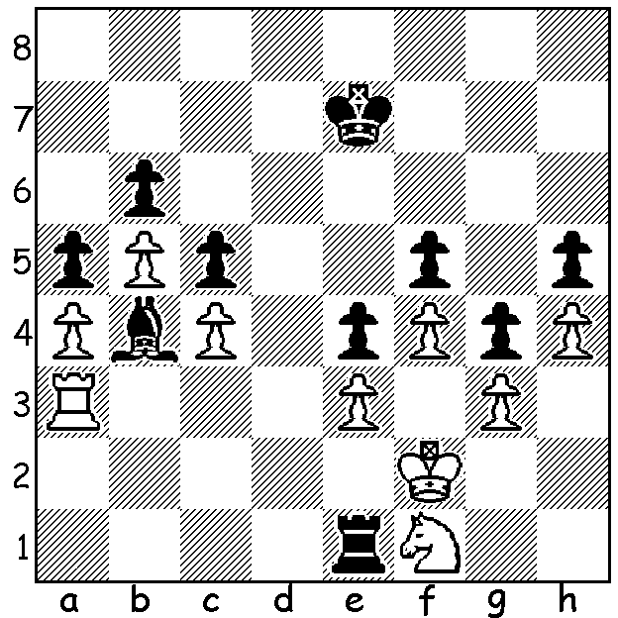
I was referred by John Fedec to an interesting computer chess match played in December. The match pitted new boy on the block, Google's AlphaZero, against Stockfish which, besides being world computer chess champion in 2014 and 2016, had recently defeated Houdini in the final of the World Open Computer Championship 10.5-9.5. AlphaZero had been provided with the rules but no instruction and self-taught itself in four hours to reach an amazing standard (I read in that time it played 44 million games against itself). The 100 game match, with one minute a move, proved quite one-sided with AlphaZero winning 64-36 (+28 =72). Although Stockfish made many times as many calculations each move, its brute-force, number crunching method was no match for AlphaZero's more human-like calculations at 80K per position which were concentrated on only the more promising lines. However not everyone was in awe of its achievements with Hikaru Nakamura opining that it was an unfair match since Stockfish had not been allowed access to its opening library. Moreover the one minute a move, rather than a given amount of time for a number of moves, deprived Stockfish of its built-in time management faculty. What AlphaZero did show in its wins was the ability to form long term plans and a definite preference for positional over material advantage . It was very happy to regularly sacrifice its d pawn in lines of the Queens Indian to cramp Black and won a number of games with positional piece sacrifices. The following game has been compared to Saemisch vs Nimzovitsch (Copenhagen 1926), the 'Immortal Zugzwang Game'.

AlphZero vs Stockfish
Queens Indian Defence
1.Nf3 Nf6 2.c4 b6 3.d4 e6
4.g3 Ba6 5.Qc2 c5 6.d5 exd
7.cxd Bb7 8.Bg2 Nxd5 9.0-0 Nc6
10.Rd1 Be7! 11.Qf5(a) Nf6 12.e4 g6
13.Qf4 0-0 14.e5 Nh5 15.Qg4 Re8
16.Nc3 Qb8 17.Nd5 Bf8 18.Bf4 Qc8
19.h3 Ne7 20.Ne3 Bc6 21.Rd6 Ng7
22.Rf6!(b) Qb7 23.Bh6 Nd5 24.Nxd5 Bxd5
25.Rd1 Ne6 26.Bxf8 Rxf8 27.Qh4 Bc6
28.Qh6 Rde8 29.Rd6 Bxf3(c) 30.Bxf3 Qa6
31.h4 Qa5 32.Rd1 c4 33.Rd5 Qe1+
34.Kg2 c3 35.bxc Qxc3 36.h5 Re7
37.Bd1! Qe1 38.Bb3 Rd8 39.Rf3 Qe4
40.Qd2 Qg4 41.Bd1 Qe4(d) 42.h6 Nc7
43.Rd6 Ne6 44.Bb3!! Qxe5 45.Rd5 Qh8(e)
46.Qb4 Nc5 47.Rxc5!! bxc5 48.Qh4! Rde8
49.Rf6 Rf8 50.Qf4 a5 51.g4 d5
52.Bxd5 Rd7 53.Bc4 a4 54.g5 a3
55.Qf3 Rc7 56.Qxa3(f)

a) Not 11.Rxd5? Nb4.
b) Not fearing the rook's incarceration by ...Ne6.
c) Removing a potentially dangerous attcking piece.
d) Not 41...Qxh5 42.Rxf7.
e) Black must defend g7.
f) With White planning to march his a pawn to promotion Black played the hopeless 56...Qxf6 but resigned a few moves later.

SOLUTION: Did you select 1...Rxf1+? Unfortunately the move is a mistake – 2.Kxf1 and Black has no king entry. Black can defend his kingside pawns & even if White sacrifices bishop for pawn there is still no king entry. If you made this error you were not alone as it was also chosen by Stockfish. Black played 1...Rc1 and soon won.

