Wei Yi vs Gawain Jones
(Tata Steel 2018): White wins a pawn:
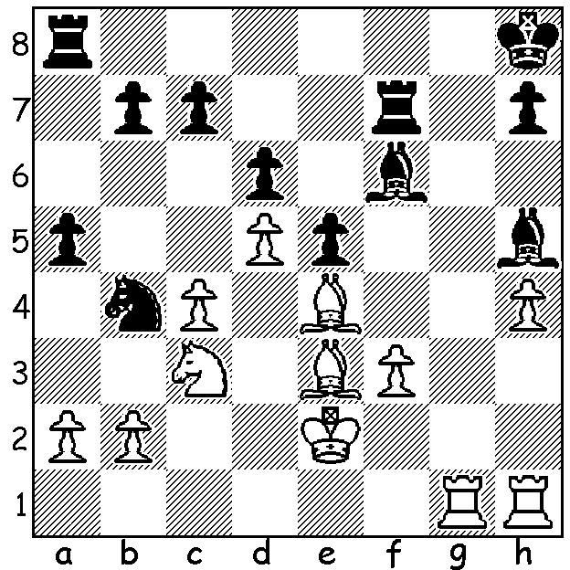




Last week I wrote about the amazing new
Google chess programme Alpha Zero which
comfortably defeated the previously best
chess computer Stockfish in a match 64-36
(+28 =72). As I said, AlphaZero showed in
its wins the ability to form long term plans
and a definite preference for positional over
material advantage. It was very happy to
regularly sacrifice its d pawn in lines of the
Queens Indian to cramp Black and won a
number of games with positional piece sacrifices.
Here are two examples:

AlphaZero vs Stockfish
French Defence, Steinitz Variation
1.d4 e6 2.e4 d5 3.Nc3 Nf6
4.e5 Nfd7 5.f4 c5 6.Nf3 cxd(a)
7.Nb5 Bb4+ 8.Bd2 Bc5 9.b4 Be7
10.Nbxd4 Nc6 11.c3 a5 12.b5 Nxd4
13.cxd4 Nb6 14.a4 Nc4 15.Bd3 Nxd2
16.Kxd2!(b) Bd7 17.Ke3 b6 18.g4 h5
19.Qg1 hxg 20.Qxg4 Bf8 21.h4 Qe7
22.Rhc1 g6 23.Rc2 Kd8 24.Rac1 Qe8
25.Rc7 Rc8 26.Rxc8 Bxc8 27.Rc6 Bb7!
28.Rc2(c) Kd7 29.Ng5 Be7 30.Bxg6!! Bxg5
31.Qxg5 fxg6 32.f5! Rg8(d) 33.Qh6 Qf7
34.f6 Kd8 35.Kd2 Kd7 36.Rc1 Kd8
37.Qe3 Qf8 38.Qc3 Qb4 39.Qxb4 axb4
40.Rg1 b3 41.Kc3 Bc8 42.Kxb3 Bd7
43.Kb4 Be8 44.Ra1 Kc7 45.a5 Bd7
46.axb6+ Kxb6 47.Ra6+ Kb7 48.Kc5 Rd8
49.Ra2 Rc8+ 50.Kd6 Be8 51.Ke7 g5
52.hxg5 resigns

a) 6...Nc6 is better.
b) A novel idea to gain a safe place for the king.
c) 28.Rxb6?? Kc7.
d) 32...exf5 (32 ...gxf5 33.Qg7+) 33.Qf6 Qf8 34.e6+ Ke8 35.Qxg6+ Kd8 36.Qg5+ Ke8 37.Rc7

AlphaZero vs Stockfish
Queens Indian, Polugayevsky Gambit
1.Nf3 Nf6 2.d4 e6 3.c4 b6
4.Bg2 Be7 5.Bg2 Be7 6.0-0 0-0
7.cxd Nxd5 8.Nh4 c6 9.cxd Nxd5
10.Nf5 Nc7 11.e4 d5 12.exd Nxd5
13.Nc3 Nxc3 14.Qg4 g6 15.Nh6+ Kg7
16.bxc3 Bc8 17.Qf4 Qd6 18.Qa4 g5
19.Re1 Kxh6 20.h4 f6 21.Be3 Bf5
22.Rad1 Qa3 23.Qc4 b5 24.hxg+ fxg
25.Qh4+ Kg6 26.Qh1 Kg7 27.Be4 Bg6?
28.Bxg6 hxg6 29.Qh3 Bf6 30.Kg2 Qxa2
31.Rh1 Qg8 32.c4 Re8 33.Bd4 Bxd4
34.Rxd4 Rd8 35.Rxd8 Qxd8 36.Qe6 Nd7
37.Rd1 Nc5 38.Rxd8 Nxe6 39.Raa8
and Black resigns on move 56.

SOLUTION: 1.Rg5! Bg6 (1...Bxg5? 2.hxg5 wins piece) 2.Bxg6 hxg6 3.Rxg6 and wins. More on
the Tata Steel next week.

