Viswanathan Anand vs Hou Yi Fan (Tata Steel 2018):
how does White manage to advance his passed pawn?

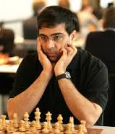

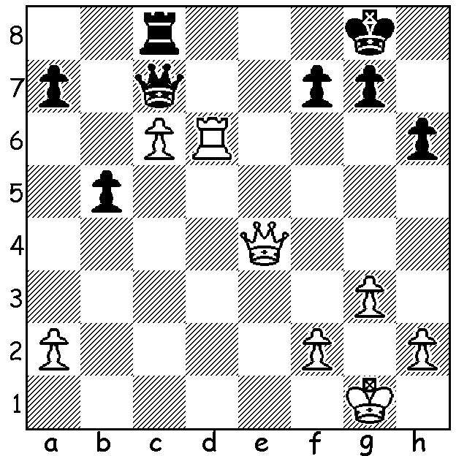

The annual Tata Steel Tournament finished with a two-way tie after the 13 rounds, necessitating a Blitz Play-Off. Anish Giri, after wins in his first two games, was never headed but lost overall lead in Rd 10 as world champion Magnus Carlsen drew level. Giri had played by far the more impressive chess, belying his drawing reputation (Carlsen blundered a piece in hisgame vs Gawain Jones but still won after his opponent failed to block th kingside pawns allowing Carlsen a winning attack), but Dutch hopes of a local winner were dashed as Carlsen won the first blitz and agreed a draw in a likely winning position in the second. With six Tata Steel tournament wins Carlsen has now overtaken Vishy Anand (five victories). Leading scores: Giri & Carlsen 9/13, Vladimir Kramnik & Shakhriyer Mamedyarov 8.5, Anand & Wesley So 8. Here's the first Blitz Play-Off game. No fireworks but a superb positional win reminiscent of Nimzovitsch:

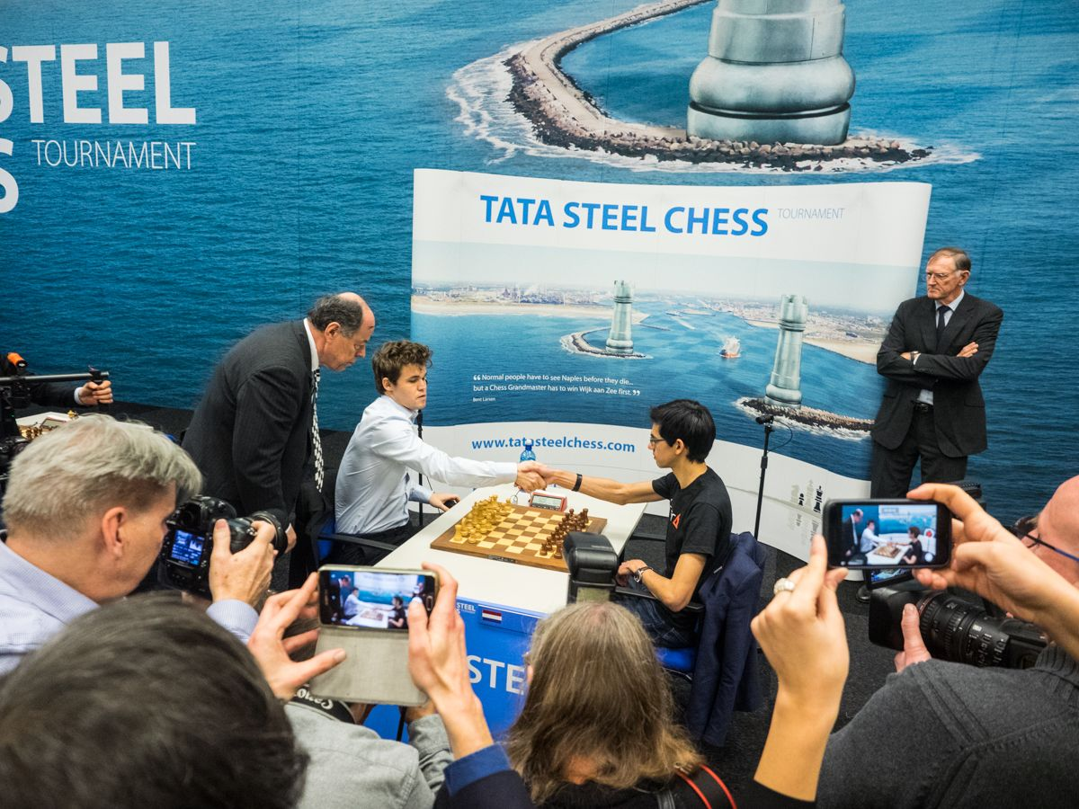
Start of Play-Off

Magnus Carlsen vs Anish Giri
2018 Tata Steel, Play-Off Game 1
Nimzovitsch Attack
1.Nf3 Nf6 2.c4 e6 3.b3 d5
4.Bb2 Be7 5.e3 0-0 6.Nc3 c5
7.cxd Nxd5 8.Nxd5 exd5 9.d4 Qa5+
10.Qd2 Qxd2+ 11.Kxd2 Nc6 12.dxc(a) Bxc5
13.Bb5 Bb4+ 14.Ke2 Be6 15.Rac1 Rac8
16.Rhd1 Be7 17.h3 a6 18.Bd3 Nb4
19.Bb1 Rxc1 20.Rxc1 Rc8 21.Rd1! Nc6
22.g4 h6 23.Nd4 Nxd4 24.Bxd4 Ba3
25.f4(b) f6(c) 26.Bg6 Kf8 27.Kf3 Ke7
28.h4 Bb4 29.Bd3 Bd7 30.e4!(d) Bc3
31.Bf2 Bc6 32.exd Bxd5+ 33.Be4 Bxe4+
34.Kxe4 Ke6(e) 35.f5+ Ke7 36.Rc1 Rc6(f)
37.Kd3 Bb4 38.Rxc6 bxc6(g) 39.Kc4 Bd6
40.Bc5 Kd7 41.h5! Bf4 42.Bf8 Ke8
43.Bc5 (43.Bxg7? Kf7) 43...Kd7 44.Kb4 Bd2+
45.Ka4 Kc7 46.b4 Bf4 47.Bf8 Kb6
48.Bxg7 Bg5 49.Bf8 Bf4 50.Be7 Bg5
51.Kb3 Kc7 52.Kc4 Kd7 53.Bc5 Kc7
54.Kd3 Kd7 55.Be3 Black resigns.

a) Play will revolve around White pressure against the isolated pawn on the half-open d file.
b) Planning to drive the bishop from e6.
c) 25...Rc1 would give Black a better chance of saving the game.
d) White relieves Black of his weak d pawn in order to infiltrate with his king.
e) Keeping White's king out.
f) Better 36...Rc7 37.Bd4 Ba5 38.Rxc7 Bxc7 39.Kd5 but White is still likely to win.
g) Now with weakened queenside pawns and kingside pawns susceptible to bishop attacks Black is lost.

Congratulations to WA's Rebo Fu (Australian Under 12 Championship winner) and Brent Geronimo (2nd in Australian Under 14 Championship).

The first WA Grand Prix tournament of the year will be the Perth Open, Sat 17, Sun 18 Feb (10.30 start). Info & entries Gordon Dunlop 9368 6412 / 0409812129, gordondunlop64@gmail.com

SOLUTION: 1.Rd7! Qa5 (1...Qxc6 2.Rd8+) 2.c7! Rf8 (2...Rxc7 3.Rd8#) 3.Qe7 resigns.

