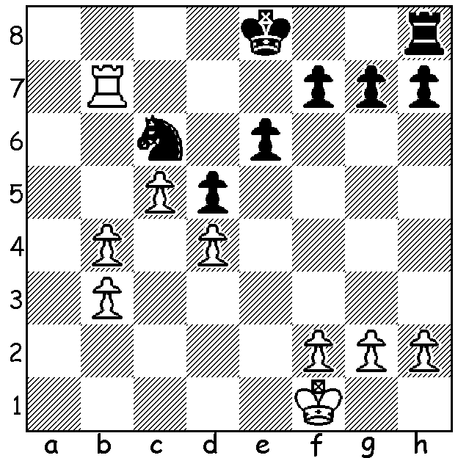

Chanda Sandipan vs Vassily Ivanchuk:
Can you find Black's best move?
(positional judgement rather than detailed analysis)

The very popular Gibraltar Open with 150 entries clashed with the Tata Steel event but still attracted a number of top GMs. Hikaru Nakamura had won the previous four years and started off with five wins but then drew his last five games to finish =1st with six others. Nikta Vitiugov, Michael Adams and Le Quang Liem were then unluckily eliminated because of lower performance ratings (playing against lower rated opposition than the four players who remained, Nakamura, Maxime Vachier-Lagrave, Levon Aronian and Richard Rapport). Here are some minis from Rd 1
with a report on the Play-Off next week :

Mickail Antipov vs Ylon Schwartz
Sicilian Defence
1.e4 c5 2.Nf3 e6
3.d4 cxd 4.Nxd4 Nf6
5.Nc3 d6 6.g4 h6
7.g5 hxg 8.Bxg5 a6
9.f4 Qc7 10.Qd2 Nbd7
11.0-0-0 b5 12.Bg2 Bb7
13.Rhe1 Rxh2 14.Nd5?! Qc4(a)
15.Re3 Nxe4? 16.Nxe6!! fxe6(b)
17.Bxe4 resigns(c)

a) 14...exd5 was best but scary.
b) 16...Nxd2 17.Ndc7+ Qxc7 18.Nxc7# or 16...Bxd5 17.Qxd5!
c) 17...Rxd2 18.Bg6#.

Flavio Perez vs Grigoriy Oparin
Two Knights Defence
1.e4 e5 2.Nf3 Nc6
3.Bc4 Nf6 4.d3 Be7
5.0-0 0-0 6.Nc3 d6
7.a3 Bg4 8.Be3 Kh8
9.h3 Bh4 10.g4 Nxg4
11.hxg4 Bxg4 12.Nb1(d) Qd7
13.Nbd2 f5 14.exf d5
15.Bb3 Rxf5 White resigns

d) 12.Kg2 gives a better chance.

Nils Grandelius vs Rodney Oscar Perez Garcia
Queens Gambit, Slav Defence
1.d4 d5 2.c4 c6
3.Nf3 Nf6 4.Nc3 dxc
5.a4 e6 6.e3 c5
7.Bxc4 Nc6 8.0-0 cxd
9.Nxd4 Qc7 10.Ncb5 Qb8
11.e4 Ne5(e) 12.Bf4 a6
13.Rc1! axb5 14.Bxb5+ Bd7
15.Bxd7+ Nfxd7 16.Nb5 Ra5(f)
17.Nc7+ Kd8 18.Qd2 Rc5
19.Bxe5 Rxe5 20.Rfd1 resigns

e) Cicumspect was 11...Be7 preparing to castle.
f) 16...Bc5 was a must but after17.Rxc5! Nxc5 18.Nd6+ Ke7 19.Bxe5 Rd8! 20.Qc1 Rxd6 21.Qxc5 f6 22.Bxd6+ Qxd6 Black likely to lose.

The first WA Grand Prix tournament of the year will be the Perth Open, tomorrow, Sat 17 and Sun 18 Feb (10.30 start). Info & entries Gordon Dunlop 9368 6412 / 0409812129, gordondunlop64@gmail.com

SOLUTION: Black played 1..0-0 but soon lost after 2.b5 Na5 3.Rc7. The best move was 1...Rf8! saving his rook, defending his f pawn and keeping his king near White's dangerous passed pawns.

